SUBJECT | TFISL and TEKSS - Update the fixed Assets register and calculation of the depreciation
RECORDER (Name Designation) | Deepika Thilakarathna (Assistant Accountant, Finance)
APPROVED BY (Name Designation) | Stanley Samidas
CREATED DATE | 06/12/2016
NO. OF PAGES INCLUDING THIS PAGE | 03
OFFICE PROCESS RECORD

Process : TFISL and TEKSS - Update the fixed Assets register and calculation of the depreciation
Recorder : Deepika Thilakarathna

Objective : Ensure the Accuracy Fixed Assets Register

01.Report Company and Financial Balance sheet Standard double click on property plant and equipment Export to Excel

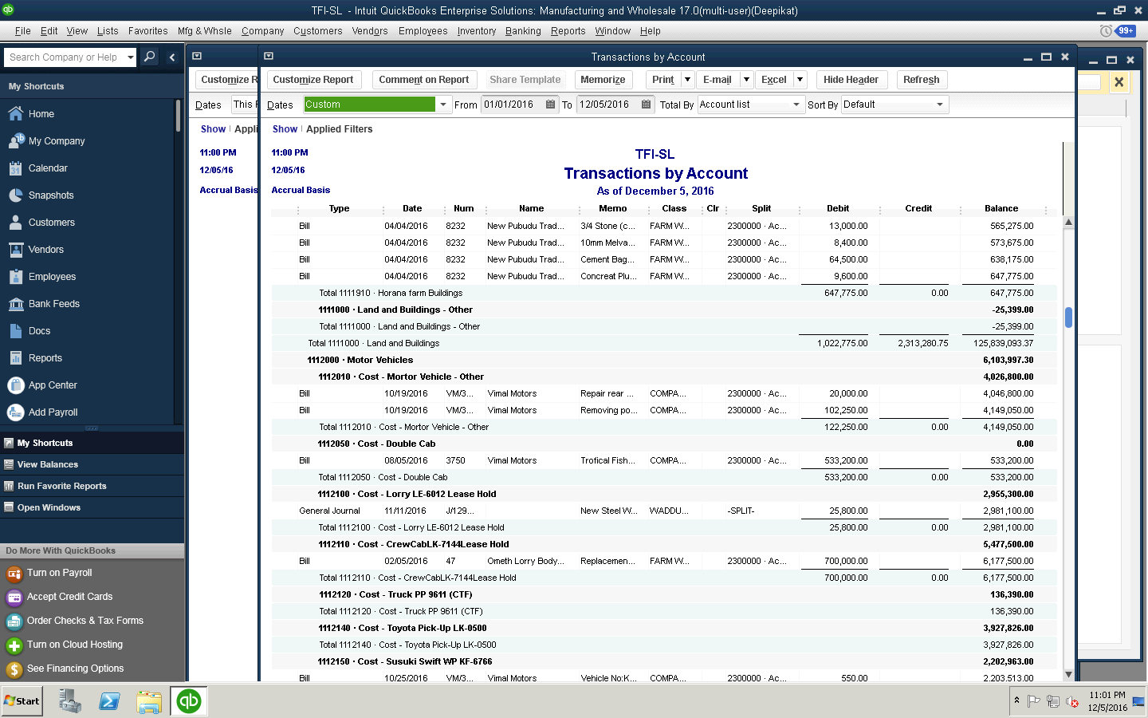

2. Update Fixed assets addition
3. Calculate the depreciation with reference to the date of purchase
4.Update the Quick Book Accordingly

