SUBJECT | TFISL - Post the SVAT credit vouchers to suppliers
RECORDER (Name Designation) | Deepika Thilakarathna (Assistant Accountant, Finance)
APPROVED BY (Name Designation) | Stanley Samidas
CREATED DATE | 06/12/2016
NO. OF PAGES INCLUDING THIS PAGE | 03

OFFICE PROCESS RECORD

Process : TFISL - Post the SVAT credit vouchers to suppliers
Recorder : Deepika Thilakarathna

Objective : Tax filing and issuing SVAT vouchers accurately and timely

- By reference to the form 05 (IRD Website ) get the list SVAT Suppliers relevant to the particular month prepare excel sheet to the following format

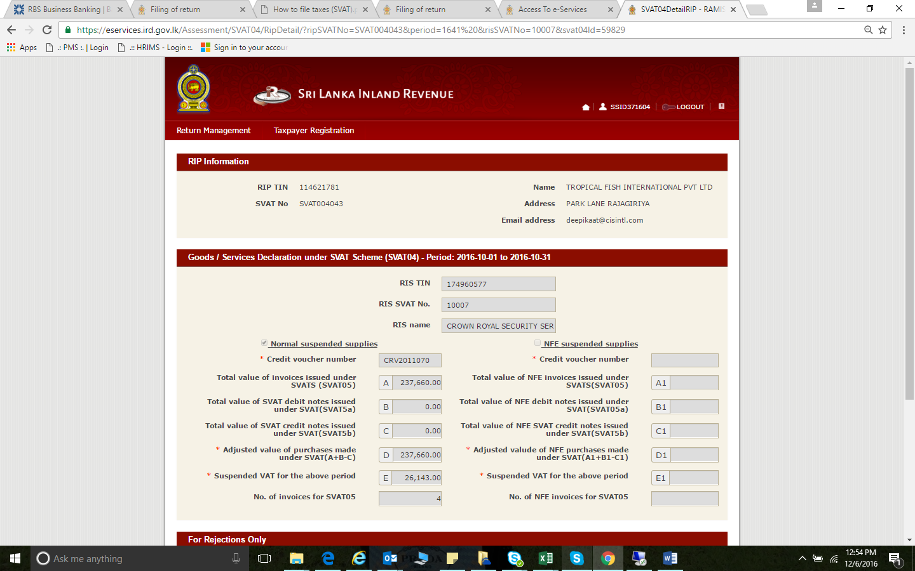
Supplier |  | Address |  | No of SVAT Credit voucher |  | SVAT Credit Voucher Numbers

2. repare list of Supplier Adders
3.Post the Original SVAT vouchers customer copy to the client

