SUBJECT | TFISL - Monthly Filling the Vat Return
RECORDER (Name Designation) | Deepika Thilakarathna (Assistant Accountant, Finance)
APPROVED BY (Name Designation) | Stanley Samidas
CREATED DATE | 06/12/2016
NO. OF PAGES INCLUDING THIS PAGE | 05
OFFICE PROCESS RECORD

Process : TFISL - Monthly Filling the Vat Return
Recorder : Deepika Thilakarathna

Objective : Timely/Accurate submission and avoid BOI permission for importing.

- Get the VAT return from Inland Revenue department
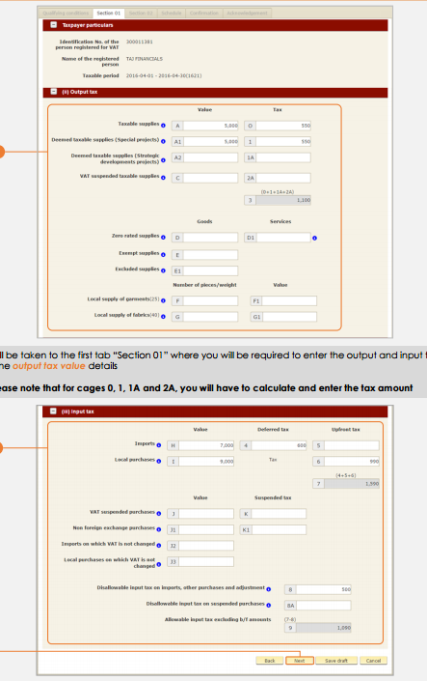

2. Get the monthly total of following figures and check the accuracy

* Total Export made during the month
*Total Import made during the month
*Total SVAT Suppliers
3. Fil the VAT Return get the sign from authorized person
4. Sent it to the Inland Revenue Department

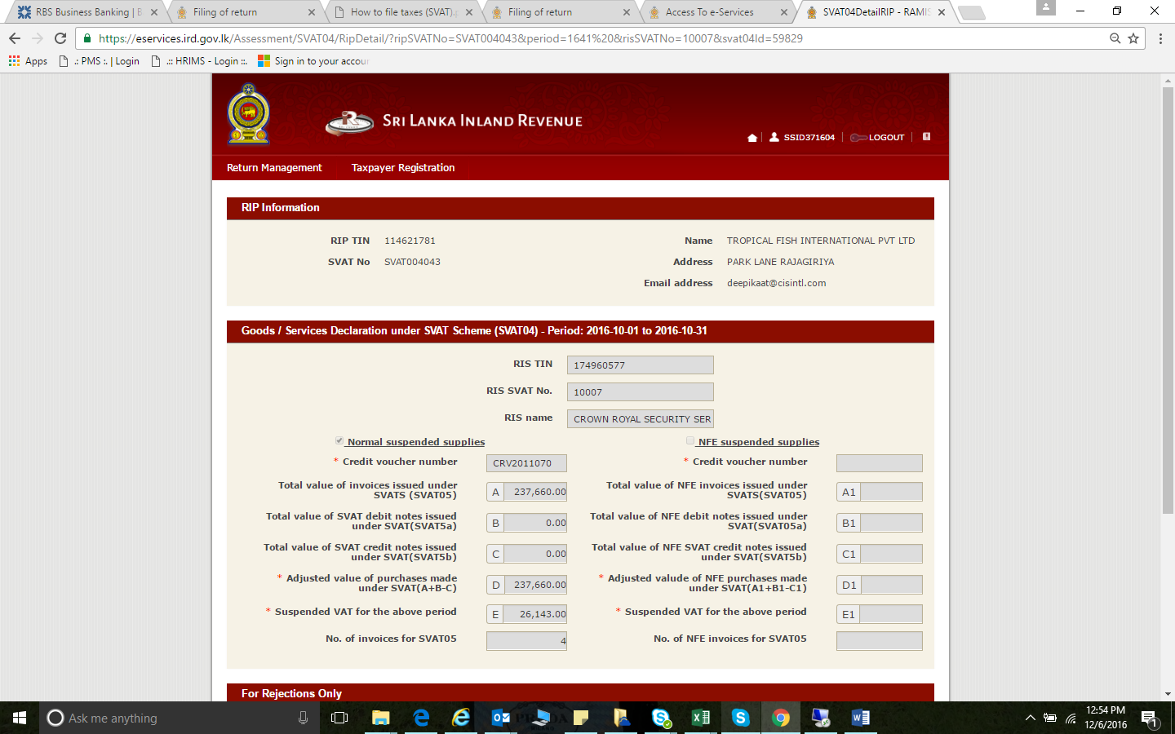
Supplier |  | Address |  | No of SVAT Credit voucher |  | SVAT Credit Voucher Numbers

2. repare list of Supplier Adders
3.Post the Original SVAT vouchers customer copy to the client

