SUBJECT | TFISL - Monthly applying for VAT Extent ion letter and obtain
RECORDER (Name Designation) | Deepika Thilakarathna (Assistant Accountant, Finance)
APPROVED BY (Name Designation) | Stanley Samidas
CREATED DATE | 06/12/2016
NO. OF PAGES INCLUDING THIS PAGE | 03
OFFICE PROCESS RECORD

Process : TFISL - Monthly applying for VAT Extent ion letter and obtain
Recorder : Deepika Thilakarathna

Objective : Ensure importation done without any difficulties.

01. Apply for Vat Extension Letter-prepared the letter to following format get the signature from finance director)
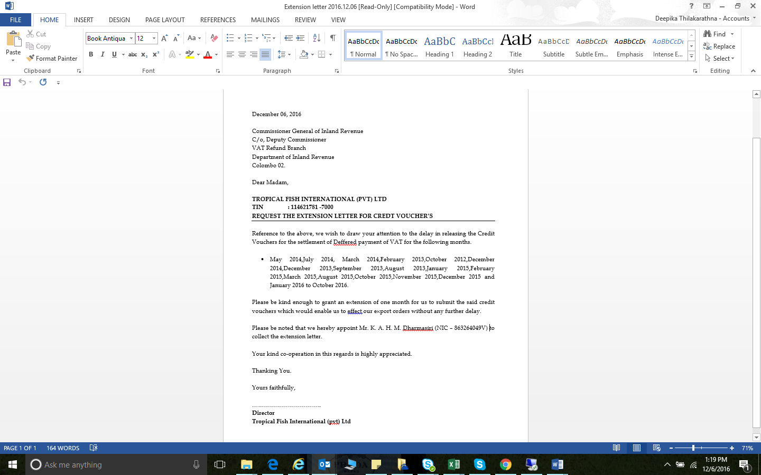

2. Sent to the IRD
3. Once get the Extension letter get the approval from BOI

