SUBJECT | Daily AR Report
RECORDER (Name Designation) | Deepika Thilakarathna (Assistant Accountant, Finance)
APPROVED BY (Name Designation) | Stanley Samidas
CREATED DATE | 06/12/2016
NO. OF PAGES INCLUDING THIS PAGE | 04
OFFICE PROCESS RECORD

Process : Daily AR Report
Recorder : Deepika Thilakarathna

Objective : To ensure the Account receivables are collected on time.

Process is as bellow.
- Generate the QB AR report

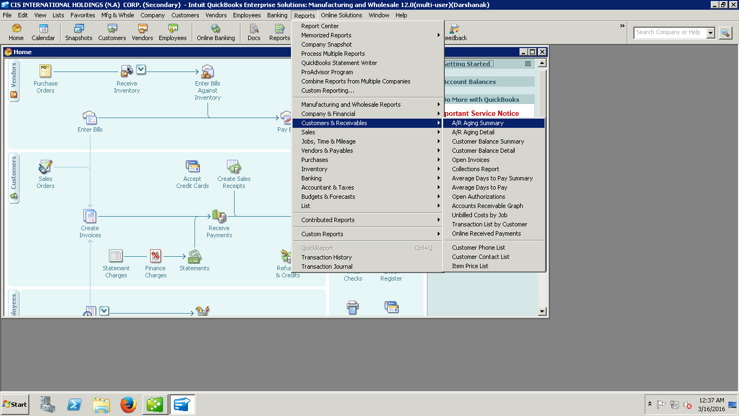

Edit the QB report As Available data in our record.
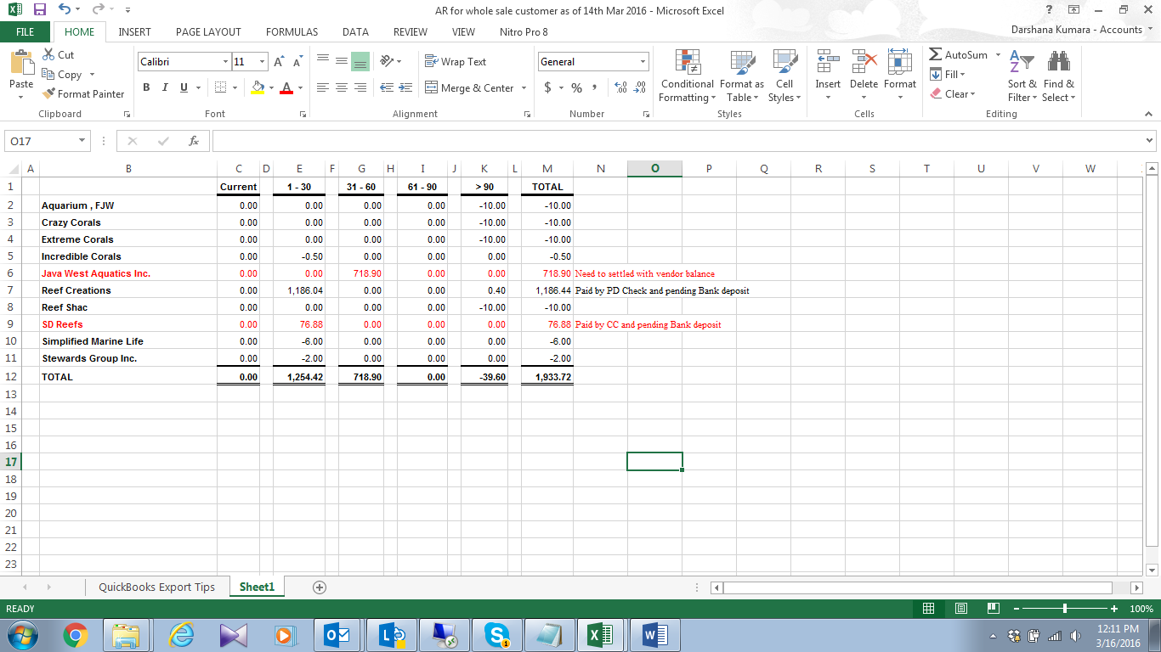

02. Need to send this Report to Andreas and Brian

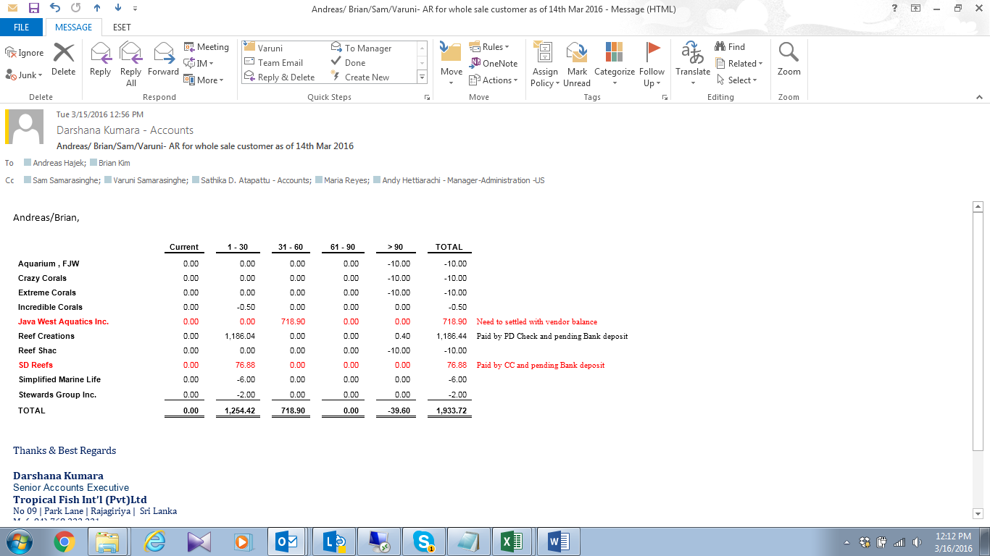
03. Discussed and inform to management if overdue or bad debts have

