SUBJECT | TFI UK and TFIAU Transaction report
RECORDER (Name Designation) | Deepika Thilakarathna (Assistant Accountant, Finance)
APPROVED BY (Name Designation) | Stanley Samidas
CREATED DATE | 06/12/2016
NO. OF PAGES INCLUDING THIS PAGE | 03
OFFICE PROCESS RECORD

Process : TFI UK and TFIAU Transaction report
Recorder : Deepika Thilakarathna

Objective : To ensure all the Transactions are Update in timely Manner.

Process is as bellow.
- Go to report and then click Accounts and Taxes after that Transaction detail by accounts
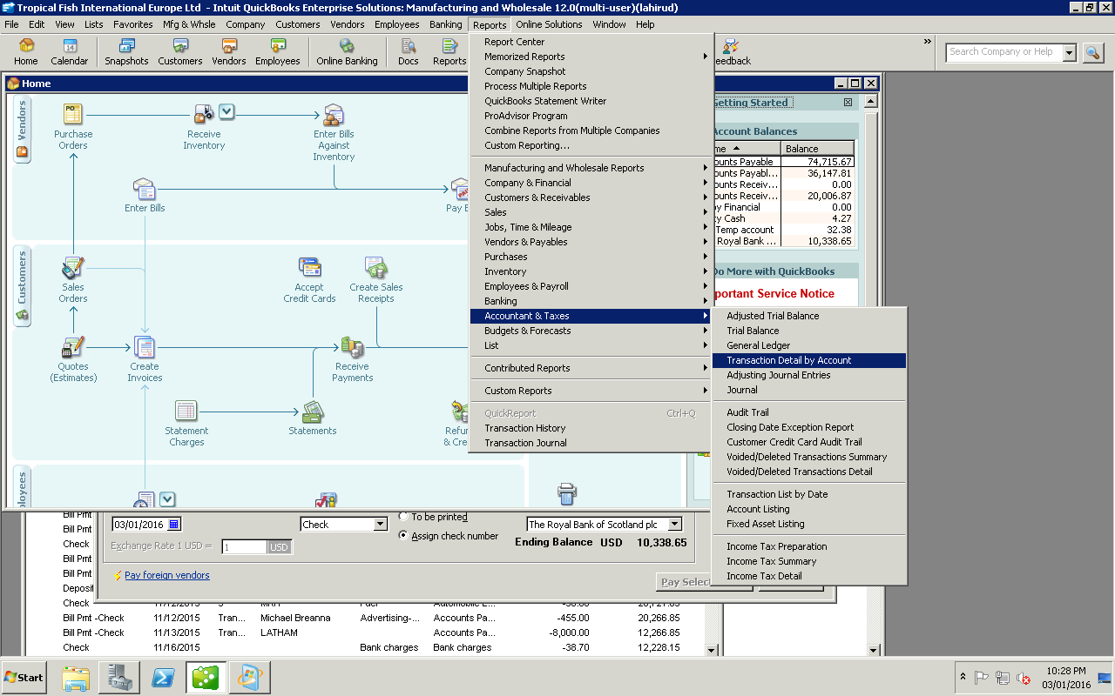

Then select the date range and export it to the excel by clicking exell
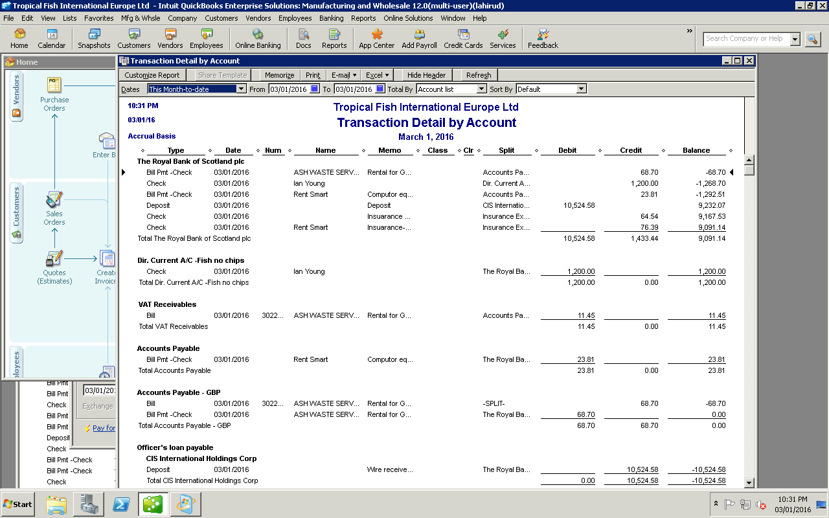
02.Need to send this to Ian Foster for review

