SUBJECT | TFI UK and TFIAU entering
RECORDER (Name Designation) | Deepika Thilakarathna (Assistant Accountant, Finance)
APPROVED BY (Name Designation) | Stanley Samidas
CREATED DATE | 06/12/2016
NO. OF PAGES INCLUDING THIS PAGE | 04
OFFICE PROCESS RECORD

Process : TFI UK and TFIAU entering
Recorder : Deepika Thilakarathna

Objective : To ensure all the Expenses and Bills are Update in timely Manner

- End of the everyday Ian/Daniel will send the Bills through Email. Save the bill creating separate folder vendor wise by checking the accuracy of the bill.

- After saving we have to enter the Bills to Quick books.
- Select- Vendor- enter bills.
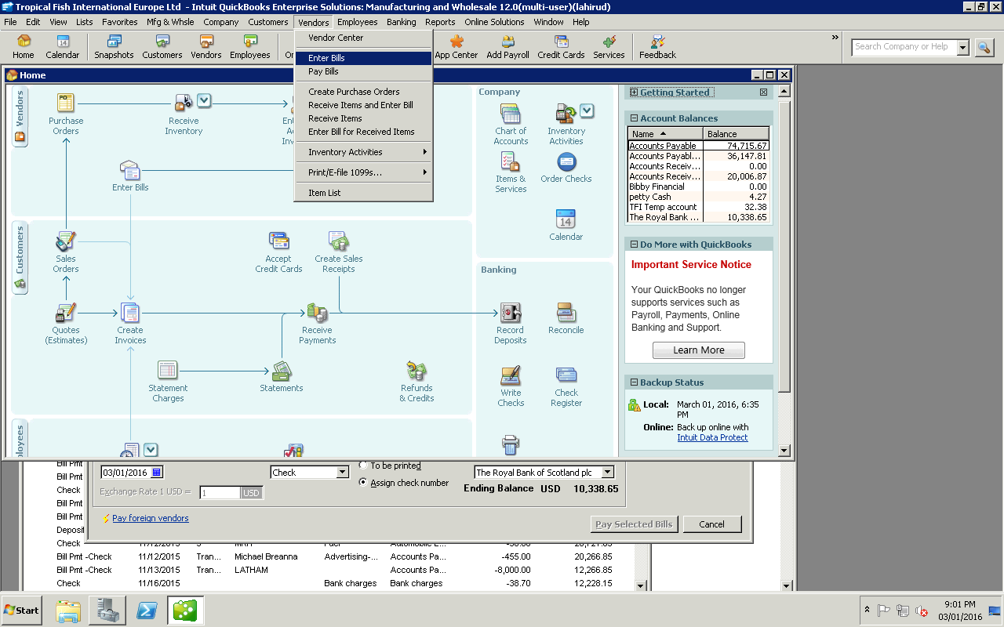

3. After update in Quick books we have to attached that bill to the system
4. Then we have to saved that bill in vendor folder in the drop box
5. After that needs Delete that tempaory folder in the drop box.

Enter amount
Select date
- Select vendor from QB. BY CLICKING THE DOWN ARROW KEY
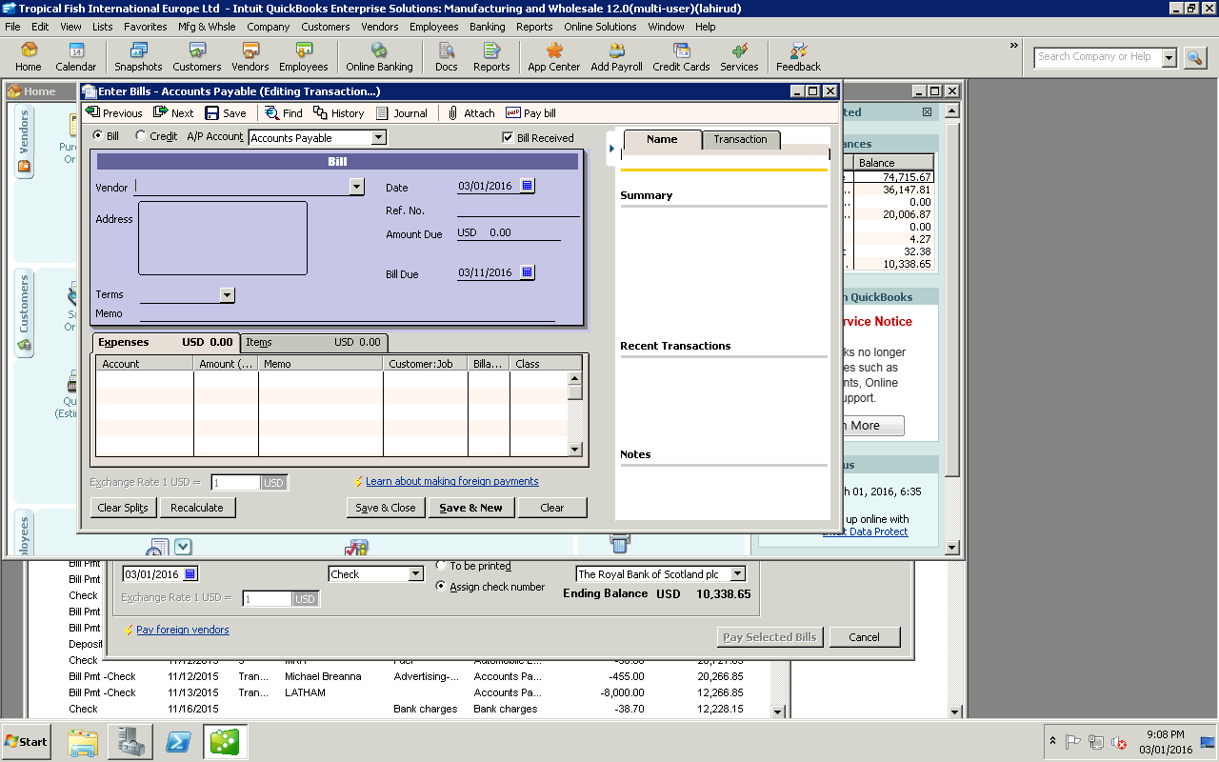

Process is described bellow How to extract the bills from the Drop Box

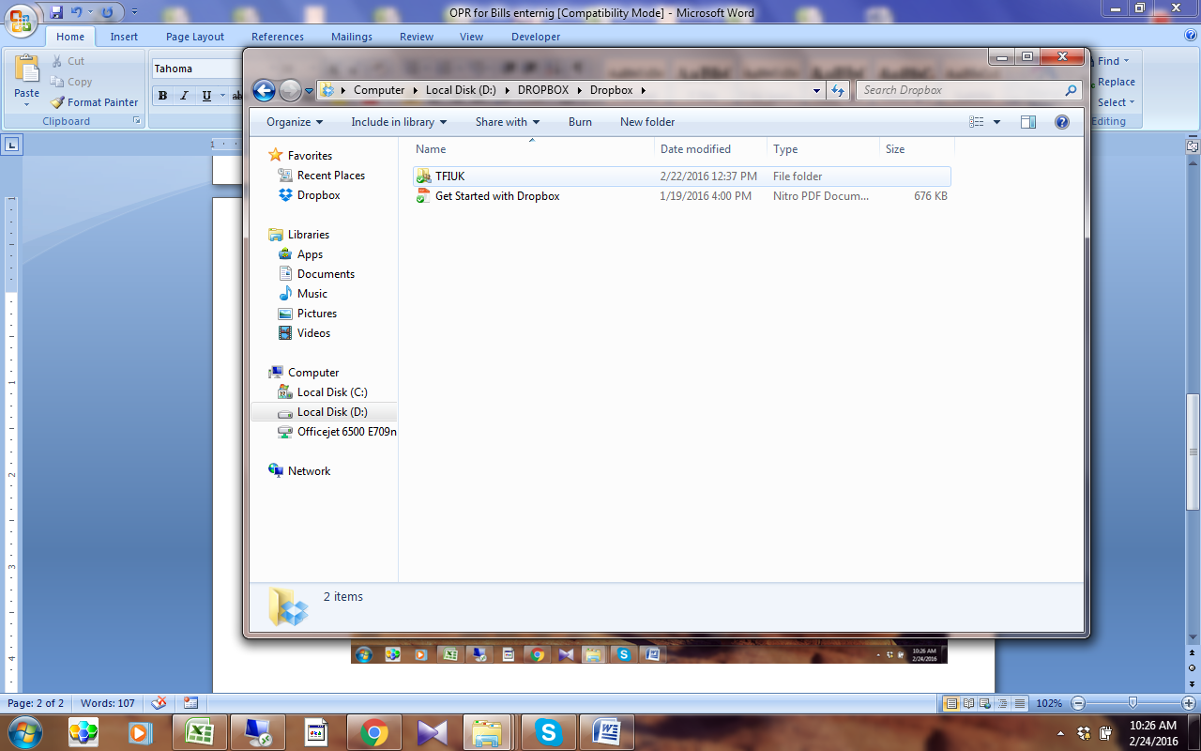

3.Attached the Copy of the Bill to QB

