SUBJECT | TFI UK and TFIAU incoming Sales
RECORDER (Name Designation) | Deepika Thilakarathna (Assistant Accountant, Finance)
APPROVED BY (Name Designation) | Stanley Samidas
CREATED DATE | 06/12/2016
NO. OF PAGES INCLUDING THIS PAGE | 04
OFFICE PROCESS RECORD

Process : TFI UK and TFIAU incoming Sales
Recorder : Deepika Thilakaratnna

Objective : To ensure all the Invoices are Update in timely Manner

01. Collect the all Invoices from Ian and Daniel daily basis
2). after receive invoice them relating to that day enter the Quick books and attached it in proper manner in the system.
03) Maintain the Daily invoice work sheet
Process describe as follows. Click customer and then create invoice
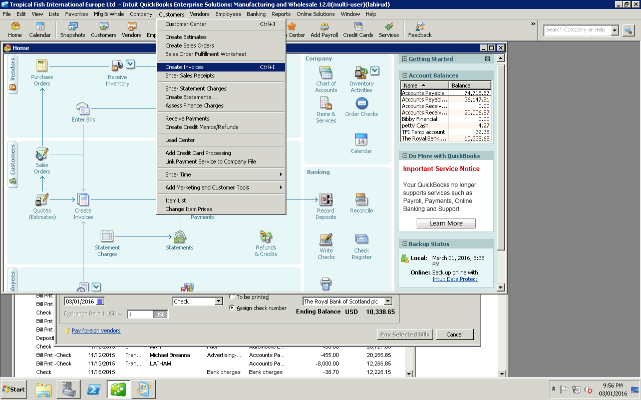

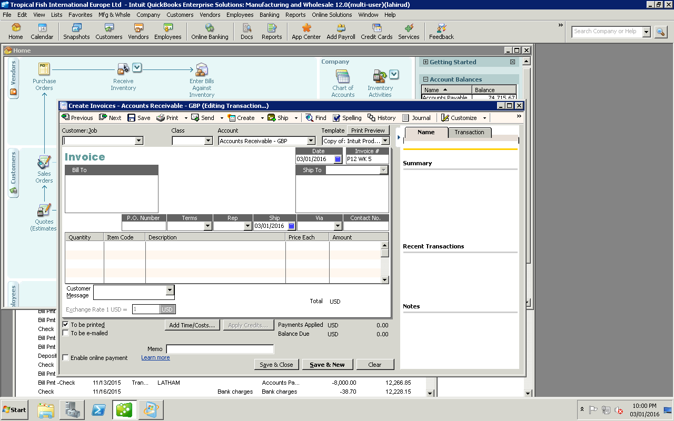
03) Select Date
04 Click save and new
01) Click arrow key-Select Pets at Home.
02) Select Invoice No

04) Get the Fund received from Paymentch web site and record it in to the QB
05) Maintain the AR outstanding balance report

