OFFICE PROCESS RECORD

SUBJECT | Preparing monthly and weekly sales report
RECORDER (Name Designation) | Chathurangani Ranaweera (Accounts Executive )
APPROVED BY (Name Designation) | Stanley Samidas – Senior Accountant
CREATED DATE | 12/07/2016
NO. OF PAGES INCLUDING THIS PAGE | 02

Objective : Record all the invoices in the sales invoice report and make sure that
Sales by customer report is accurately prepared.

- Agree with the items prices in the Commercial Invoice and update into report according to following format
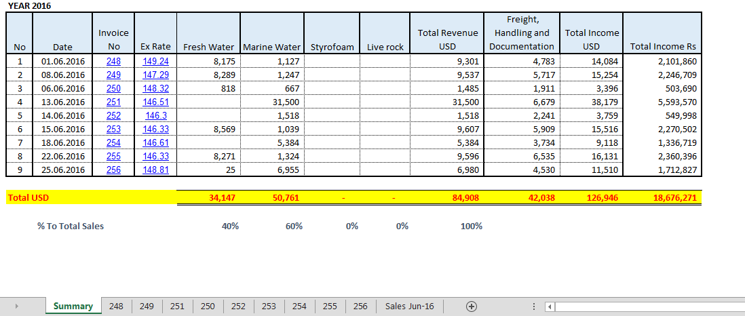

- After entered an Invoice Completely, Check Total Value of Entered Invoice with Total Value of Commercial Invoice

- Updating weekly and monthly sales and comparing with budgeted sales according to following format.

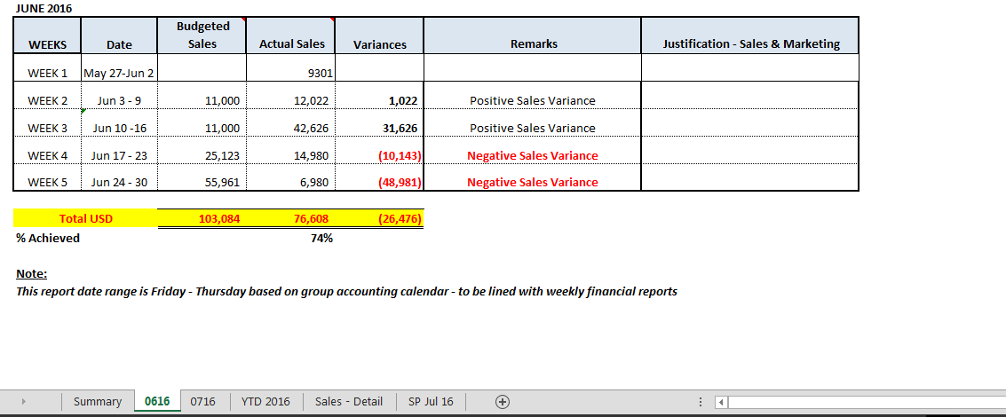
- Ensure all the invoices are recorded with comparing sales by customer report.

