OFFICE PROCESS RECORD

SUBJECT | TFI recording sales and payment received
RECORDER (Name Designation) | Chathurangani Ranaweera (Accounts Executive )
APPROVED BY (Name Designation) | Stanley Samidas – Senior Accountant
CREATED DATE | 12/15/2016
NO. OF PAGES INCLUDING THIS PAGE | 02

After entered Invoice need to enter funds transfer in following manner.

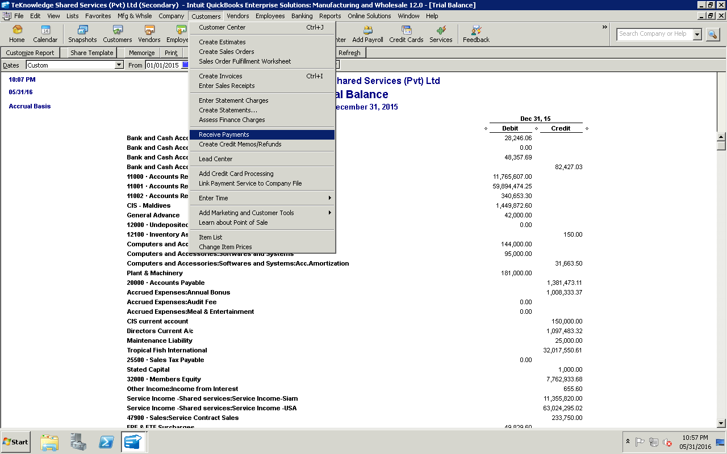

07. Select the relevant invoice and settle it as as follows.
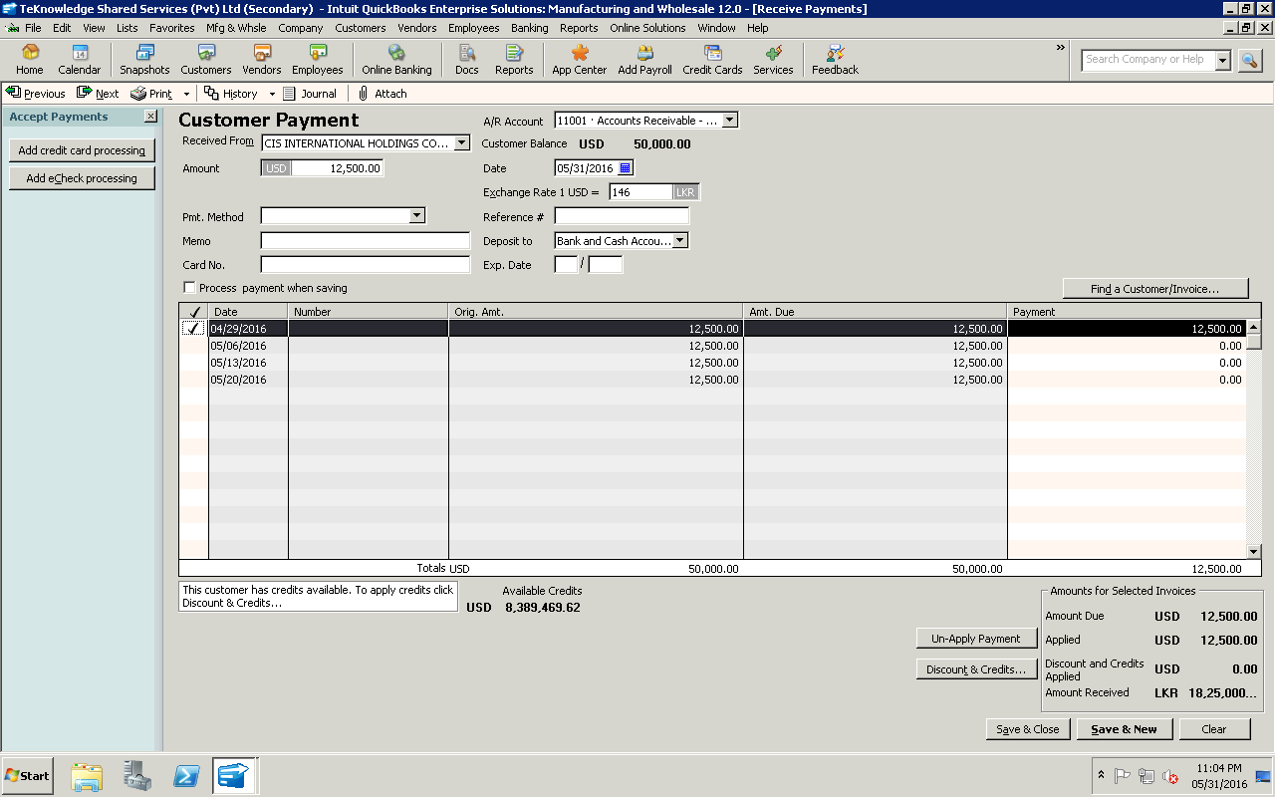

Select Custormer Select Amount Select invoice to settled.

Select Save and Close
Select bank A/c

