SUBJECT | OPR for Creating Purchase Orders in ETF
DEPARTMENT | Marketing – Order Entry
RECORDER (Name Designation) | Ravihari Punchihewa : Executive - Order Entry

APPROVED BY (Name Designation)
LAST UPDATE | 07/07/2016

PATH ON NETWORK FOLDER
NO. OF PAGES INCLUDING THIS PAGE | 5

Step 1:
Go to Sales and customer Management and Select “View enter sales order”
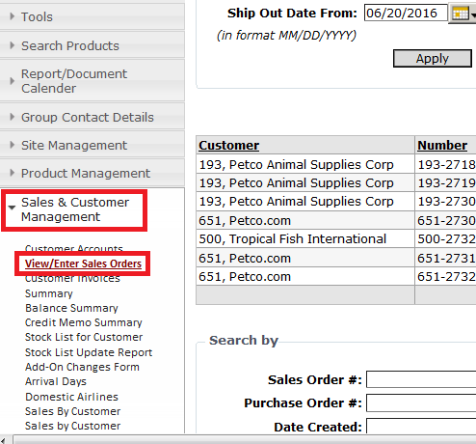

Step 2:
Click on to “Enter new Sales Order” icon to enter new sales order
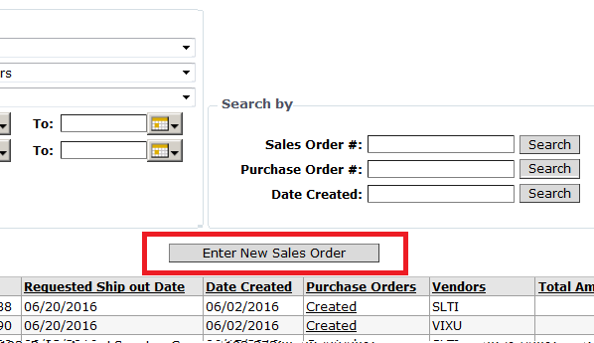

Step 3:
Fill below with relevant details
- Customer: Select customer from drop down list
- Requested ship out date to customer: select the date from calendar
- CIS Item Code: Put CIS code and click “Look Up” icon and select item code
- Total Qty: Put total qty in text box
- Click “Add Item” icon
IMPORTANT:
  - Double check the basic criteria when placing the orders - Scientific Name
  - Double check the basic criteria when placing the orders - Fulfilment history of the Livestock item
  - Double check the basic criteria when placing the orders - Price paid on previous occasions
  - Double check the basic criteria when placing the orders - .For a given item, grade the existing vendor list (of aprox of 100-125 vendors) in to ‘Primary’, ‘Secondary A’ and ‘Secondary B’ categories.

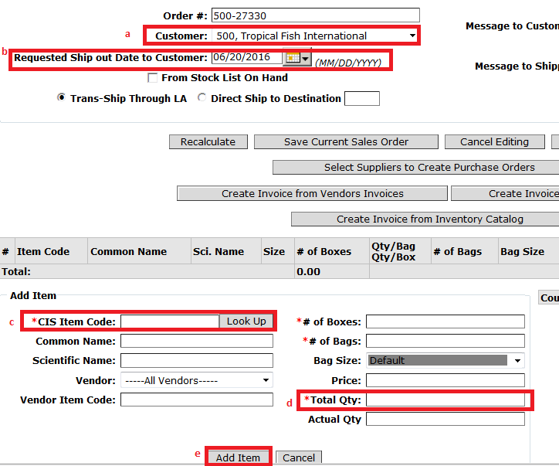

Step 4:
Once you add the item, screen will appeared as below

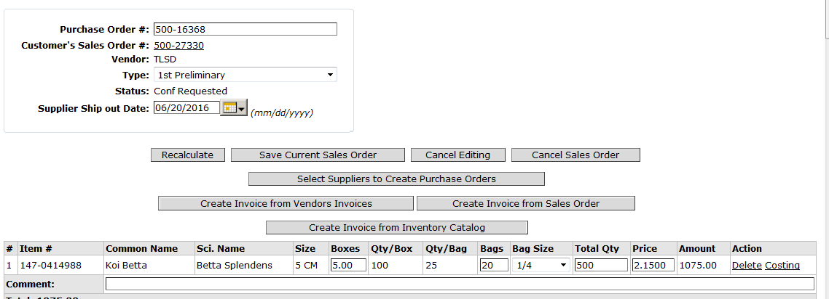

Step 5:
After entering all items, click “Select supplier to create purchase order”
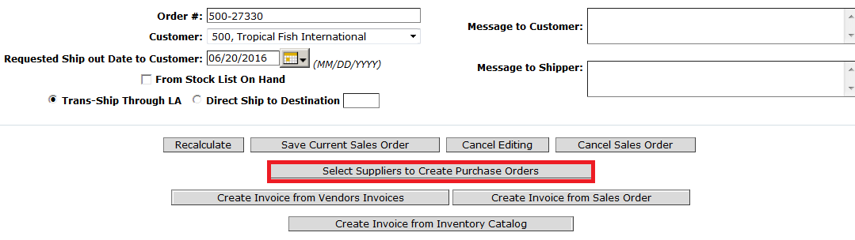

Step 6:
Once you get below screen, select the ship out date from calendar and Select create first preliminary order
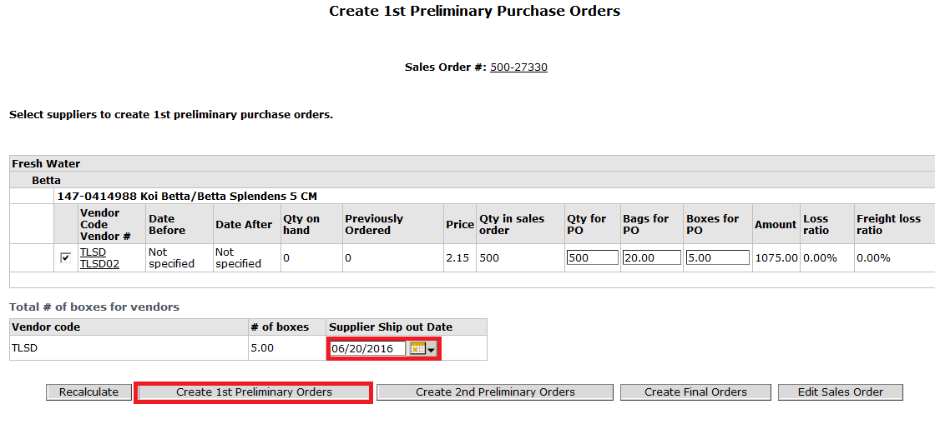
Step 7:
If you want to add new items to the PO or edit PO details , select “created” icon
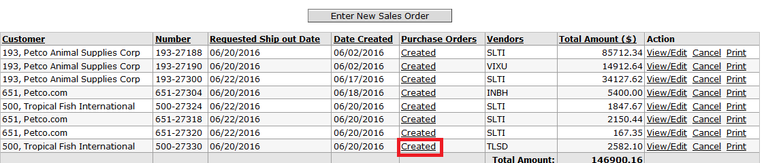

Step 8:
Follow the same steps and click “Save Order” after editing.

