OFFICE PROCESS RECORD

Subject | OPR for US CIS Labour Efficiency Analysis Report
Department | Labor Management
Recorder | Dilan Maduranga
Approved by | Suja Wahab
Created date | 01/12/2015
Last updated | 14/05/2016
No of pages including in the OPR | 04

US CIS Labour Efficiency Analysis Report

Following guidelines are basically used to complete the Labour Efficiency Analysis Report which can be divided into the following sections

  - Introduction : a) Productivity worksheet
b) Productivity worksheets Data entry sheets
c) Productivity Worksheet Received Summary

  - Overall Analysis : a) Labor Projected Vs Actual Station wise analyses
b) Projected Vs Actual – Individual wise analyses
c) Projected Vs Actual variance movement throughout the week analyses
d) Productivity worksheets submission analysis

- a) Introduction of Productivity Sheet

The Productivity worksheet completed by using daily Productivity worksheets from individual employees
Enter all the data that listed in Productivity Worksheet and check for the deficiencies with Station ID Report
If found any error, record those errors in Productivity worksheet Deficiencies report

Figure: 1 Sample Productivity Worksheet

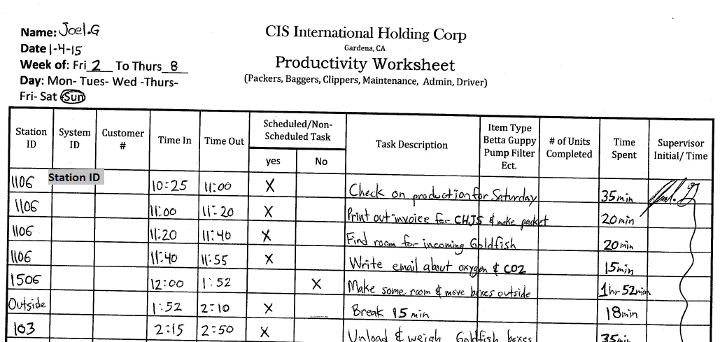

Employees in US WH need to record all the details that applicable in the Productivity worksheet

- Station ID details- According to Updated Station ID report
- System ID –Most of the time this column is applicable for QA and Maintenance team(Explains what is/are the system/s they are worked in those hours)
- Customer # - who is the customer (193 stands for Petco packing and Bagging Processes,651 Stands for Petco.com packing and Bagging processes)
- Time In - Time that starts working on relevant substation
- Time Out -Time that ends working on same Substation
- Scheduled /Nonscheduled task – Need to mark whether it is a scheduled task or not (Mostly applicable for Live Stock care -System Maintenance Master Station)
- Task Description – Explains the task that completed in related substation(Detail description)
- Item type- Fish types, Bags, Labels, Boxes, Cups, Cup sets etc.
- # of Units Completed – Total Count of completed units
- Time Spent-Total time spent on that particular Substation
- Supervisor Initial –Each and every task need to audit by Supervisor for the work completion and also for the Productivity Worksheet Completion

Figure 2 : Productivity Worksheet to Data entry

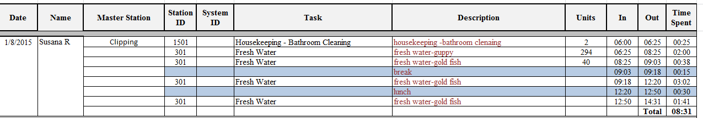

Note: Break and Miscellaneous hours are highlighted by using different Color.

Below details need to be updated into Productivity Worksheet Data Entry

- Master Station Id –Categorize Master Stations according to the Master Station ID’s
- Master station – Master Station task in detail
- Actual Labor – No of total employees involved in that particular Master Station
- Actual Man Hours -Total hours spent on each Master station (Summary of Labor Actual Station wise)
- Actual Units – Total unit Count from Employee Productivity Worksheet
- Employee name and the Date

Figure 3 : Productivity Worksheets Received Summary

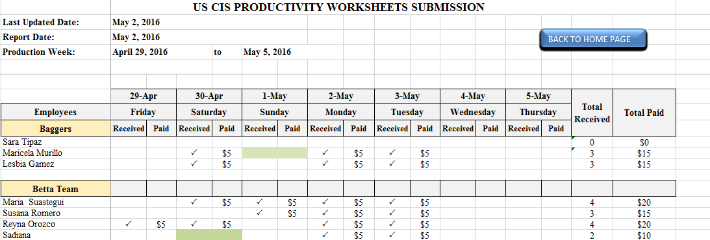

Above depicted excel sheet is used to show the employee attendance and Productivity worksheets submission each day throughout a week. This report is essential document for calculating the daily wages for employees. Supportive documents for the preparation of Productivity Worksheets Received Data entry Sheet are sign-out sheet and PWS of employees’.

- Overall analysis

Figure 4 : Labor Projected Vs Actual Station wise Analysis Graph

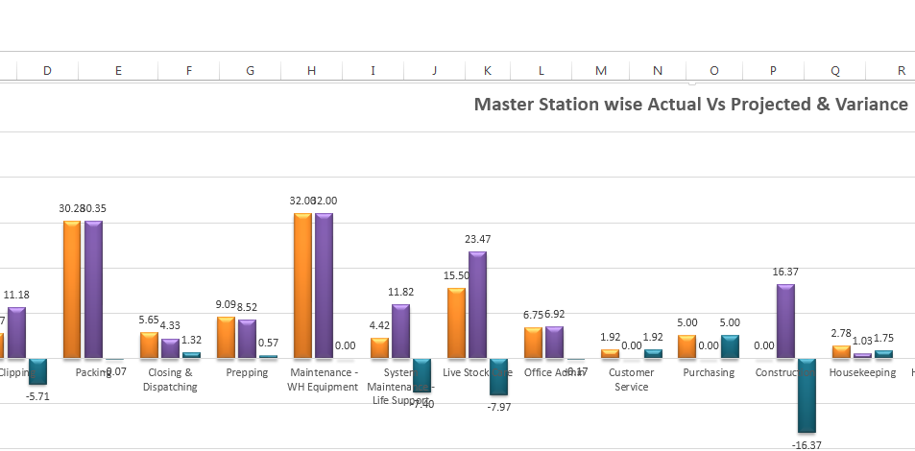

Data Entry operator’s Role

Calculate total time Spent in a particular substation by each employee within a day for entering “Substation wise projected vs Actual Sheet”

Data Analyst’s Role

Step 1: Check all the details that has been derived from Productivity worksheet and verify whether total working hours for that particular station is correct by using below Source Documents.

- Productivity Worksheet
- Sign out Sheet
- Daily Forecast Man hours sheet

Step 2: Identify the top 3 stations with inefficiency in term of both unit wise and hourly wise as per the graph depicted figure 4. By using Productivity worksheets Data entry sheets and Daily Labour forecast report projected hours and actual Hours in depth analysis can be made.

Note: For packing team/ closing and dispatching team unit wise projection and actual completion data is available in the system, the model called “Dash Board”.

Step 3: Analysis should be made having considered e-mails, discussions had with US WH and other external factors. As per the analysis if there is a discrepancy which is not justifiable to the Analyst’s knowledge the question should be escalated to the US WH Managing with a view to get a valid explanation through Daily Question Log.

Following details also should be appeared in the projected vs Station Wise Analysis Report.

- Planned Man Hours – Total projected hours for each Master Station(Source Document: Daily Forecast Man hours report )
- Actual Man Hours – Total Hours taken by each employee in each master station( Source document Productivity worksheets)
- Station wise Variance – Percentage hourly wise difference between Planned and Actual Man hours
- Unit wise Variance - Percentage unit wise difference

Figure 5 : Projected vs Actual Individual wise Analysis Graph

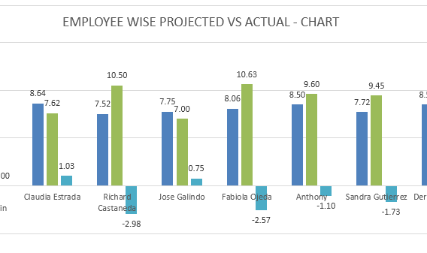

Data Entry Operator’s Role

Entering to the “PROJECTED VS ACTUAL-DATA ENTRY” sheet total time Spent by each employee within a day.

Data Analyst’s Role

Step 1 : Check all the details that has been derived from Productivity worksheet and verify whether total working hours taken by each employee and forecast is correct by using below Source Documents.

- Productivity Worksheet
- Sign out Sheet
- Daily Forecast Man hours sheet

Step 2: Identify the big offenders. On other hand Analyst needs find out who has not met the benchmark. By using depicted graph under figure 5 and productivity worksheets in depth analysis can be made. Move over, it could be found out whether each employee has performed well or not.

Step 3 : If the there is an employee who has not adhered with benchmark or unit wise projection, the Analyst found it is not acceptable who can either straight away call the explanation from respective individual asking for valid reasons or address US WH calling explanation.

Note: For packing team/ closing and dispatching team unit wise projection and actual completion data is available individually in the system, the model called “Dash Board”.

Figure 6 : Projected Vs Actual Variance Movement Throughout the week Analyses Graph

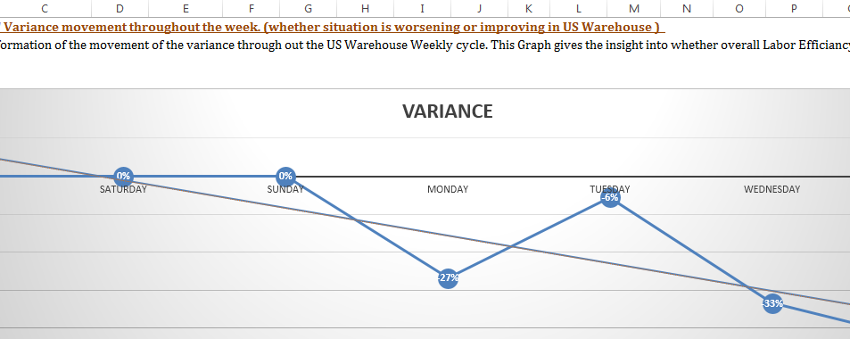

Data Analyst’s Role

Step 1 : “Projected vs Actual by Days” sheet should be updated each and every day by using the total Actual Labour hours vs Forecast Labour hours data in the sheet called “ PROJECTED VS ACTUAL BY EMPLOYEE”.

Step 2 : Above Graph gives the insight into whether overall Labor Efficiency is improved or declined during the week, Based on the behavior of the graph Data Analyst should be able to interpret his own predictions/ recommendations.

Figure 7: Productivity worksheets submission analysis

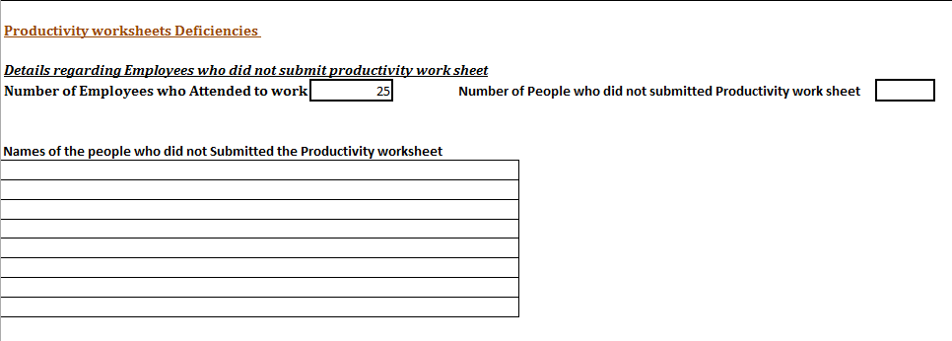

Productivity worksheets submission analysis is based on the Productivity Worksheets Deficiencies Report which consists of details regarding Employees who did not submit productivity work sheet. By looking at the Productivity work sheets received summary sheet, Data Analyst could give his/her suggestions and opinion about the daily productivity submission.

