CIS INTERNATIONAL HOLDINGS (N.A) CORP
Subject | Updating Petty Cash Report
Object | To ensure all the Petty cash are Update in timely Manner
Department | Finance
Recorder | Nisansala Dilhani -(Accounts Executive)
Approved By | Deepika Thilakarathne (Accountant)
Created Date
Last Updated | 07.20.2019
Path on Network Folder | Teknowledge Shared Services\Finance Dept. - Documents\OPR's\Nisansala Dilhani
No Of pages including this OPR | 03

- Get the Maria’s petty cash expenses details mail and save below folder.
Teknowledge Shared Services\Finance Dept. - Documents\Operational\CIS INTERNATIONAL HOLDINGS (N.A) CORP\2019\Petty Cash\Weekly Report
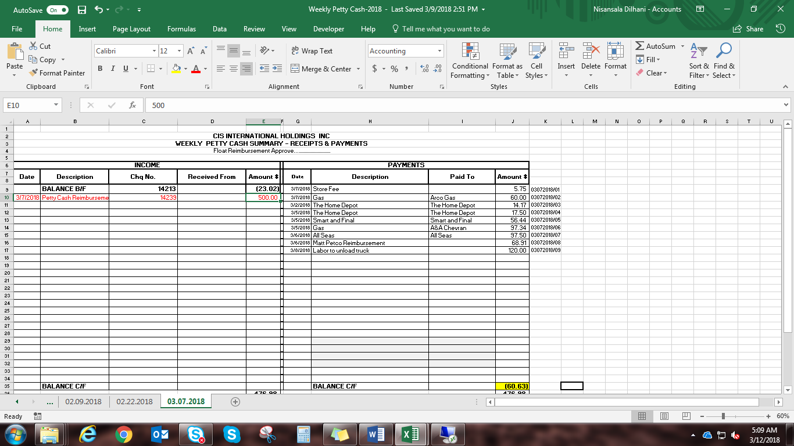
2. All petty cash should be record in QB and update the report in excel

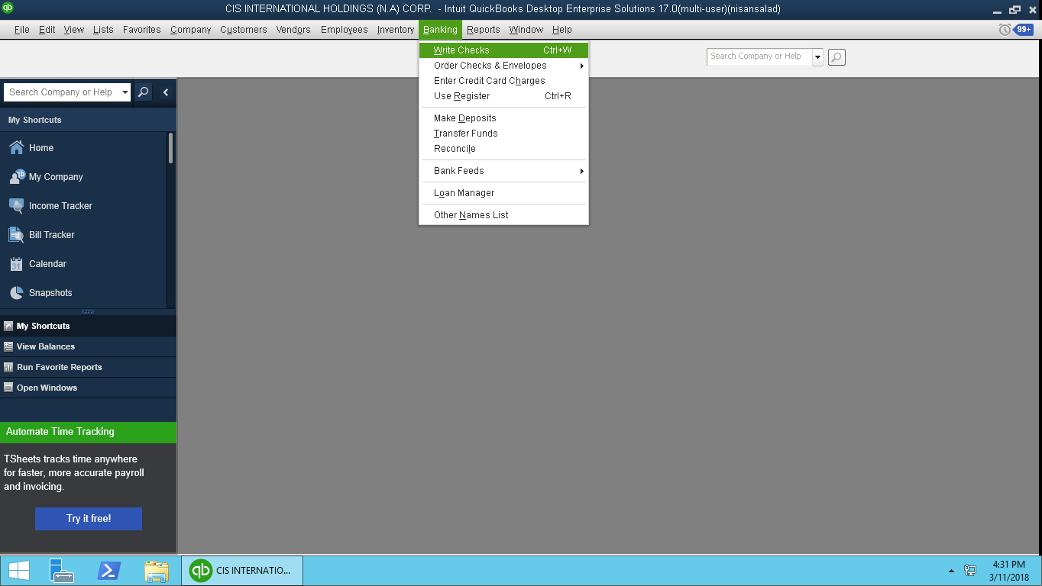
Then
01)Select vendor. 02) Select date 03) Enter amount 4) enter description
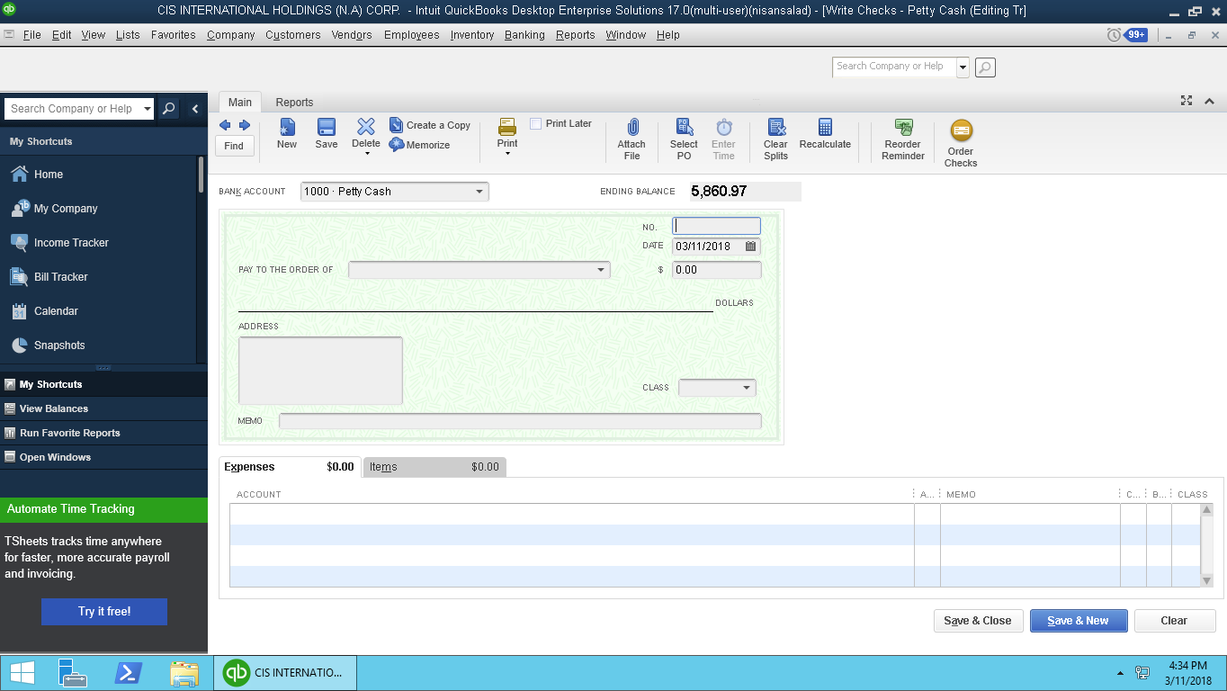
05) Select Accounts type 06) Click
3. Check petty cash balance at the end of the week.
4. If any difference in balance need to inform to Maria and get feedback

