CIS INTERNATIONAL HOLDINGS (N.A) CORP

Subject | Reconcile inventory tracker and check status report with QB
Object | To ensure all the checks are Update correctly and in timely Manner
Department | Finance
Recorder | Nisansala Dilhani - (Accounts Executive)
Approved By | Deepika Thilakarathne (Accountant)
Created Date
Last Updated | 07.20.2019
Path on Network Folder | Teknowledge Shared Services\Finance Dept. - Documents\OPR's\Nisansala Dilhani
No Of pages including this OPR | 02

1. Check the Dry/live inventory tracker and dry goods send by US Admin every day.
2. Once all the tracker has been updated in QB, open the daily check status again send by US Admin.
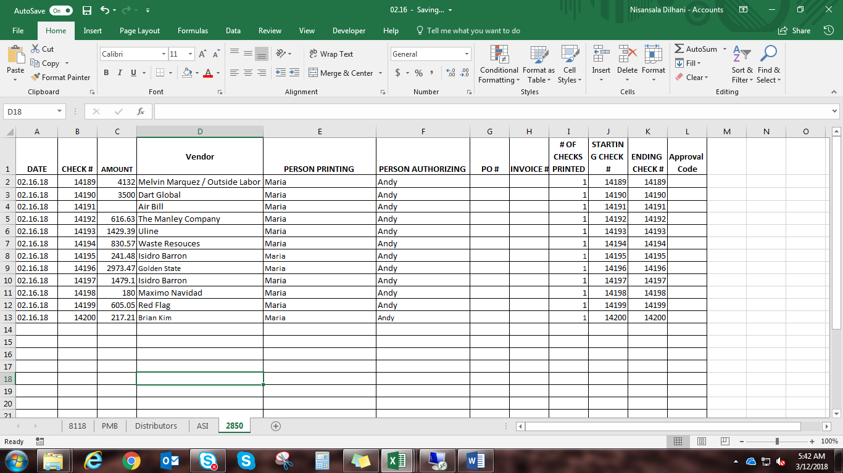
3. Analyze the checks which have been printed by “Deepika and Maria, Nisansala” are already been updated in the system or not - by auditing check numbers and any blank checks used
4. If any check is not updated send a mail to US Admin requesting for the tracker and the invoice or scanned copy.
5. Doing the need corrections with payment information if necessary.
