**TEKNOWLEDGE SHARED SERVICES-SRI LANKA**

**OPR: CIS Pallet Forecast for UPS**

|  |  |
| --- | --- |
| SUBJECT | CIS Pallet Forecast for UPS |
| DEPARTMENT | PRODUCTION PLANNING |
| RECORDER | BUDDIKA MADURANGANA |
| APPROVED BY |  |
| CREATED DATE | 03/04/2016 |
| LAST UPDATED |  |
| PATH ON NETWORK FOLDER |  |
| NO. OF PAGES INCLUDING THIS PAGE | 2 |

Objective

Need to submit the projected number of pallets required for the day to UPS on each shipping day.

Calculation

1. Once the production plan completed, take the summery of box requirement for the day Coast wise.

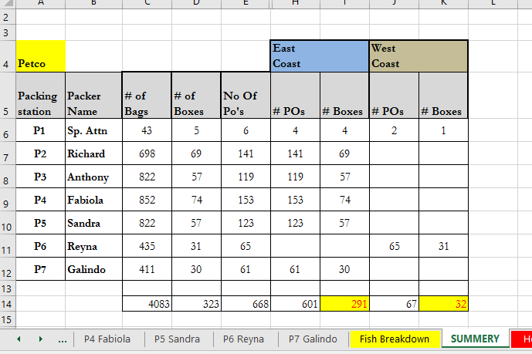

1. Base on the Grouped/Ungrouped POs planned for each coast, Box size projection to be done.
2. Approximate number of boxes can be stacked,

A: 60

B: 45-50

C: 36

F: 24

Number of Pallets required = Number of boxes / No of boxes can be stacked

1. Once the projection is made,
2. Following format to be filled in email,

Subject: CIS VOLUME FORECAST (DAY) (Date)

UPS,

Here is the quantity of pallets shipping out today.

00        East coast pallet

00       West coast pallet

1. Ground pallet
2. Email recipients,

Laura Orozco [lorozco@ups.com](mailto:lorozco@ups.com) ; Johnny Scott [johnnyscott@ups.com](mailto:johnnyscott@ups.com) ; 'lale@ups.com'; 'lursini@ups.com' ; 'agyima@ups.com'; Harper Munro <hmunro@ups.com>; Lorraine Liebsack <lliebsack@ups.com>; Ernesto Sanchez <ernestosanchez@ups.com>; 'snevels@ups.com'; Jesus De Avila <jdeavila@ups.com>; 'jwilson2@ups.com'

Cc: Sam Samarasinghe <sam@etropicalfish.com >; Andy Hettiarachi - Manager-Administration -US [andyh@etropicalfish.com](mailto:andyh@etropicalfish.com)