**TEKNOWLEDGE SHARED SERVICES-SRI LANKA**

**OPR: BONUSE CALCULATTION**

|  |  |
| --- | --- |
| SUBJECT | BONUSE CALCULATION FOR THE WEEK |
| DEPARTMENT | PRODUCTION PLANNING |
| RECORDER | SIVANTHA SAMEERA |
| APPROVED BY |  |
| CREATED DATE |  |
| LAST UPDATED |  |
| PATH ON NETWORK FOLDER |  |
| NO. OF PAGES INCLUDING THIS PAGE | 3 |

**Objective**

To accurately calculate the weekly employee bonus amount.

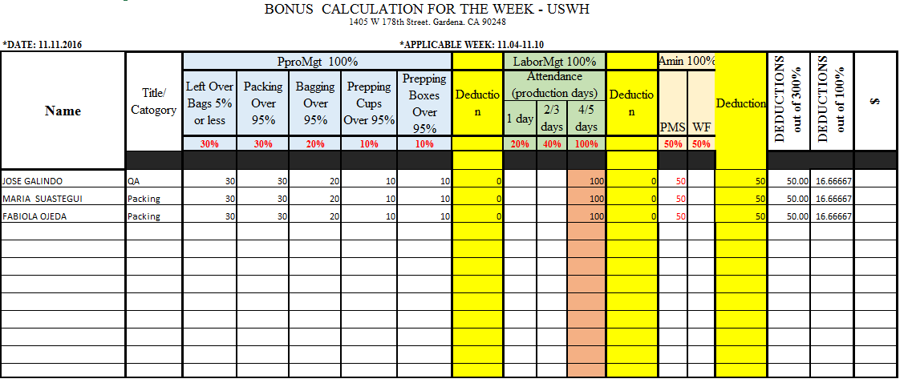Bonus calculation format

Bonus calculation scheme filled by three department.

1. Production management
2. Labour management
3. System admin

**Production planning**

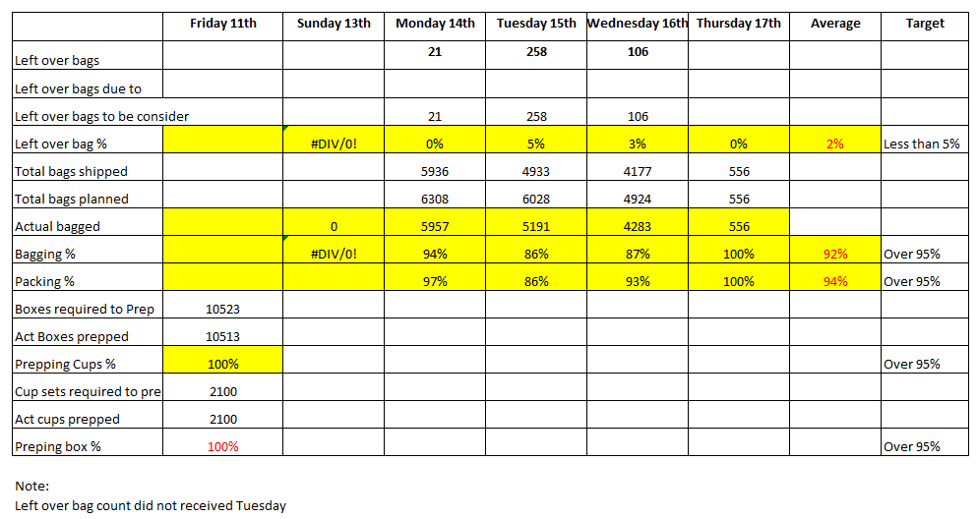Use the blow mention format to calculate the bonus under production Management.

There are five dimensions to evaluate the calculate bonus.

1. **Left over bag count**

Left over bag count can be taken system generated E-mail. It will indicate the left over bag count.

Due to the bonus scheme it must be 5% or less than that.

**Method = (Total bag shipped / left over bag to be consider) X100**

And here have a another column “left over bag to be consider”, if in a special case left over bag count goes up we can take only reasonable number of bag out of that bag count. So finally left over bag count calculated based on the figure of that “left over bag to be consider” in here we can put a special note under the note.

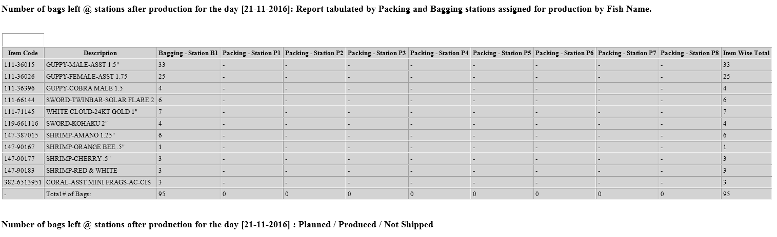

1. **Bagging percentage**

Due to the bonus scheme it must be 95% or greater than that.

**Method = (Total bag Planned / Actual bag shipped) X100**

We can take total bag planned in Packer/Fish Breakdown daily prepared by production planning and Actual bag shipped can be taken shipped quantity report prepared by production planning department.

1. **Packing percentage**

Due to the bonus scheme it must be 95% or greater than that.

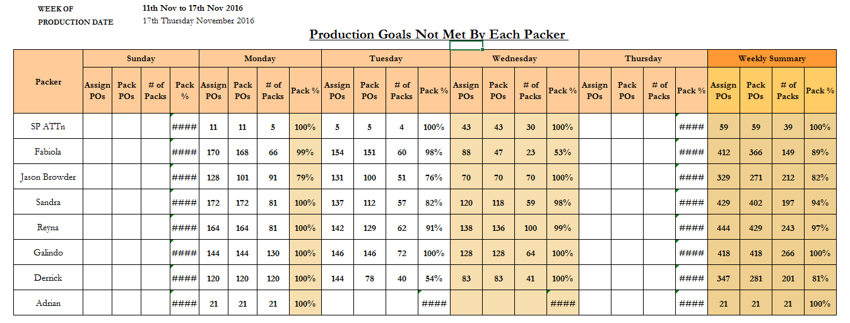Packing percentage can be taken US CIS Master Production &amp;amp; Labor tracker prepared by Production planning.

1. **Box prepping percentage**

Due to the bonus scheme it must be 95% or greater than that.

Under here count of box required to prep can be taken Dry good prep report send by production planning department and actual prep count ban be taken prepping feedback report sent by the USWH.

1. **Cups prepping percentage**

Due to the bonus scheme it must be 95% or greater than that.

Under here count of cups required to prep can be taken Dry good prep report send by production planning department and actual prep count ban be taken prepping feedback report sent by the USWH.

After completing those five dimensions we can take final figures for the bonus calculation report.