TeKnowledge Shared Services (Pvt) Ltd

1. **OPR FOR WEEKLY REPORT FOR TOTAL SALES VALUE OF ORDERS RECEIVED – REPORT DUE ON MONDAYS AT 4PM GMT (BI-WEEKLY REPORT)**

|  |  |
| --- | --- |
| **SUBJECT** | **OPR for Weekly Report for Total Sales Value of Orders Received - Report sent to TFI UK every Monday at 04:00PM GMT (Bi-weekly Report)** |
| **DEPARTMENT** | **Customer Services Department** |
| **RECORDER (Name & Designation)** | **Andrea Meikle - Executive** |
| **APPROVEDBY (Name & Designation)** | **Purodha Perera - HOD** |
| **CREATED DATE** | **16/03/2016** |
| **LAST UPDATED** |  |
| **PATH ON NETWORK FOLDER** |  |
| **NO. OF PAGES INCLUDING THIS PAGE** | **Two** |

**Introduction:**

This Report is prepared to reflect the initial **Total Sales Value of Orders Received** post the week of orders sent in by PAH stores. This report is sent to the MD at TFIUK via the Report Calendar every Mondays by 4PM GMT.

**Contents:**

1. Email address Order notifications are received to
2. Order Notification
3. Order Notification content
4. Email sent to TFIUK via Report Calendar

**Process:**

1. Order notifications are sent by PAH stores to the following email address: [PAHPO@TFIUK.co.uk](mailto:PAHPO@TFIUK.co.uk)

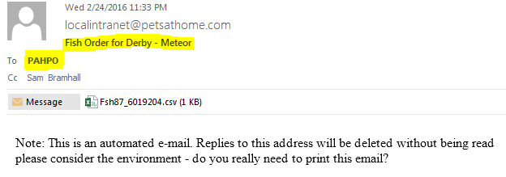

1. The following information as per the order notification received is reflected on the report per store.
2. Order Date
3. Order #
4. Store Name
5. Store #
6. No of Packs
7. Order QTY
8. Order Value

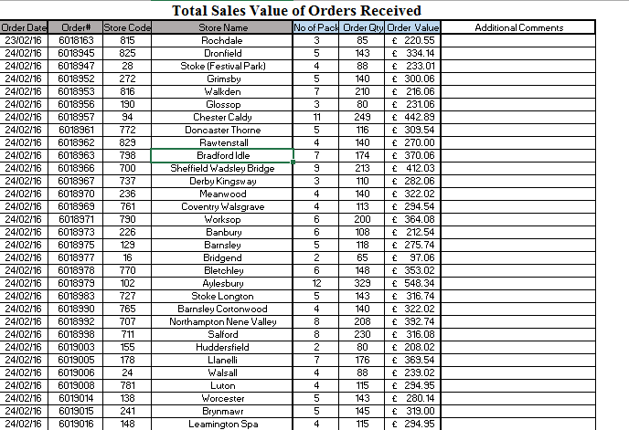

1. If any store has made two orders it will be highlighted (as shown in the below screen shot).



1. This report will contain all orders received and the report is sent to the MD at TFIUK the following week on Monday by 4PM GMT via the Report Calendar.

