TeKnowledge Shared Services (Pvt) Ltd

6. **OPR FOR WEEKLY REPORT FOR TOTAL SALES VALUE OF ORDERS SHIPPED – REPORT SENT ON FRIDAY (WEEK OF DELIVERIES ONLY) BY 4PM GMT**

**(BI-WEEKLY REPORT)**

|  |  |
| --- | --- |
| **SUBJECT** | **OPR for Weekly Report for Total Sales Value of Orders Shipped - Report sent to TFI UK every Friday at 04:00PM GMT (Bi-weekly Report)** |
| **DEPARTMENT** | **Customer Services Department** |
| **RECORDER (Name & Designation)** | **Andrea Meikle - Executive** |
| **APPROVEDBY (Name & Designation)** | **Purodha Perera - HOD** |
| **CREATED DATE** | **16/03/2016** |
| **LAST UPDATED** |  |
| **PATH ON NETWORK FOLDER** |  |
| **NO. OF PAGES INCLUDING THIS PAGE** | **Three** |

**Introduction:**

This Report is prepared to reflect the **Total Sales Value of Orders Shipped** in the week of deliveries. This report is sent to the MD at TFIUK via the Report Calendar at the end of the week that deliveries are made (every Fridays) by 4PM GMT.

This report additionally highlights

1. A variance of 10% and over between Initial Order Value and Total Sales Value
2. Initial Order Value less than Total Sales Value

**Contents:**

1. Email address delivery notifications are received to
2. Delivery Notification
3. Delivery Notification content
4. Email sent to TFIUK via Report Calendar

**Process:**

1. Delivery notifications are sent by PAH stores to the following email address: [PAHDel@TFIUK.co.uk](mailto:PAHDel@TFIUK.co.uk)

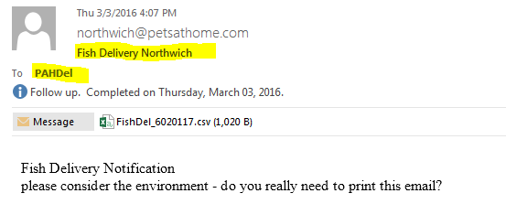

1. The following information as per the delivery notification received is reflected on the report per store segregated according to their assigned delivery days.
2. Order Date
3. Order #
4. Store Name
5. Store #
6. PAH Order QTY (Advised)
7. PAH Rejected QTY
8. PAH DOA QTY
9. PAH Accepted Total
10. Initial Order Value
11. Total Sales Value

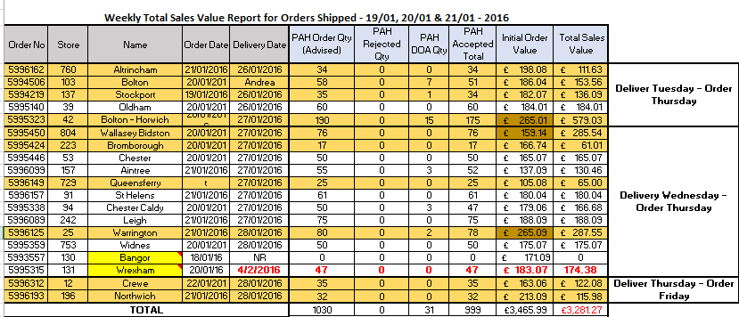

1. The Store # and Initial Order Value is compared with the entry of the Total Sales Value for each respective store from the Order Received Report.

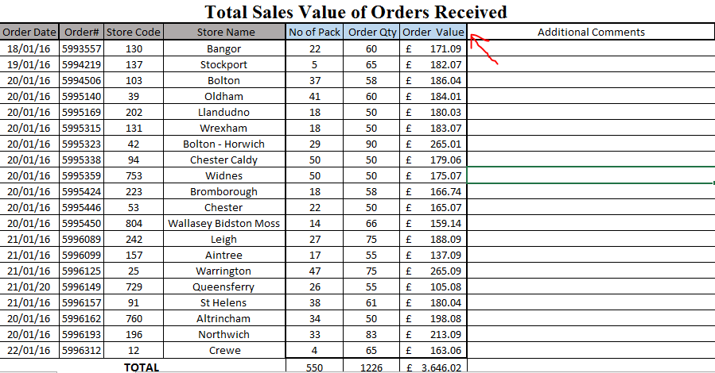

1. Each Initial Order Value is calculated for a 10% variance and that total is checked against the Total Sales Value and highlighted accordingly in **orange** and any order with an Initial Order Value lesser than the Total Sales Value is highlighted in **brown** on the report.
2. This report will contain all deliveries received and the report is sent to the MD at TFIUK the week of deliveries on Friday by 4PM GMT via the Report Calendar.

