TeKnowledge Shared Services (Pvt) Ltd

1. **OPR FOR WEEKLY REPORT FOR NUMBER OF FISH DOA/REJECTED – REPORT SENT TO TFIUK EVERY FRIDAY AT 4PM GMT (BI-WEEKLY REPORT)**

|  |  |
| --- | --- |
| **SUBJECT** | **OPR for Weekly Report for Number of Fish DOA/Rejected - Report sent to TFI UK every Friday at 04:00PM GMT**  **(Bi-weekly Report)** |
| **DEPARTMENT** | **Customer Services Department** |
| **RECORDER (Name & Designation)** | **Andrea Meikle - Executive** |
| **APPROVEDBY (Name & Designation)** | **Purodha Perera - HOD** |
| **CREATED DATE** | **16/03/2016** |
| **LAST UPDATED** |  |
| **PATH ON NETWORK FOLDER** |  |
| **NO. OF PAGES INCLUDING THIS PAGE** | **Two** |

**Introduction:**

This Report is prepared to reflect the **Total Number of Fish DOA/Rejected** for the week of deliveries (per store). This report is sent to the MD at TFI UK via the Report Calendar at the end of the week that deliveries are made (every Fridays) by 4PM GMT.

**Contents:**

1. Email address delivery notifications are received to
2. Delivery Notification
3. Fish DOA/Rejected data
4. Email sent to TFIUK via Report Calendar

**Process:**

1. Delivery notifications are sent by PAH stores to the following email address: [PAHDel@TFIUK.co.uk](mailto:PAHDel@TFIUK.co.uk)

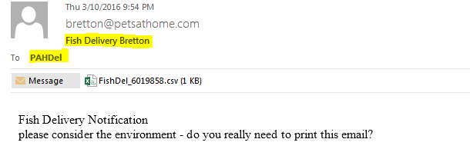

1. The information for number of fish DOA/Rejected is captured from the delivery notification received (per store).

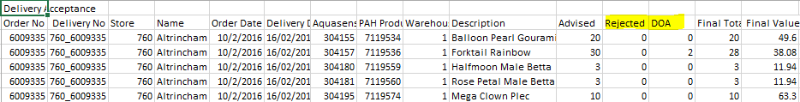

1. This information is entered into the week’s report as per information on each delivery note received.

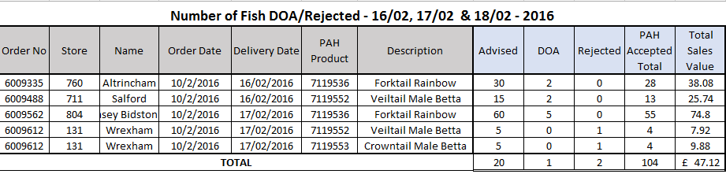

1. This report will contain the total Number of Fish DOA/Rejected for the week’s deliveries and the report is sent to the MD at TFIUK the following week on Monday by 4PM GMT via the Report Calendar.

