TeKnowledge Shared Services (Pvt) Ltd

9. **OPR FOR DELIVERY NOTIFICATION EMAIL STATUS – SENT TO TFIUK EVERY WEDNESDAY/ THURSDAY/ FRIDAY AT 4PM GMT**

|  |  |
| --- | --- |
| **SUBJECT** | **OPR for Delivery Notification email status - Sent to Ian.F and Ian.Y every Wednesday / Thursday / Friday at 04:00PM GMT** |
| **DEPARTMENT** | **Customer Services Department** |
| **RECORDER (Name & Designation)** | **Andrea Meikle - Executive** |
| **APPROVEDBY (Name & Designation)** | **Purodha Perera - HOD** |
| **CREATED DATE** | **16/03/2016** |
| **LAST UPDATED** |  |
| **PATH ON NETWORK FOLDER** |  |
| **NO. OF PAGES INCLUDING THIS PAGE** | **Two** |

**Introduction:**

This is a notification sent out to the MD and WH Manager at TFIUK on the week of deliveries.

For deliveries made on Tuesday, a status update is sent every Wednesday by 4PM GMT with a list of allocated stores delivery notifications are received from and not received from.

The same goes for deliveries made for Wednesday (status notification is sent out on Thursday by 4PM GMT) and Thursday (status notification is sent out on Friday by 4PM GMT).

**Contents:**

1. Stores with allocated days of delivery
2. Preparation of day’s Delivery Status Notifications
3. Notification sent to TFIUK

**Process:**

1. Once delivery notifications are received (Tuesday/Wednesday/Thursday), refer to the listed stores assigned for these days delivery.

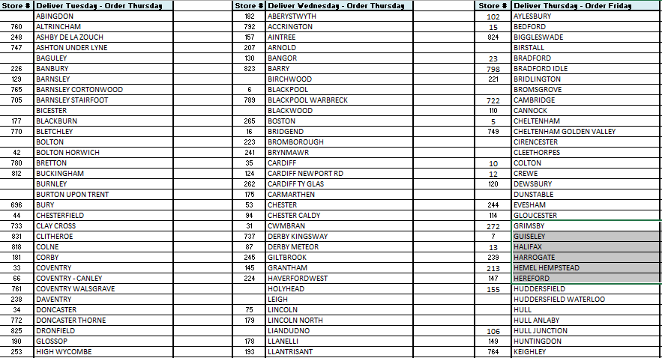

1. **Tuesday’s Delivery Status Notification** – List down all notifications received and not received (highlighting the delivery notes not received). This notification email is sent every Wednesday by 4PM GMT to TFIUK.

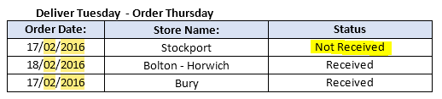

**Wednesday’s Delivery Status Notification** - List down all notifications received and not received (highlighting the delivery notes not received). This notification email is sent every Thursday by 4PM GMT to TFIUK.

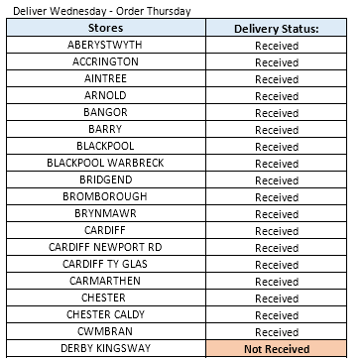

**Thursday’s Delivery Status Notification** - List down all notifications received and not received (highlighting the delivery notes not received). This notification email is sent every Friday by 4PM GMT to TFIUK.

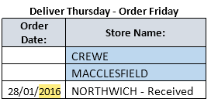

1. For each allocated day an email is sent to TFIUK with the list of delivery status notifications.

