TeKnowledge Shared Services (Pvt) Ltd

10. **OPR FOR ABSENT DELIVERY NOTIFICATION – SENT TO PAH UK EVERY WEDNESDAY/ THURSDAY/ FRIDAY AT 4PM GMT**

|  |  |
| --- | --- |
| **SUBJECT** | **OPR for Absent Delivery Notifications - Sent to Sam. B at PAH every Wednesday / Thursday / Friday at 04:00PM GMT** |
| **DEPARTMENT** | **Customer Services Department** |
| **RECORDER (Name & Designation)** | **Andrea Meikle - Executive** |
| **APPROVEDBY (Name & Designation)** | **Purodha Perera - HOD** |
| **CREATED DATE** | **16/03/2016** |
| **LAST UPDATED** |  |
| **PATH ON NETWORK FOLDER** |  |
| **NO. OF PAGES INCLUDING THIS PAGE** | **Two** |

**Introduction:**

Like the delivery notification status, all delivery notifications not received for the day’s allocated stores, an Absent Delivery Notification is sent to the MD at TFIUK and respective personnel at PAH UK. This is so the respective personnel at PAH UK can follow up with the stores and request a Delivery Notification be sent.

**Contents:**

1. Stores with allocated days of delivery
2. Preparation of day’s Absent Delivery Notifications
3. Notification sent to TFIUK & PAH UK

**Process:**

1. Once delivery notifications are received (Tuesday/Wednesday/Thursday), refer to the listed stores assigned for these days delivery. Stores from the list that had a delivery but did not produce a delivery notification are listed separately.

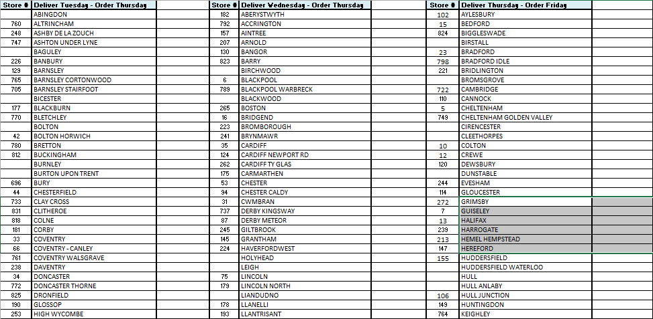

1. **Tuesday’s Absent Delivery Notification** – List down all notifications not received. This notification email is sent every Wednesday by 4PM GMT to TFIUK & PAH UK from the email group [pahabsentdel@TFIUK.co.uk](mailto:pahabsentdel@TFIUK.co.uk)

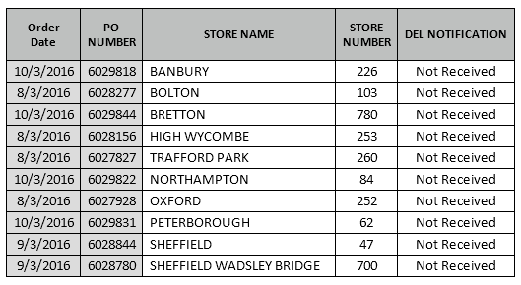

**Wednesday’s Delivery Status Notification** - List down all notifications not received. This notification email is sent every Thursday by 4PM GMT to TFIUK & PAH UK from the email group [pahabsentdel@TFIUK.co.uk](mailto:pahabsentdel@TFIUK.co.uk)

**Thursday’s Delivery Status Notification** - List down all notifications not received. This notification email is sent every Friday by 4PM GMT to TFIUK & PAH UK from the email group [pahabsentdel@TFIUK.co.uk](mailto:pahabsentdel@TFIUK.co.uk)

1. For each allocated day an email is sent to TFIUK and PAH UK with the list of delivery notifications not received “TO:” the email group - [pahabsentdel@TFIUK.co.uk](mailto:pahabsentdel@TFIUK.co.uk)

And from the email group - [pahabsentdel@TFIUK.co.uk](mailto:pahabsentdel@TFIUK.co.uk)

