TeKnowledge Shared Services (Pvt) Ltd

11. **WEEKLY OVERVIEW OF DELIVERY STATUS’ – SENT TO TFIUK EVERY FRIDAY AT 4PM GMT (BI-WEEKLY NOTIFICATION)**

|  |  |
| --- | --- |
| **SUBJECT** | **OPR for Weekly overview of Delivery Status - Sent to TFIUK every Friday at 04:00PM GMT (Bi-weekly Notification)** |
| **DEPARTMENT** | **Customer Services Department** |
| **RECORDER (Name & Designation)** | **Andrea Meikle - Executive** |
| **APPROVEDBY (Name & Designation)** | **Purodha Perera - HOD** |
| **CREATED DATE** | **20/03/2016** |
| **LAST UPDATED** |  |
| **PATH ON NETWORK FOLDER** |  |
| **NO. OF PAGES INCLUDING THIS PAGE** | **Two** |

**Introduction:**

A weekly overview of all Delivery Notification Status updates for the week are compiled into one list and sent as an overview to TFIUK for review.

**Contents:**

1. Preparation of Delivery Notification Status Lists
2. Compilation of Lists
3. Email sent to TFIUK

**Process:**

1. All delivery notification status’ for each assigned delivery day sent for the week are compiled according to the assigned delivery days and sent to TFIUK every Friday by 4PM GMT as an overview of all notification status’ sent for Wednesday, Thursday & Friday.
2. A comparison of all delivery notifications received for the week till 4PM Friday is updated on the lists sent during the week.

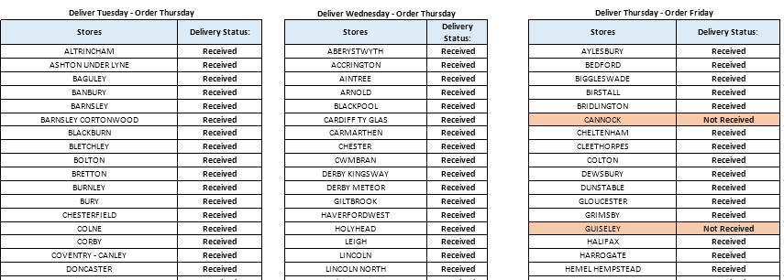

1. All three lists are compiled to one email and sent to TFIUK every Friday at 4PM GMT for review.

