TeKnowledge Shared Services (Pvt) Ltd

12. **WEEKLY OVERVIEW OF ABSENT DELIVERY NOTIFICATION STATUS’ – SENT TO TFIUK AND PAH UK EVERY FRIDAY AT 4PM GMT (BI-WEEKLY NOTIFICATION)**

|  |  |
| --- | --- |
| **SUBJECT** | **OPR for Weekly overview of Absent Delivery Notification Status - Sent to Ian.Y and Sam @ PAH every Friday at 04:00PM GMT (Bi-weekly Notification)** |
| **DEPARTMENT** | **Customer Services Department** |
| **RECORDER (Name & Designation)** | **Andrea Meikle - Executive** |
| **APPROVEDBY (Name & Designation)** | **Purodha Perera - HOD** |
| **CREATED DATE** | **20/03/2016** |
| **LAST UPDATED** |  |
| **PATH ON NETWORK FOLDER** |  |
| **NO. OF PAGES INCLUDING THIS PAGE** | **Two** |

**Introduction:**

A weekly overview of all Absent Delivery Notification Status updates is sent to TFIUK and respective personnel at PAH UK. All absent notifications are compiled into one list and sent as an overview for the respective personnel at PAH UK to chase up with the Stores that need to send in their delivery notifications.

**Contents:**

1. Preparation of Absent Delivery Notification Status Lists
2. Compilation of Lists
3. Email sent to TFIUK

**Process:**

1. All absent delivery notification status’ for each assigned delivery day sent for the week are compiled into one list and sent to TFIUK and the personnel at PAH UK very Friday by 4PM GMT as an overview of all absent notification status’ not received for Wednesday, Thursday & Friday.
2. A comparison of all absent delivery notifications for the week up till 4PM Friday is updated from the lists sent during the week. \

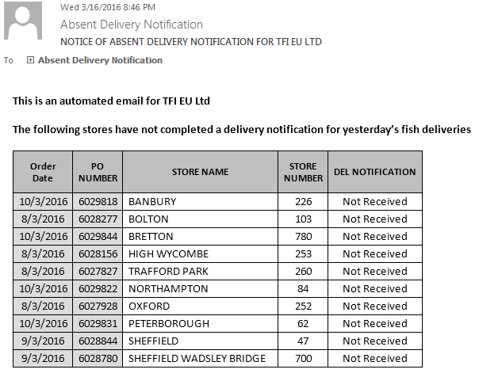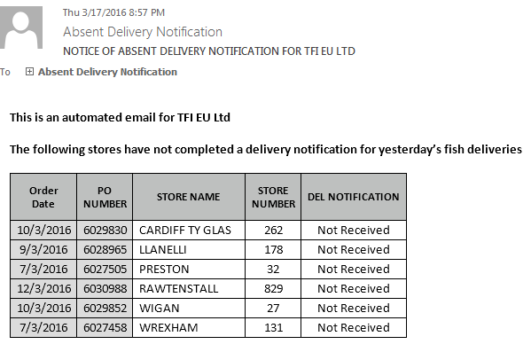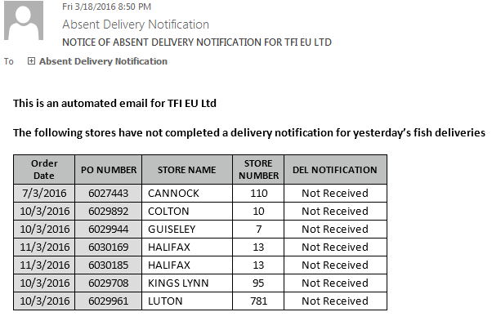

1. Absent notifications from all three lists are compiled into one list as an overview and sent to TFIUK every Friday at 4PM GMT for review.

