TeKnowledge Shared Services (Pvt) Ltd

3. **OPR FOR ORDERS RECEIVED BY WEDNESAY 8PM GMT – REPORT TO BE SENT BY 8:30AM GMT ON THURSDAY (BI-WEEKLY REPORT)**

|  |  |
| --- | --- |
| **SUBJECT** | **OPR for Orders received by Wednesday 8PM (GMT) - Report sent every Thursday at 8:30am (Bi-weekly Report)** |
| **DEPARTMENT** | **Customer Services Department** |
| **RECORDER (Name & Designation)** | **Andrea Meikle - Executive** |
| **APPROVEDBY (Name & Designation)** | **Purodha Perera - HOD** |
| **CREATED DATE** | **15/03/2016** |
| **LAST UPDATED** |  |
| **PATH ON NETWORK FOLDER** |  |
| **NO. OF PAGES INCLUDING THIS PAGE** | **Two** |

**Introduction:**

This Report is for Orders received from PAH Stores with deliveries for Tuesday and Wednesday and it is sent to the MD at TFIUK and respective personnel at PAH via the Report Calendar on the requested Day and time (Thursdays by 8:30AM GMT on weeks of Order). The cut-off time to have these orders in are by 8PM GMT Wednesdays.

**Contents:**

1. Email address Orders are received to
2. Order Notification
3. Order Notification Status Report
4. Email sent to TFIUK and PAH via Report Calendar

**Process:**

1. Order notifications are sent by PAH stores to the following email address: [PAHPO@TFIUK.co.uk](mailto:PAHPO@TFIUK.co.uk)

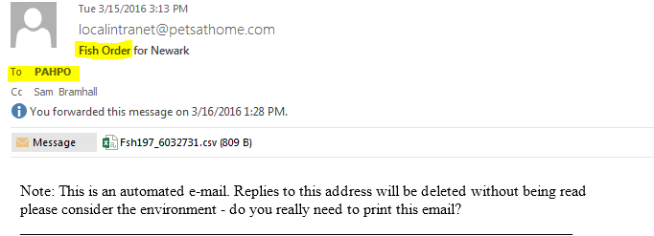

1. Order # and Order Status is added to the Order Notification report according to the PAH store’s assigned delivery date.

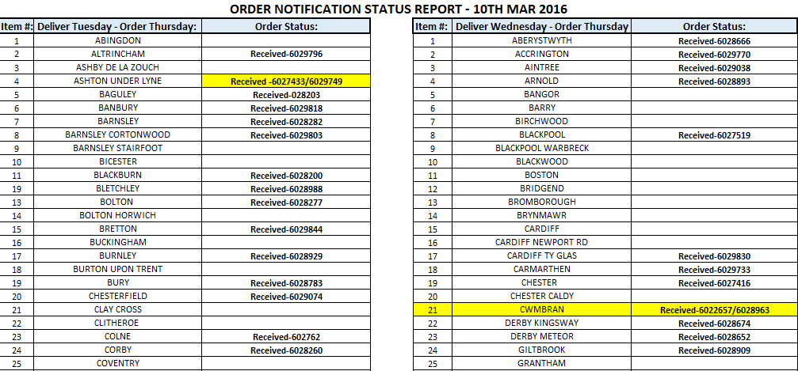

1. If any store has made two orders it will be highlighted (as shown in the above screen shot) and mentioned on the email the report is sent on.
2. This report will contain all orders received by 8PM GMT every Wednesday (week of orders only) and will be sent to the MD at TFIUK and the respective personnel at PAH by 8:30AM GMT Thursdays via the Report Calendar.

