TeKnowledge Shared Services (Pvt) Ltd

1. **FOR ORDERS RECEIVED BY THURSDAY 8PM GMT – REPORT TO BE SENT ON FRIDAY BY 8:30AM GM (BI-WEEKLY REPORT)**

|  |  |
| --- | --- |
| **SUBJECT** | **OPR for Orders received by Thursday 8PM (GMT) - Report sent every Friday at 8:30am (Bi-weekly Report)** |
| **DEPARTMENT** | **Customer Services Department** |
| **RECORDER (Name & Designation)** | **Andrea Meikle - Executive** |
| **APPROVEDBY (Name & Designation)** | **Purodha Perera - HOD** |
| **CREATED DATE** | **15/03/2016** |
| **LAST UPDATED** |  |
| **PATH ON NETWORK FOLDER** |  |
| **NO. OF PAGES INCLUDING THIS PAGE** | **Two** |

**Introduction:**

This Report is for Orders received by PAH Stores with deliveries for Thursdays and it is sent to the MD at TFIUK and respective personnel at PAH via the Report Calendar on the requested Day and time (Fridays by 8:30AM GMT on weeks of Order). The cut-off time to have these orders in are by 8PM GMT Thursday.

**Contents:**

1. Email address Orders are received to
2. Order Notification
3. Order Notification Status Report
4. Email sent to TFIUK and PAH via Report Calendar

**Process:**

1. Order notifications are sent by PAH stores to the following email address: [PAHPO@TFIUK.co.uk](mailto:PAHPO@TFIUK.co.uk)

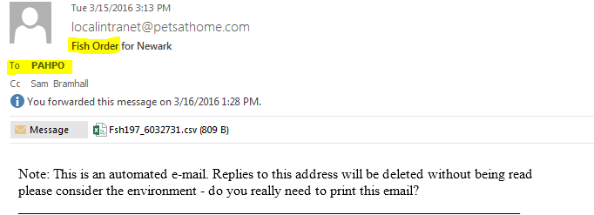

1. Order # and Order Status is added to the Order Notification report according to the PAH store’s assigned delivery date.

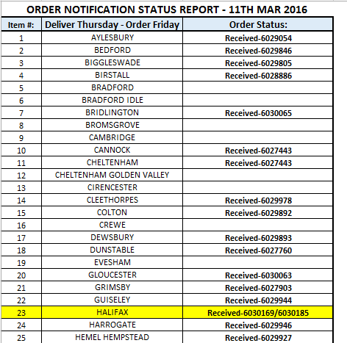

1. If any store has made two orders it will be highlighted (as shown in the above screen shot) and mentioned on the email the report is sent on.
2. This report will contain all orders received by 8PM GMT every Thursday (week of orders only) and will be sent to the MD at TFIUK and the respective personnel at PAH by 8:30AM GMT on Friday via the Report Calendar.

