TeKnowledge Shared Services (Pvt) Ltd

15. **WEEKLY OVERVIEW OF ABSENT ORDER NOTIFICATION STATUS’ – SENT TO TFIUK AND PAH UK EVERY FRIDAY AT 11:30PM GMT (BI-WEEKLY NOTIFICATION)**

|  |  |
| --- | --- |
| **SUBJECT** | **OPR for Weekly overview of Absent Order Notification Status - Sent to Ian.Y and Sam @ PAH every Friday at 11:30PM GMT (Bi-weekly Notification)** |
| **DEPARTMENT** | **Customer Services Department** |
| **RECORDER (Name & Designation)** | **Andrea Meikle - Executive** |
| **APPROVEDBY (Name & Designation)** | **Purodha Perera - HOD** |
| **CREATED DATE** | **20/03/2016** |
| **LAST UPDATED** |  |
| **PATH ON NETWORK FOLDER** |  |
| **NO. OF PAGES INCLUDING THIS PAGE** | **Two** |

**Introduction:**

A weekly overview of all Absent Orders are sent to TFIUK and respective personnel at PAH UK for review and follow up with the Stores that have not placed their orders for the week.

**Contents:**

1. Preparation of Absent Order Notification Status Lists
2. Compilation of Lists
3. Email sent to TFIUK

**Process:**

1. A comparison of all absent order notifications for the week up till Friday is updated from the lists sent during the week.

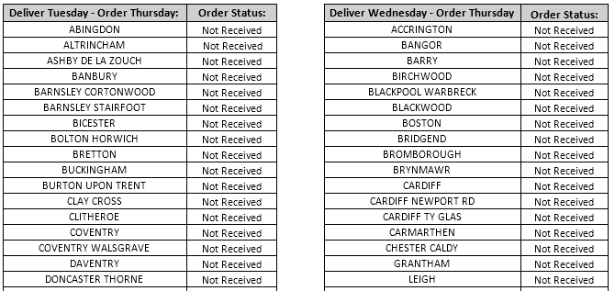 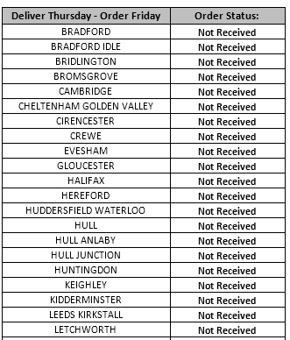

1. Preparation of list for all absent order notification (for each assigned delivery day) for the week are compiled into one list and sent to TFIUK and the personnel at PAH UK very Friday by 11:30AM GMT as an overview of all orders not received for the week.
2. This list is sent to TFIUK on Fridays (week of orders) by 11:30AM GMT and the respective personnel at PAH UK for review and follow up with PAH Stores.