**TEKNOWLEDGE SHARED SERVICES-SRI LANKA**

**OPR PRODUCTION TRACKER**

|  |  |
| --- | --- |
| SUBJECT | OPR PRODUCTION TRACKER |
| DEPARTMENT | PRODUCTION PLANNING |
| RECORDER | BUDDIKA MADURANGANA |
| APPROVED BY |  |
| CREATED DATE | 03/04/2016 |
| LAST UPDATED |  |
| PATH ON NETWORK FOLDER |  |
| NO. OF PAGES INCLUDING THIS PAGE | 3 |

**Objective**

Production Tracker is required to prepare as a projection for the coming week on Thursday and to be updated with actual data on Sunday. After that daily Production details are required to update on the same file and used to discuss in daily meeting.

1. Create the report with projected data on Thursday with below details
2. Projected fish quantities based on average of last six week records & projected daily ship quantities

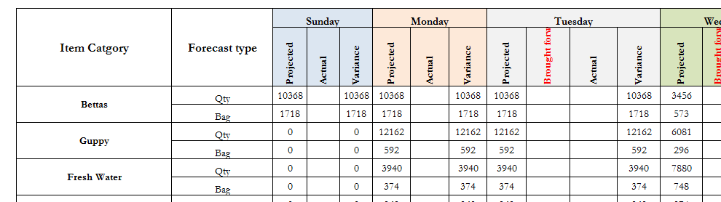

1. If any promo is planned, consider the fish quantities
2. Projected number of POs as back orders and new orders

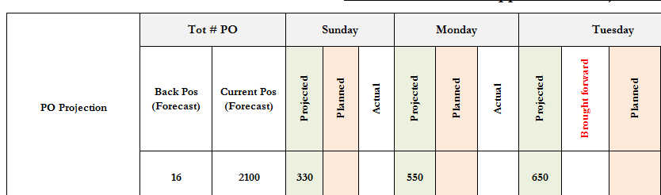

1. Projected PO distribution in week

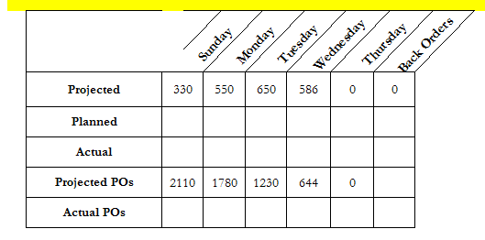

1. PO burn down chart according to the Projected PO distribution

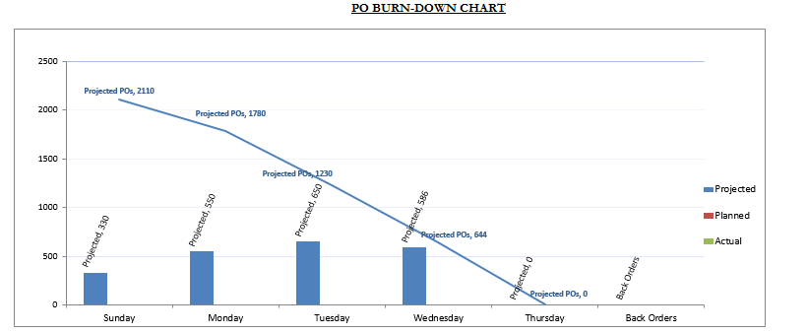

1. Shipment details

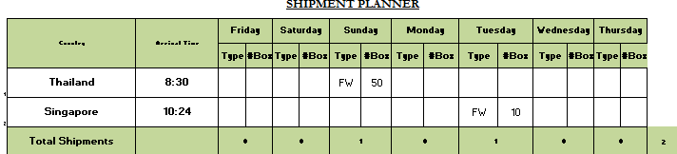

1. Dry good requirement Box and Cup

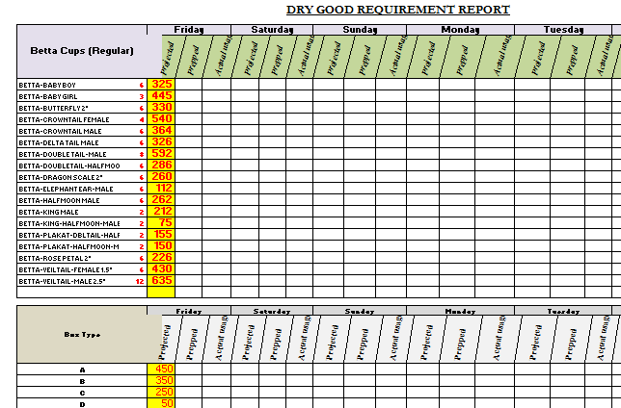

1. Packer assignment-actual
2. Packer Performance-Actual
3. Open PO details