**TEKNOWLEDGE SHARED SERVICES-SRI LANKA**

**OPR PETCO.COM #651 PLANNING**

|  |  |
| --- | --- |
| SUBJECT | OPR PETCO.COM #651 PLANNING |
| DEPARTMENT | PRODUCTION PLANNING |
| RECORDER | BUDDIKA MADURANGANA |
| APPROVED BY |  |
| CREATED DATE | 02/24/2015 |
| LAST UPDATED | 03/04/2016 |
| PATH ON NETWORK FOLDER |  |
| NO. OF PAGES INCLUDING THIS PAGE | 4 |

**Objective**

To provide Open Petco.com PO list with required item list to the Warehouse from Monday to Thursday. This report must be provided before 6.00 am US time.

POs will be considered to the production, which created up to 12.00 mid night previous day and any back POs remaining.

**Generate Petco.com MPOs.**

Petco.com POs are required to be assigned (Generate MPOs) to ETF from Sunday to Wednesday 12.00 mid night US time. (Monday to Thursday 2.30 PM SL time as per the current time diference).

Path: EDI Details – Purchase Orders

<http://www.cisintl.com/PurchaseOrders.aspx>

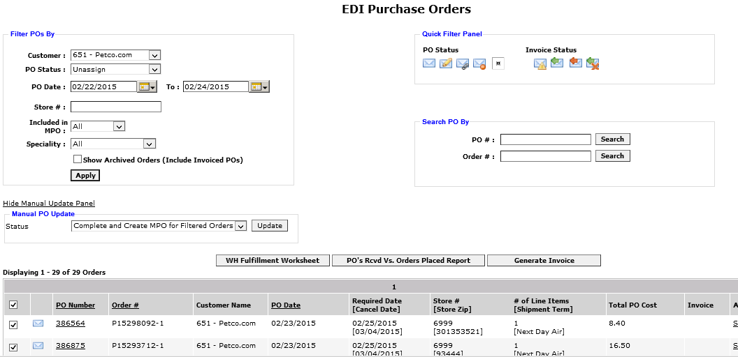

**PO List**

PO list to be taken from production planning screen as mentioned below.

Path: Production Planning Admin – Production Planning New

<http://www.cisintl.com/ProductionMatrix/ProductionPlanning_NEW.aspx>

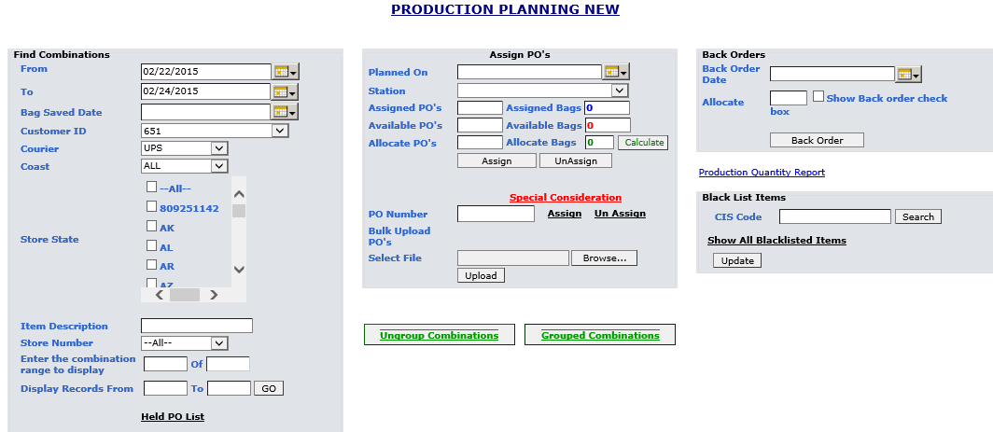

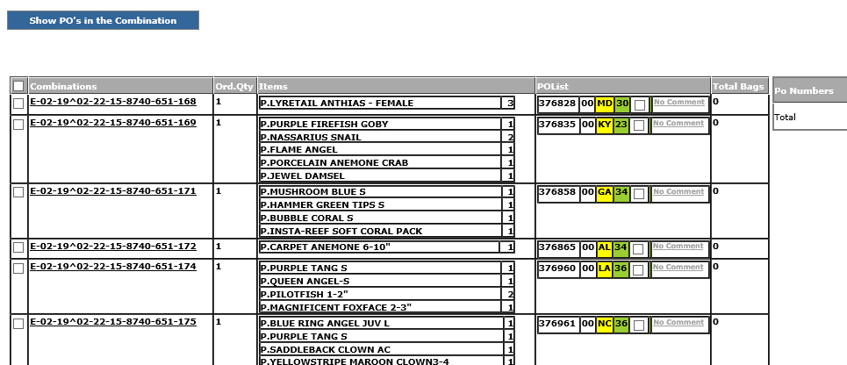

This list to be copied to Excel with following format.

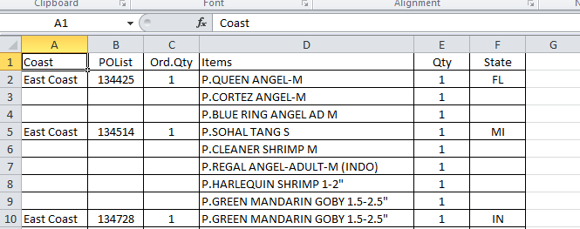

**Item Summery**

Once the POs list is prepared, items & quantity columns to be copied to second page and need to get total requirement for each fish type. Only the summery of required items to be provided in second sheet as below.

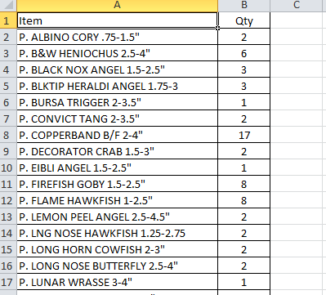

Petco.com PO & Item summery should contains two tabs once it prepared.



Recipients

**To:** [**richardc@etropicalfish.com;sandrag@etropicalfish.com**](mailto:richardc@etropicalfish.com;sandrag@etropicalfish.com)

**Cc:** [**andyh@etropicalfish.com;JessicaT@etropicalfish.com;JoelG@etropicalfish.com;prodmgt@cisintl.com;WHMgt@etropicalfish.com**](mailto:andyh@etropicalfish.com;JessicaT@etropicalfish.com;JoelG@etropicalfish.com;prodmgt@cisintl.com;WHMgt@etropicalfish.com)

Subject: **Sandra |Summery Report For Petco.com**

**Note: Report is assigned under Production Planner Access.**