**TEKNOWLEDGE SHARED SERVICES-SRI LANKA**

**OPR FOR DAILY UPDATE MEETING**

|  |  |
| --- | --- |
| SUBJECT | OPR FOR DAILY UPDATE MEETING |
| DEPARTMENT | SYSTEM ADMIN |
| RECORDER | RUWANI KRISHANGA |
| APPROVED BY |  |
| CREATED DATE | 22/04/2015 |
| LAST UPDATED | 11/05/2016 |
| PATH ON NETWORK FOLDER |  |
| NO. OF PAGES INCLUDING THIS PAGE | 2 |

# Objectives

* To summarize all the follow ups (email communication and etc) which comes under SL-Office/Farms, US- Office/WH, UK, Maldives, Thailand, Figi which enable all the System Admin Team Members to be aware on all updated and urgent details.

**How to Conduct the Meeting :**

* Meeting Agenda to be prepared according to the company guide lines. Please refer the OPR created for same.
* It should be received by all the team members daily as auto generated alert via ETF
* Meeting to be done at 9.30am weekly.
* Updates relevant to the previous day and any urgent work to be discussed and tasks to be assigned between team members
* The time duration for the meeting should be maximum 45 minutes ( PMS Tracker 20minutes and 10 for other issues )
* Meeting minutes to be uploaded in Meeting Calendar>Add Meeting Minutes to be received by relevant team members

# Format to be used

Following excel format will be used as Meeting Tracker.

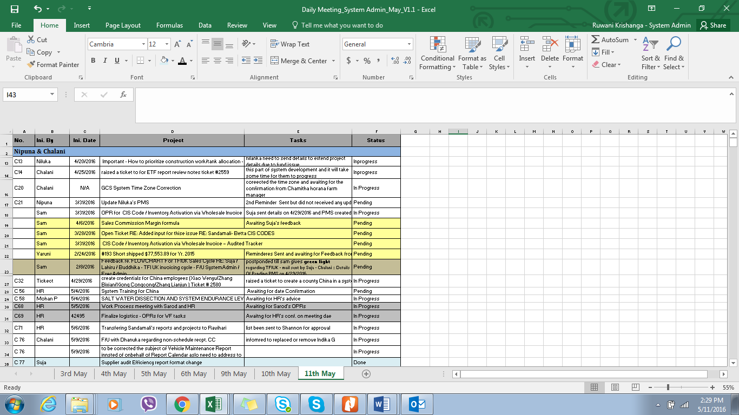

* The excel sheet to be updated by discussing and highlighting all the pending, day to day and urgent work.
* Once excel file should be maintained for one particular month given the name “ Daily Meeting_System Admin_May”
* Should create separate sheets for the days starting fro 1st to the end of the month and name the work sheet accordingly
* Work done should be clearly marked “Done” and should turn in to Blue Color.

Define Columns :

1. “No” Column: It has given a code by considering task owners first name with allocated task numbers
2. Initiated Date Column : The date of the email received with the new task and any urgent work initiated date
3. Project Column : The new follow up/ PMS or task to be summarized in this column
4. Task Owner Column: The team member of the System Admin who is responsible on the project to be mentioned.
5. Tasks Column: Relevant task to be carried out to be listed
6. Status Column: Whether it is in progress/Pending or completed
7. This Tracker to be saved in a Separate Folder by giving correct File Name