**TEKNOWLEDGE SHARED SERVICES (PVT) LTD**

**OPR for Performance Reports – Reports Summary, Meeting Summary & Work Flows**

|  |  |
| --- | --- |
| **SUBJECT** | Reports Summary, Meeting Summary & Work Flows |
| **RECORDER (Name Designation)** | Nipuna Madumal – Junior Executive System Admin |
| **APPROVED BY (Name Designation)** |  |
| **CREATED DATE** | 03/28/2016 |
| **NO. OF PAGES INCLUDING THIS PAGE** | 07 |

Content

1. Report Calendar Performance Summary Report
2. Meeting Calendar Performance Report
3. Work Flow Summary Report
4. **Report Calendar Performance Summary Report**

Main purpose of this report is to measure the monthly report performance of the employees. And also when there is a employee does not complete their reports in consecutively take necessary actions.

According to the system generated mails on Report Calendar we prepare a report for a month about report performance of the employee. Also by using these e-mails send pending reports mail when an employee not good enouhg to complete their reports.

Following you can see that e-mail we use to prepare this report.

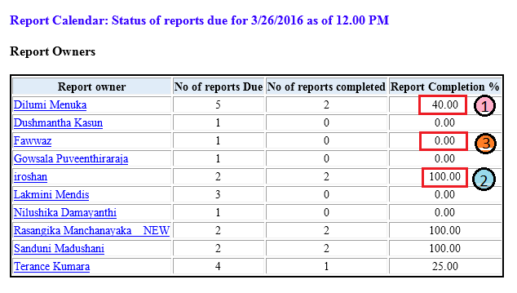

As you can see above screen shot we categorize states report completion in to three.

1 – Reports incomplete

2 – Reports Complete

3 – Reports Not Done

Also when a report pending consecutively 3 days, in that scenario we notice via e-mail from the department head of that report owner and aware about that and take necessary action.

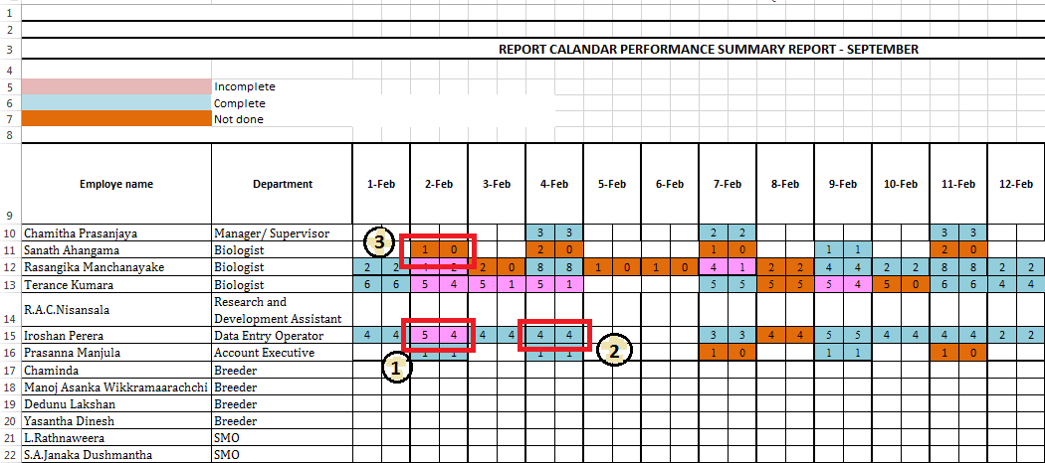The report format can be seen as following screen shot.

According to the report calendar mails we fill this report. In this format we use different three colures for identify the status of the completion. This report is containing head office and farm separately.

1 – Reports Incomplete (Use Pink)

2- Reports Complete (Use Blue)

3- Reports Not Done (Use Orange)

By using this report we can get two indicators.

1. 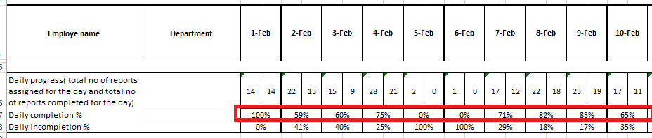Daliy Report Completion Percentage.

We can get idea about daily report completion percentage by using this report.

1. Employee wise Report Completion Percentage.

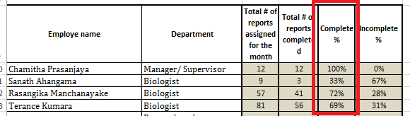

We can get idea about employee wise report completion percentage for a month.

1. **Meeting Calendar Performance Report**

In ETF has different kind of Meetings. Meetings are used to discuss daily, weekly or monthly progress/schedules/matters in the departments regarding the operations. In here we select meetings held in SL and create a performance summary.

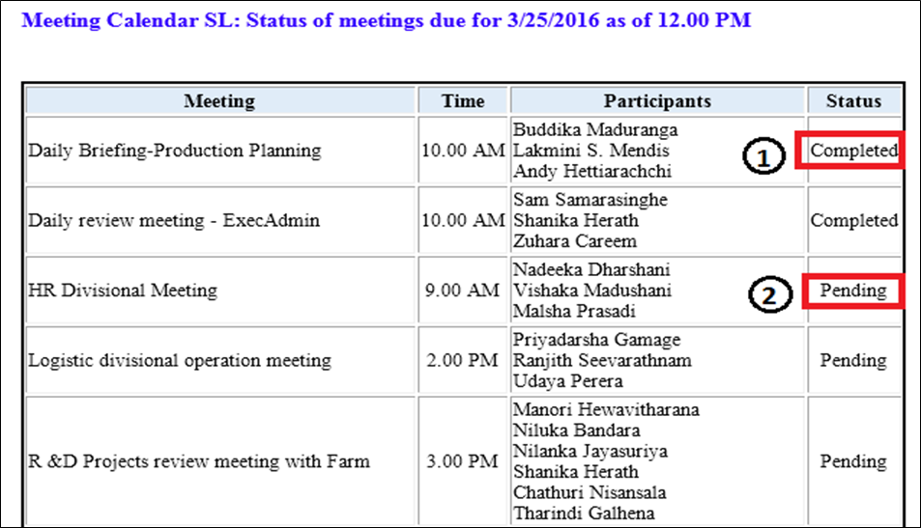According to the system generated mails on Meeting Calendar we prepare a report for a month about meeting performance of the employee. We use following type of format for record it.

As you can see above screen shot you can see two status.

1 – Meeting is complete

2 – Meeting is pending

If the meeting is held and meeting minute is upload to the ETF it showed as completed.

If the meeting is not held or weather the meeting is held but meeting minute is not upload to ETF it shows as pending.

By using this Meeting Status e-mails we sending mails for pending meetings.

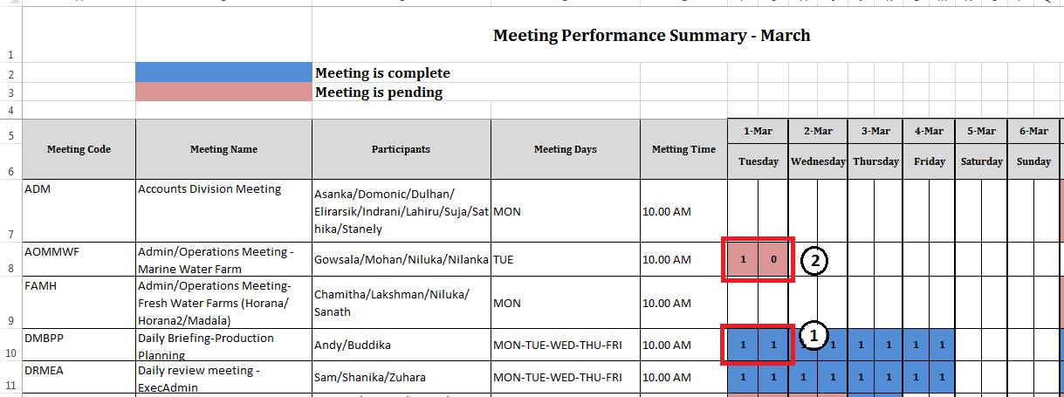According to the Meeting Calendar Status fill the Meeting Performance Summary Report. You can see the format of that as follows.

According to the meeting calendar mails we fill this report. In this format we use different two colures for identify the status of the completion.

1 – Meeting is Complete (Use Blue)

2 – Meeting is Pending (Use Red)

1. **Work Flow Summary Report**

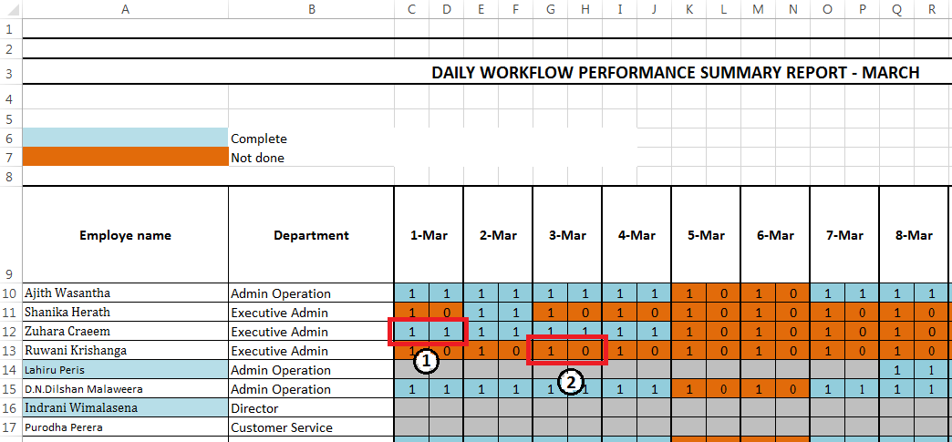This report is arrange according to the work flow updates of the employees. Employees who have work flows in the PMS, should have update their daily routines. According to that this report is create. If work flow if update mark as “1” in the report. If work flow is not update mark as “0” in the report. We use both individual and department work flow update mails for this.