**Tropical Fish Intl Ltd**

**OPR FOR LOGISTIC SHIPMENT CHECK LIST**

|  |  |
| --- | --- |
| **SUBJECT** | **Obtain best rates/quotes from Agents for Sea/Air Shippments** |
| **DEPARTMENT** | **Logistic Colombo** |
| **RECORDER (Name & Designation)** | **Ranjith Seevaratnam, Priyadhasha, Udaya Perera** |
| **APPROVEDBY (Name & Designation)** | **Udaya Perera** |
| **CREATED DATE** | **10\03\2016** |
| **LAST UPDATED** |  |
| **PATH ON NETWORK FOLDER** | **Z:\Gen Log\OPR** |
| **NO. OF PAGES INCLUDING THIS PAGE** | **1** |

**Obtain best rates/quotes from Agents for Sea/Air Shipments**

Contact approved forwarders and obtaining quotations. Based on best quotation we will then select an agent.

Required Details:

Route mentioned with transit details

Frequency/ Days – How often and departure/ Arrival time

Rate per Kgs

Commodity

Example -1

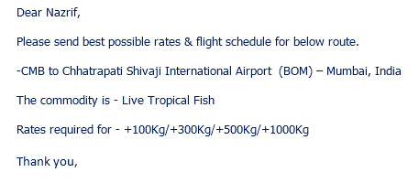

Freight Rate & connection Tracker comparison.

