**Tropical Fish Intl Ltd**

**OPR FOR LOGISTIC SHIPMENT CHECK LIST**

|  |  |
| --- | --- |
| **SUBJECT** | **Filling the Documents (Import/Export) for Digital and Manual Methods** |
| **DEPARTMENT** | **Logistic Colombo** |
| **RECORDER (Name & Designation)** | **Ranjith Seevaratnam, Priyadhasha, Udaya Perera** |
| **APPROVEDBY (Name & Designation)** | **Udaya Perera** |
| **CREATED DATE** | **28/04/2016** |
| **LAST UPDATED** |  |
| **PATH ON NETWORK FOLDER** | **Z:\Gen Log\OPR** |
| **NO. OF PAGES INCLUDING THIS PAGE** | 4 |

**Filling the Documents (Import/Export) for Digital and Manual Methods**

Filling the Documents (Import/Export) for Digital and Manual Methodsa

1. Original Cusdec
2. Invoice
3. Packing List
4. MAWB
5. Copy of approvals

Files are stored (Digital)

1. Copy of CUSDEC_1

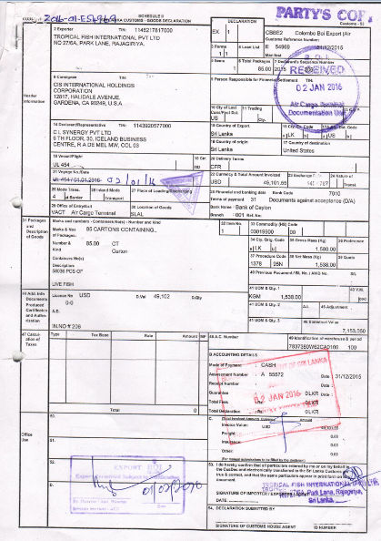

Copy of CUSDEC_2

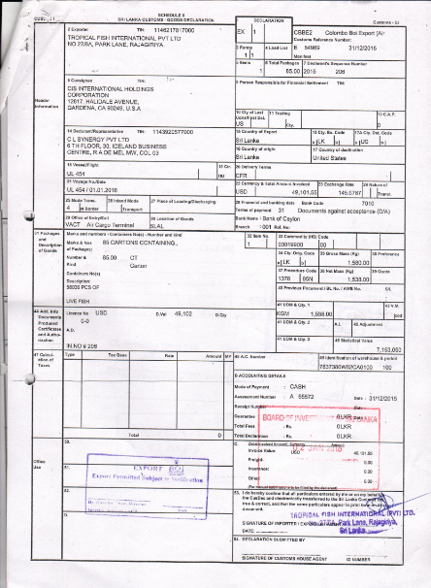

Copy of MAWB

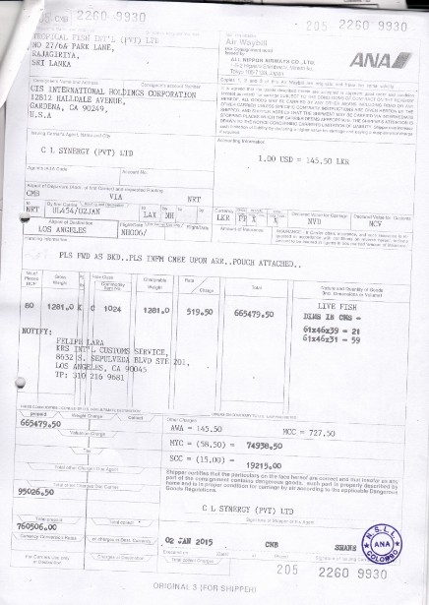

Copy of Invoice

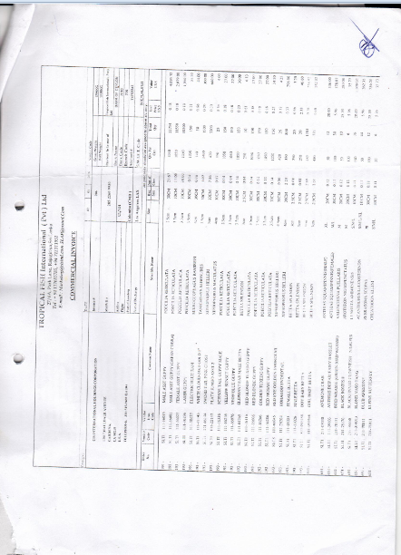

Back up Link at storage,

