**Tropical Fish Intl Ltd**

**OPR FOR LOGISTIC SHIPMENT CHECK LIST**

|  |  |
| --- | --- |
| **SUBJECT** | **shipment clearance coordination tracker** |
| **DEPARTMENT** | **Logistic Colombo** |
| **RECORDER (Name & Designation)** | **Udaya Perera** |
| **APPROVEDBY (Name & Designation)** | **Udaya Perera** |
| **CREATED DATE** | **4/27/2016** |
| **NO. OF PAGES INCLUDING THIS PAGE** | **1** |

1. Confirmed freight details requested and received by different forwarders through mails.
2. Received freight details according to the departure and arrival dates, entered to the shipment clearance coordination tracker

Shipment clearance coordination Tracker – Format

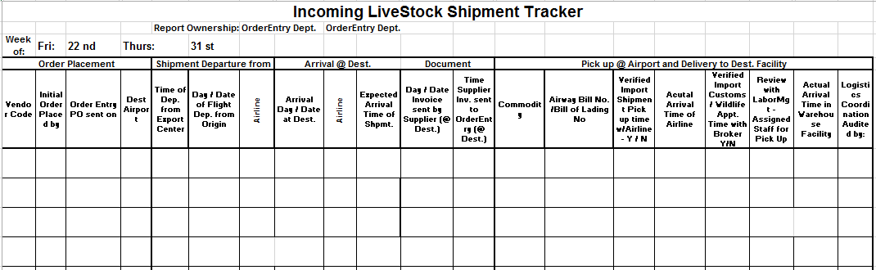

1. Completed Shipment clearance coordination Tracker send to **Air freight to LA, Sea freight to LA & UK shipments** through ETF using OPR for ETF user level

Note: System generate the email for arranged recipient on behalf of report owner.