**Tropical Fish Intl Ltd**

**OPR FOR LOGISTIC SHIPMENT CHECK LIST**

|  |  |
| --- | --- |
| **SUBJECT** | **Daily meeting with Logistics , order entry and sales & marketing** |
| **DEPARTMENT** | **Logistic Colombo** |
| **RECORDER (Name & Designation)** | **Ranjith Seevaratnam, Priyadhasha, Udaya Perera** |
| **APPROVEDBY (Name & Designation)** | **Udaya Perera** |
| **CREATED DATE** | **28/04/2016** |
| **LAST UPDATED** |  |
| **PATH ON NETWORK FOLDER** | **Z:\Gen Log\OPR** |
| **NO. OF PAGES INCLUDING THIS PAGE** | **2** |

**Weekly Logistic Meeting**

Before 48 hours agenda should be sent it to the members.

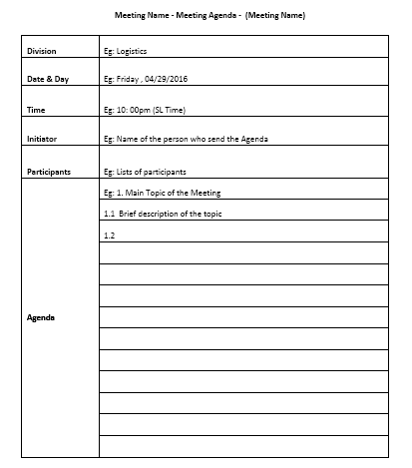

**Meeting minutes Format**

