OFFICE PROCESS RECORD

**Ingiriya OT Summary Report**

|  |  |
| --- | --- |
| Subject | How to Complete Ingiriya OT Summary Report |
| Department | Labor Planing |
| Recorder | Sanduni Madushani |
| Approved by | Dilan Maduranga |
| Created date | 09/02/2015 |
| Last updated | 20/03/2016 |
| No. of pages including this page | 02 |

1. Farm Manager Send The Actual OT Sheet After The Production Date
2. 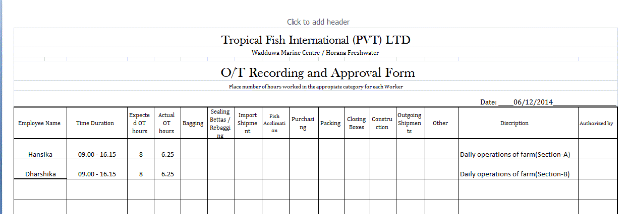Then Discuss with the farm manager & Approved the OT
3. After Approved The OT, Get The data From Actual OT Sheet
4. Fill That Data OT Summary Sheet - Time & Description – (time record in HH:MM)
5. OT Summary Sheet is divided into the following sections
6. OT Sheet

Get the data from Actual OT Sheet Description

* Normal OT - After The Normal working Time - Eg, working Hrs Is 8:00am to 17:00pm but he work to 17:30 then he get the 0:30 minutes OT Hrs
* Double OT – Mercantile Holiday Or Sundays

1. OT Summary Sheet

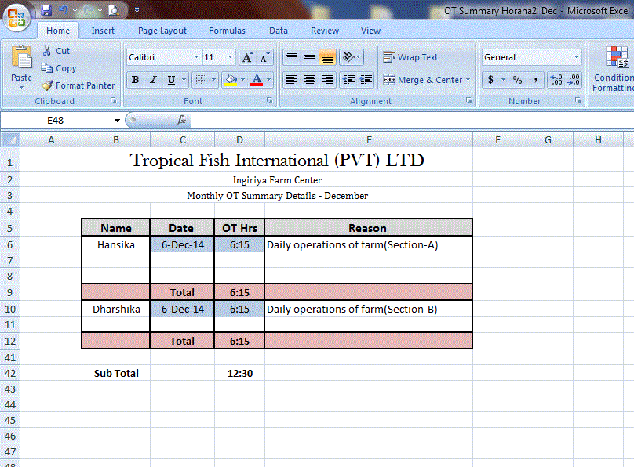

1. Then Collect the All OT Hrs & Double OT Hrs Record Them Separately (Person wise) & Get The % Of Total OT Hrs

