**This document details about, how to do the daily “end of day process” (EOD).**

* **Note :** This EOD process is done in all seven days of the week except Sunday and Monday,

At exactly 10:30 am (local time).

* **Step 1 :** Log in to ETF using : <http://www.cisintl.com/PublicSection/indexnew.aspx>
* **Step 2:** Search for the menu item “End of Day Process” from the left side of the bar, by entering it in the search box and pressing the button “Go to Menu”.
* After searching, you will be displayed the following page.

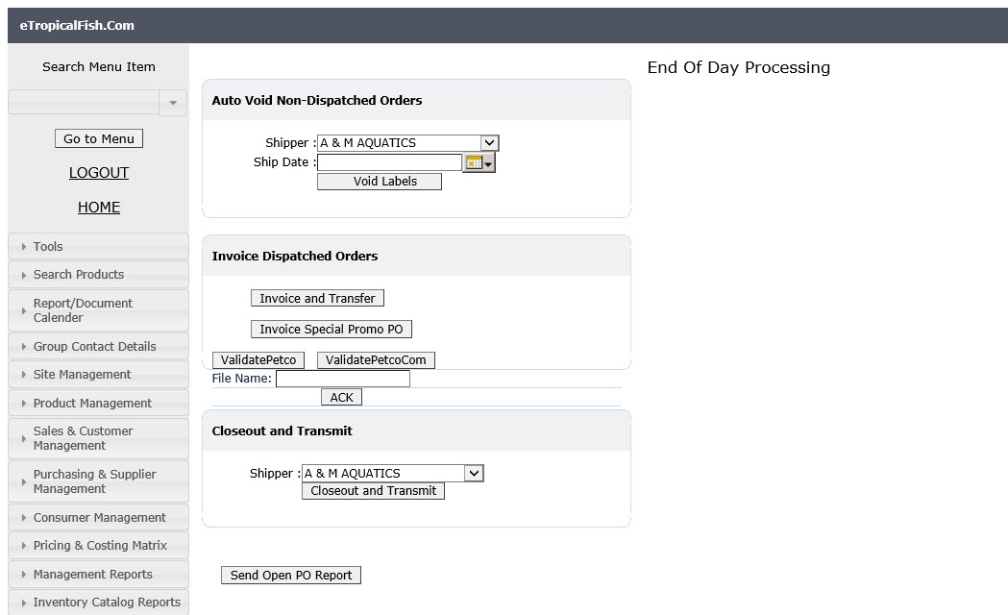

* **Step 3:** Select “Petco” customer from the Shipper dropdown.

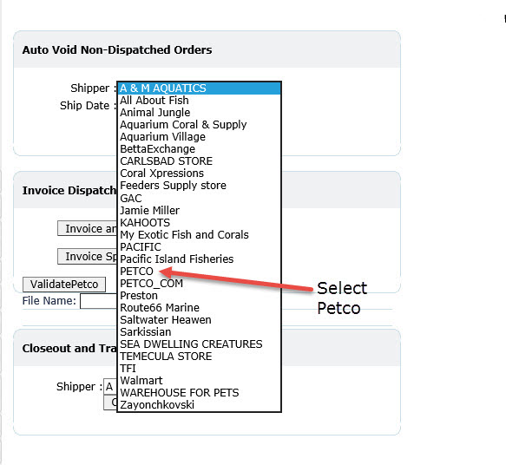

* **Step 4:** Insert yesterday (relative to today) in the calendar.

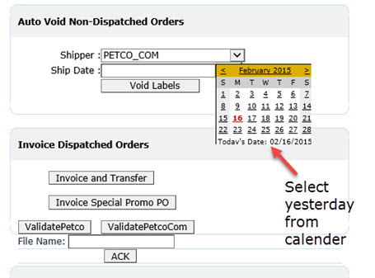

* **Step 5:** Press “Void Labels” Button.

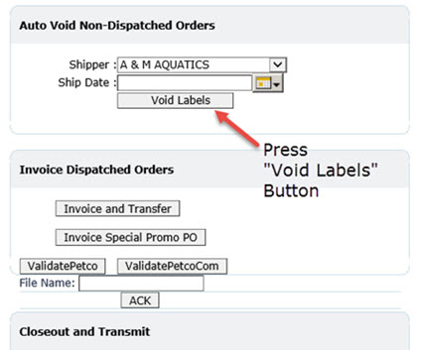

* **Step 6:** Then Press “Closeout and Transmit” Button.

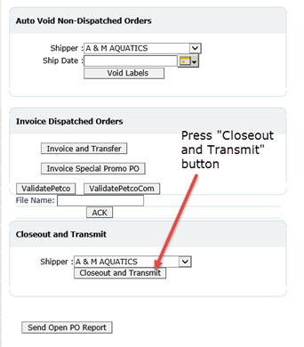

* **Step 7:** Now repreat the above steps for the other customer called “Petco.com”, Therefore, first select the “Petco.com” customer from Shipper dropdown.

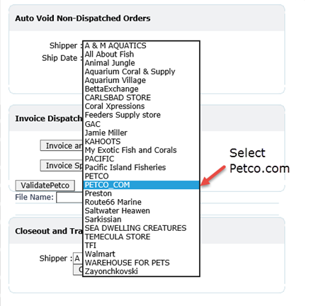

* **Step 8:** Then select yesterday (relative to today) from the calender like we have done previously.
* **Step 9:** Press “Void Labels” button.



* **Step 10:** Press again the “Closeout and Transmit” button.



* **Step 11:** Finally, press “Invoice and Transfer” button.

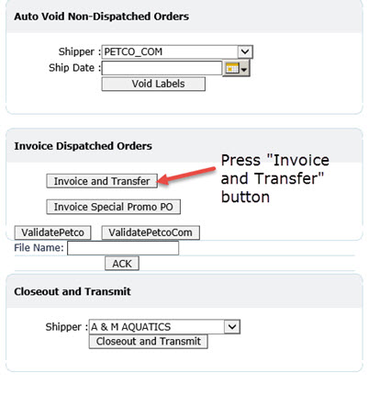

* When the End of day Process is done. You will be received an email, saying sucessfully EOD is finished.
* If any exception occur during the invocing period contact Mr. Mohan Abesekara in IT section.
* **Note :** Each time you press “Void Labels”, “Closeout and Transmit” and “Invoice and Transfer” buttons you have to check the database and make sure, whether the expected changes happened, and if not the “Void Labels” and “Closeout and Transmit” buttons can be pressed more than one time.
* **Summary :** For the Shipper “Petco” do voiding, closeout and transmitting,

For the shipper “Petco.com” do voiding, closeout and transmitting,

And finally do Invoicing.

.