**This document details about the Purchased Order Reversing process.**

* **Step 1:** Login to ETF using : <http://www.cisintl.com/PublicSection/indexnew.aspx>
* **Step 2:** Search for the menu item “Manual Invoice” from the left side of the bar, by entering it in the search box and pressing the button “Go to Menu”.
* After searching the above you will be displayed the following page.

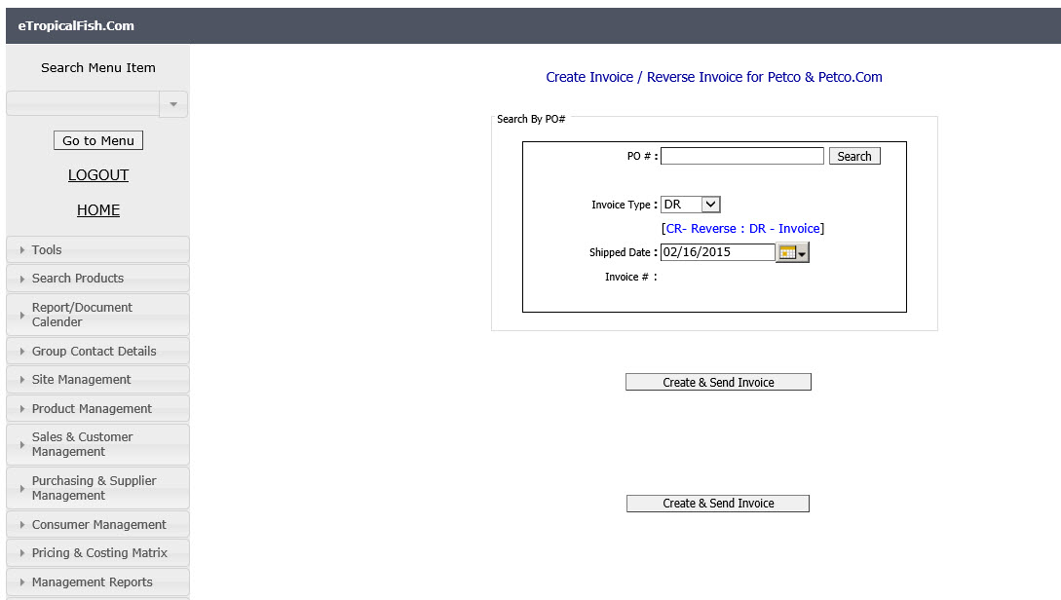

* You will receive an email with PO numbers to reverse.
* **Step 3:** Copy each PO number from the email and paste them to the “PO#” textbox, in the above shown manual invoice page.
* **Step 4:** Set the “Invoice Type” combo box value to “CR”. (CR = Reversing).
* **Step 5:** Go to **“Dashboard - PO drill down”** and search the PO number that is going to reverse, then you will get a table as follows.

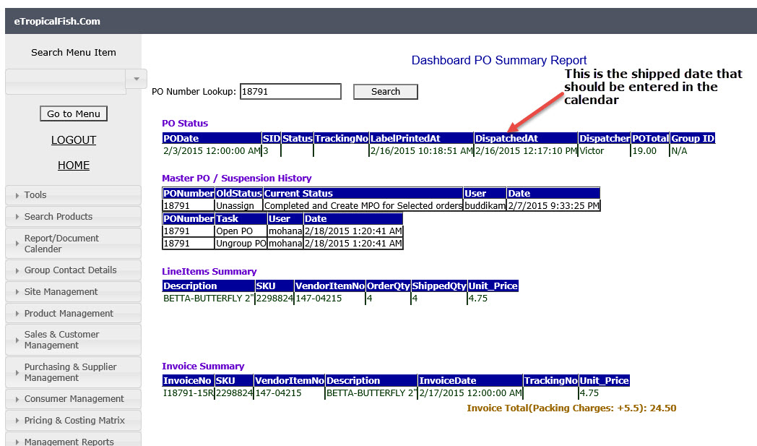

* **Step 6:** In the above screen you have to get the “Dispatched At” column date in the PO Status table. The “Dispatched” date is equal to the shipped date of the PO. Now go to “Manual Invoice” page again and select the “Shipped Date” calendar to the dispatched date, as we have taken it from PO drill down page.
* **Step 7:** Then press “Search” button in the “Manual Invoice” page, to get the resulting table.

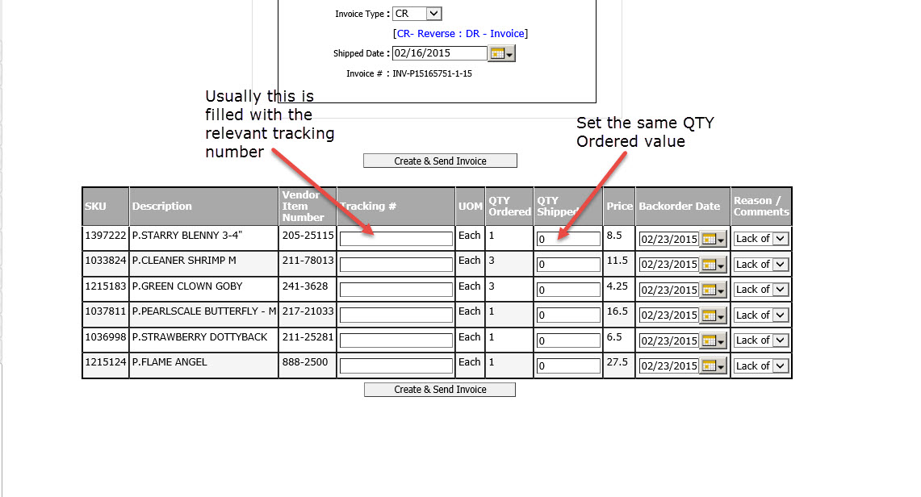

* **Step 8:** After that you will get the above shown table. This table normally comes with tracking values filled. Therefore, you have to fill only the “QTY Shipped” column with the same value as “QTY ordered”.
* **Step 9:** Then press “Create & Send Invoice” button.
* **Step 10:** Do this for all PO numbers.
* **Step 11:** Check the PO’s whether they are properly reversed, by visiting to page “Dashboard - PO drill down” from the menu of ETF.
* **Step 12:** You have to enter the reversed PO number in the search box of “Dashboard - PO drill down” page in the ETF.
* Then you will get the following screen.

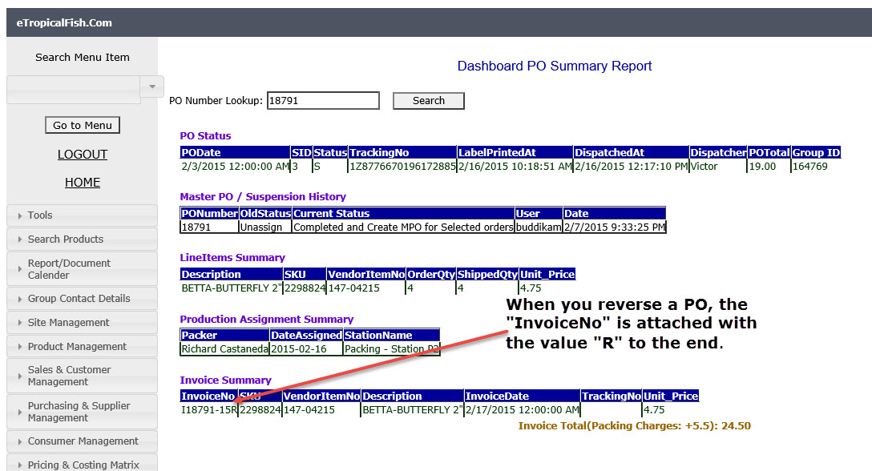

* **Step 13:** Check the value of “InvoiceNo” header in the table “Invoice Summary”. If the PO number has been reversed properly, it should be attached with the value “R” to end of the value,

Refer the above screenshot.

* **Step 14:** When you finished the reversing process, send the confirmation email as a reply.