You will be given a user login called Spiceworks, to create, update, and delete tickets.

* The login page will look as follows,

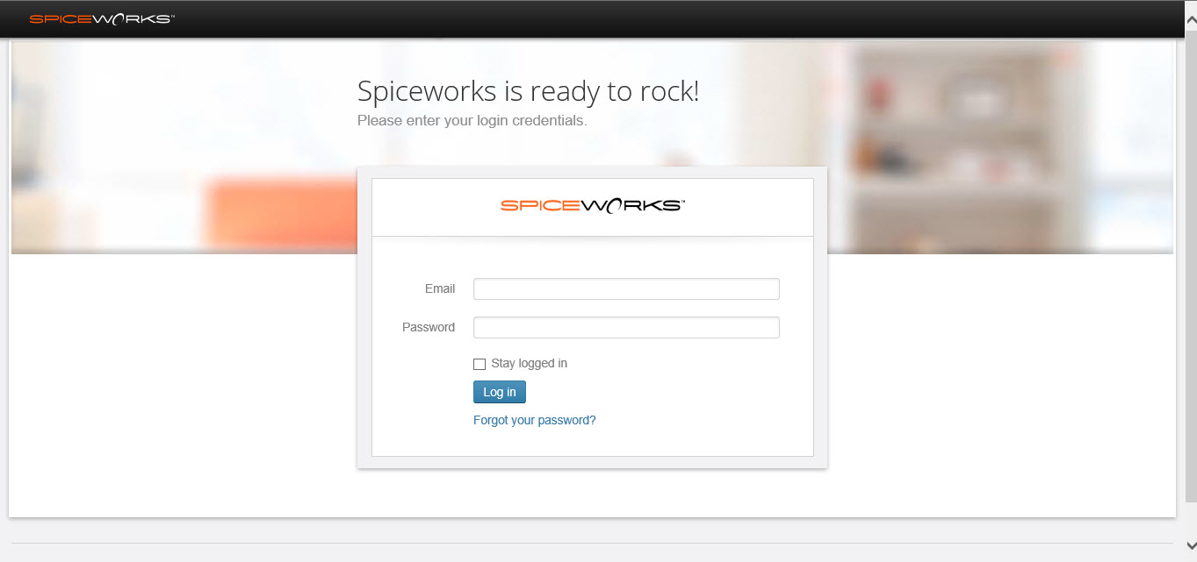

* Usually, when you have to create a ticket, you will receive an email. These tickets can be created to keep the track of issues in developing and supporting divisions. There is another need of these tickets that is, keeping the track of day to day activities. Therefore we can record activities like EOD, status change, etc. by adding them as a ticket.

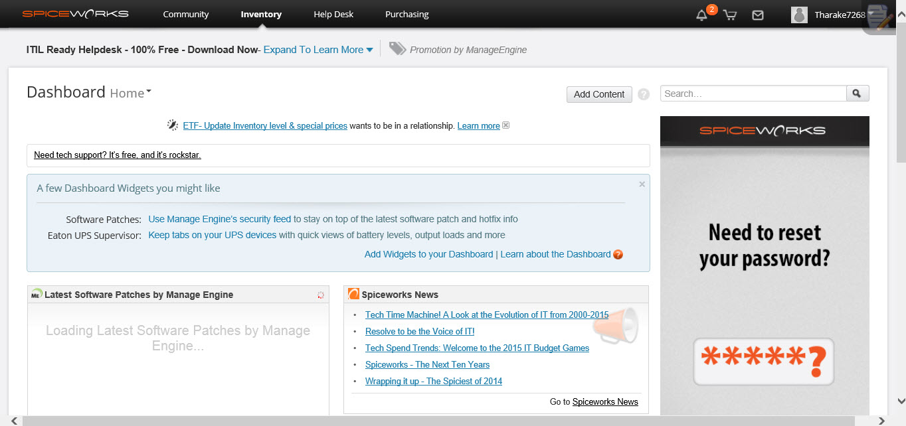

* When you are asked to create a ticket, you will receive an email that looks like follows.

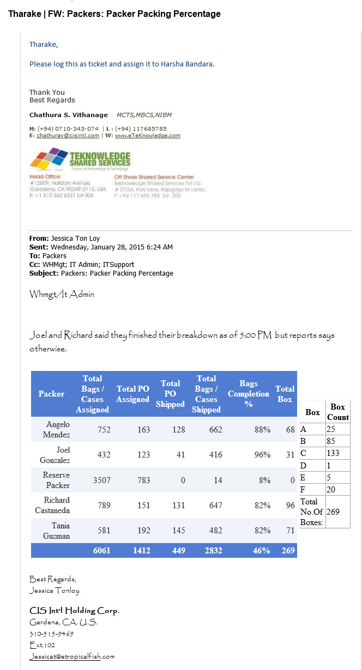

**Creating a Ticket**

* **Step 1:** Go to “Help Desk” in the menu as shown below.

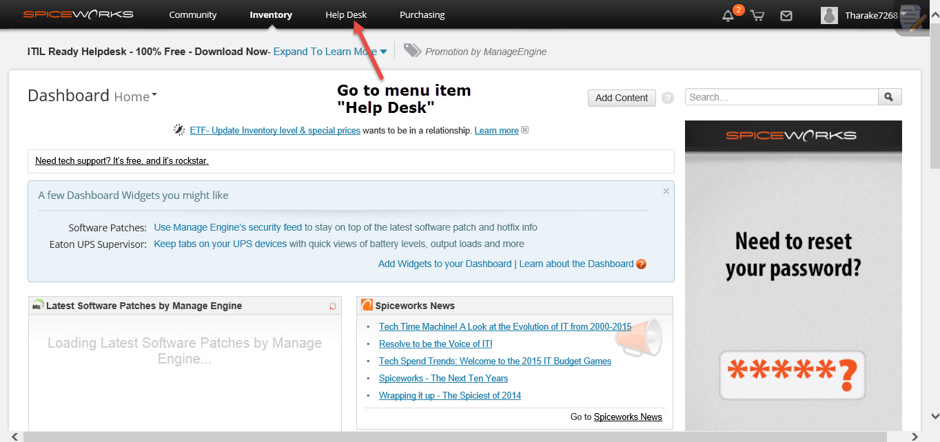

* Then you will be displayed the following page.

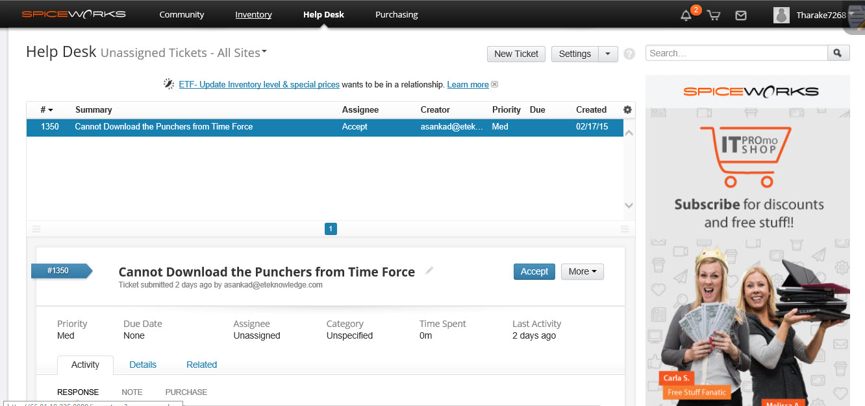

* **Step 2:** Now press the button called “New Ticket” as shown below.

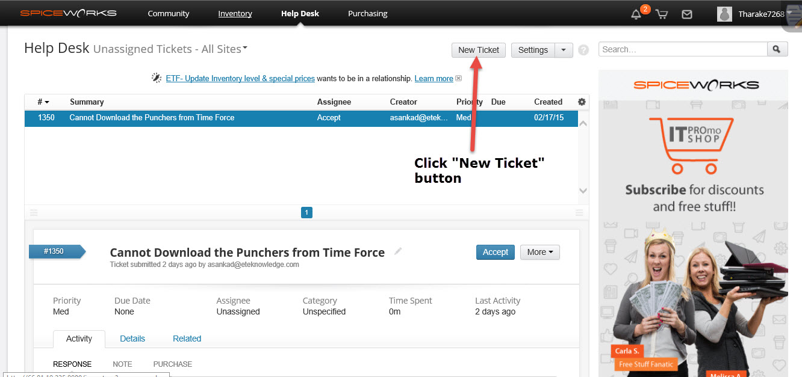

* After pressing the “New Ticket” button, you will be displayed a window with a form to fill.

The form contains the following set of data to add,

* Summary
* Description
* Assigned to
* CC Users
* Due Date
* Due time
* Priority
* Attachment (If necessary)

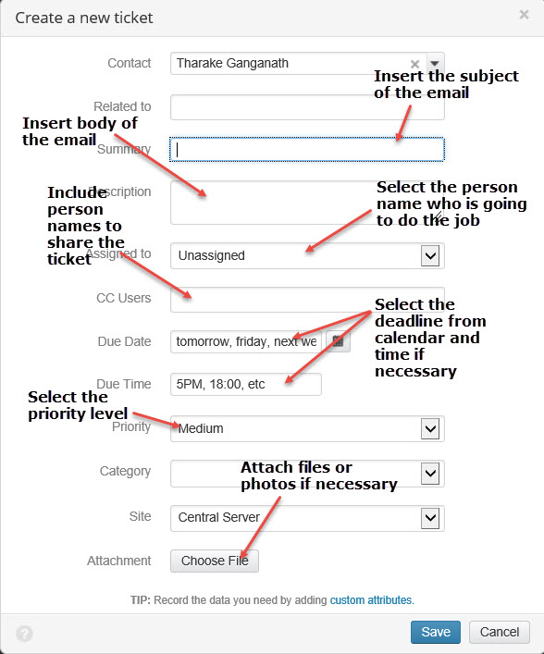

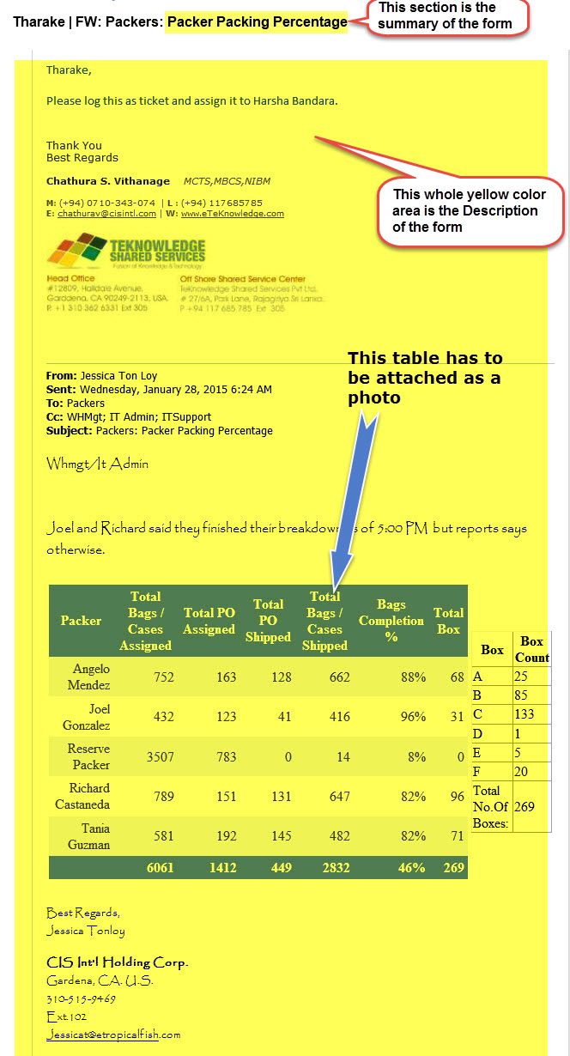

* **Step 3:** Refer the above two screenshots. You have to copy and paste what’s in the email received.
* The subject part in the email goes to “Summary” text box in the form.
* The whole body part of the mail goes to “Description” text area in the form.
* “Assigned to” field in the form is included with the responsible person who wish to deliver the solution of the issue.
* “CC Users” field is included normally with the persons, you want to share the progress of the ticket. You have to refer the conversations held in the email body and take the names of persons, to include as CC Users.
* “Due Date” and “Due Time” can be placed accordingly.
* Priority level of the issue can also be mentioned.
* If there are things such as tables, graphs etc. in the email body, you have to get a screenshot of them and attached to this form.
* **Step 4:** Then press save button in the form.
* After the save button is pressed it will be seen in the “Open tickets” section.

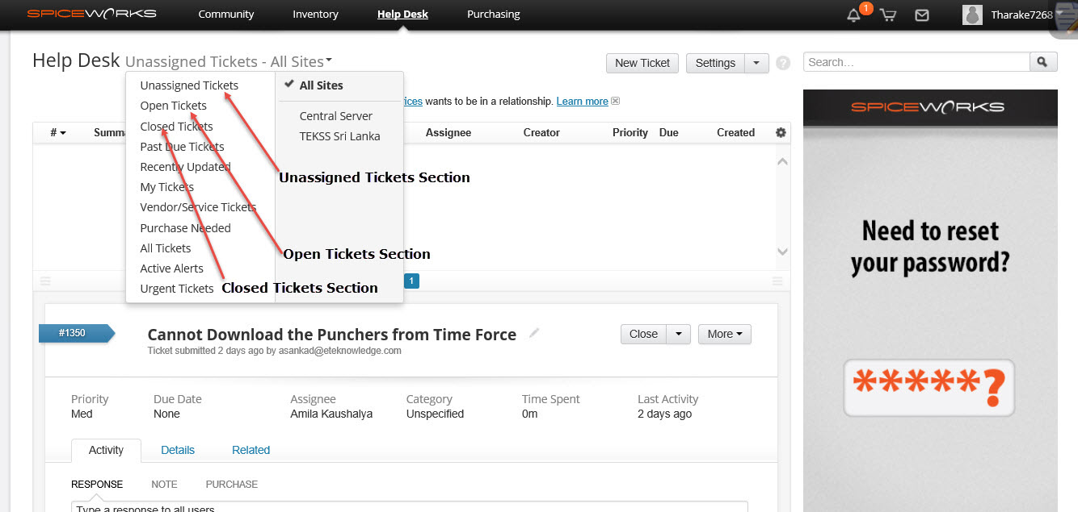

* **Step 5:** Go to open tickets in the menu. The open tickets section displays the tickets that have been assigned to somebody.
* **Step 6:** If the ticket is not assigned to somebody, it will be displayed only in “Unassigned Tickets” section.
* Below screen is displayed when you click open tickets from the menu.

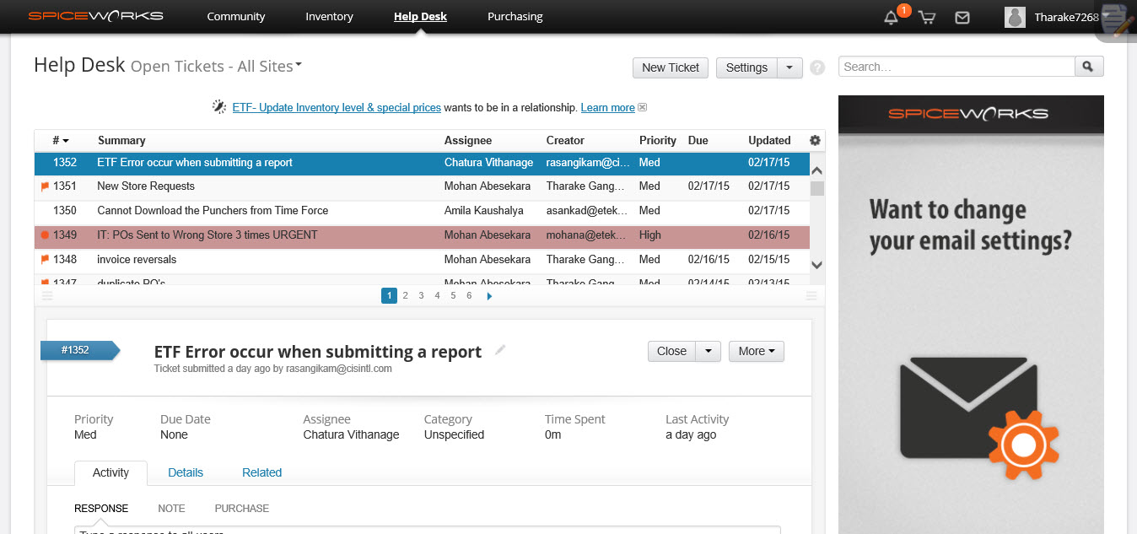

* Below screen is displayed when you click unassigned tickets from the menu.

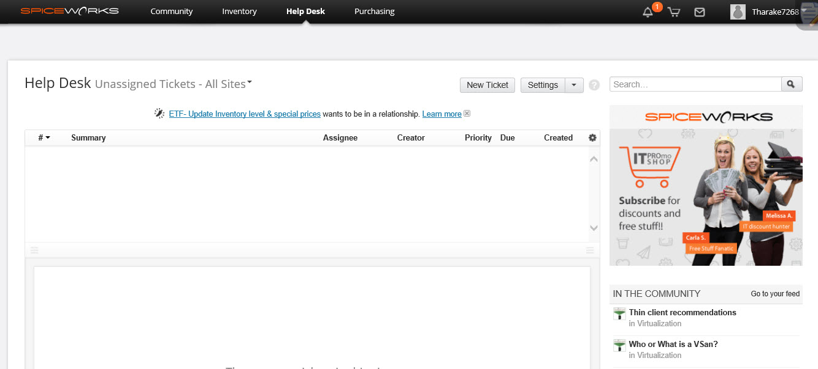

**Updating the Progress of the Ticket**

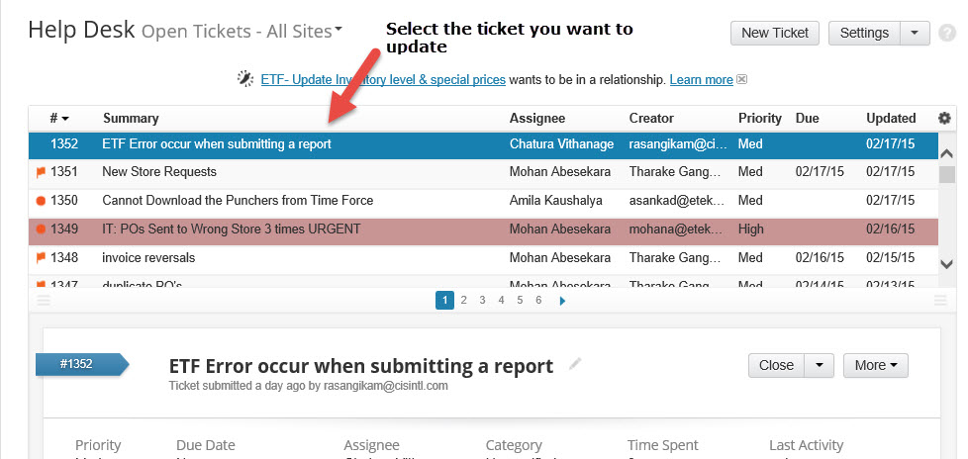

* **Step 1:** Select the ticket you want to update or add progress.
* **Step 2:** Enter the progress of the ticket in the “Response” text area and press save, as shown below.

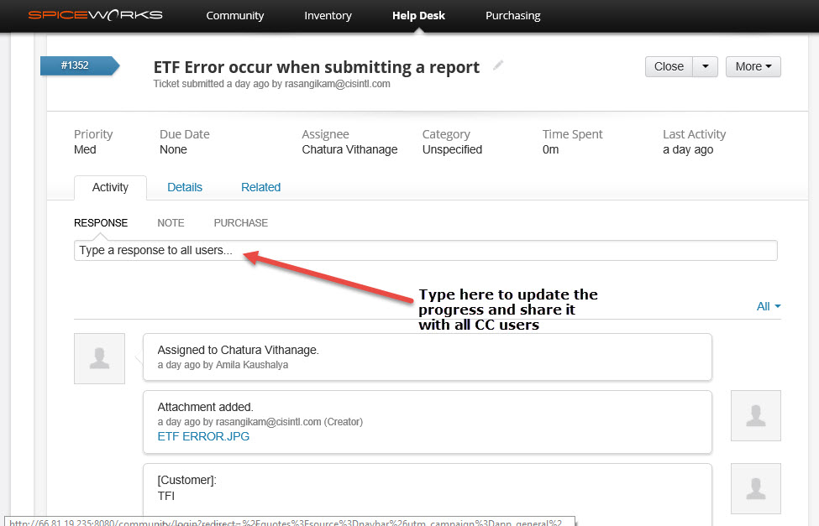

* **Step 3:** If any ticket needs to be closed, you have to first update the status of the issue by leaving a message mentioning, the relevant task is done or whatever the progress in the “Response” text area. Then select “Close Ticket” checkbox and press “Save” to close. The ticket will then be deleted from “Open Tickets” section and displayed in the “Closed Tickets” section.

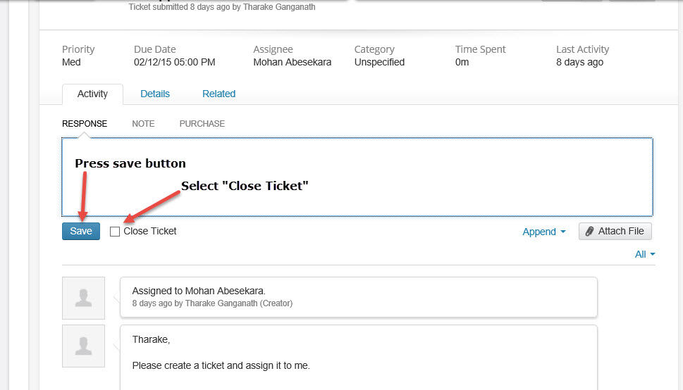

* **Step 4:** You can also update **Creator, CC Users and Assignees** you have entered previously from the details tab, refer the below screenshot.

