**Teknowledge Shared Services (PVT) LTD.**

**OPR for Check on pending procurements and attend/arrange purchases**

|  |  |
| --- | --- |
| **SUBJECT** | OPR for check on pending procurements and attend / arrange purchases |
| **RECORDER (Name Designation)** | Dishan Malaweera / Admin Operation |
| **APPROVED BY (Name Designation)** |  |
| **CREATED DATE** | 06/03/2016 |
| **NO. OF PAGES INCLUDING THIS PAGE** |  |

1. Introduction

Check recent and pending procurements of all farms (Horana,Wadduwa & Maldives ) related to all monthly dry goods requirements and urgent requirements.

1. Contents

* Horana Farm Monthly or Urgent Requirements.
* Wadduwa Farm Monthly or Urgent Requirements.
* Maldives Farm Monthly or Urgent Requirements.
* Styrofoam + Corrugated Boxes Requirement for US/UK Warehouse shipments.

1. Process

* Check mails for all pending procurements related all farms for the month.

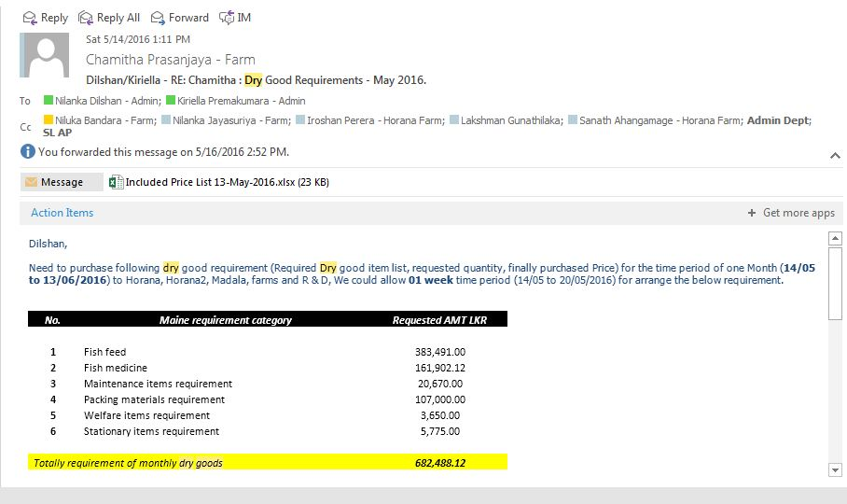

1. Check Wadduwa Farm Dry Goods Requirement

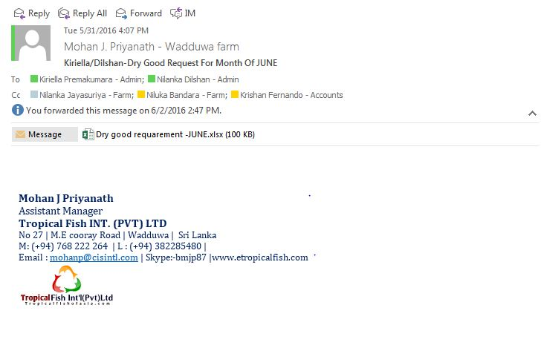

* Check any balances of the monthly dry goods requirements sent by all farms. 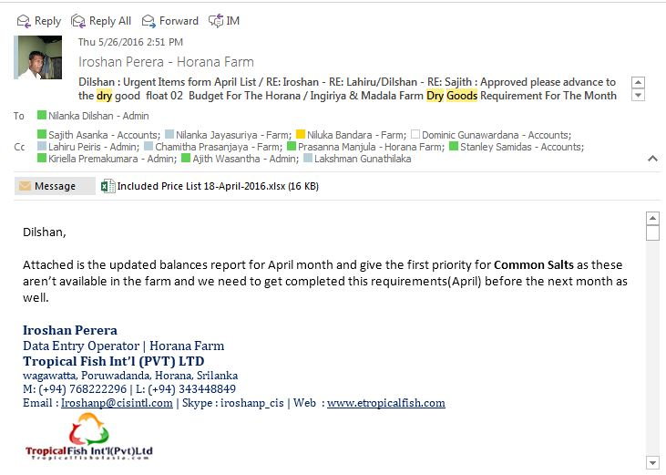
* Check any special requirements requested by Horana/Wadduwa and Maldives

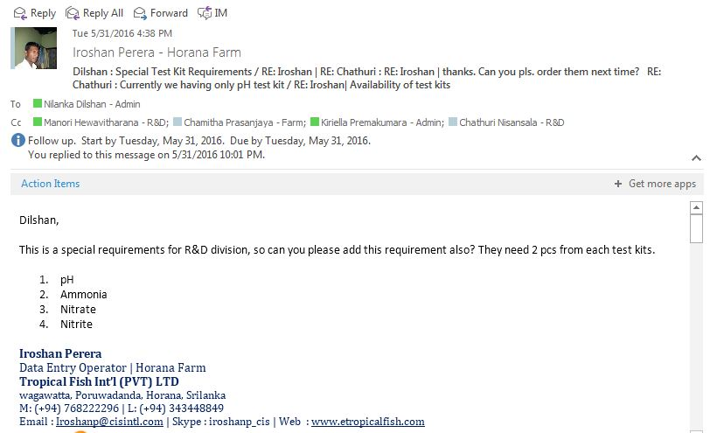

* Check any Urgent requirements requested by all farms.
* Attend & Arrange purchases for the relevant pending balance procurements.
* Arrange deliveries with purchases dry goods to farms if need ( as in urgent basis )