**Teknowledge Shared Services (PVT) LTD.**

**OPR for Obtain approvals**

|  |  |
| --- | --- |
| **SUBJECT** | OPR for Obtain approvals |
| **RECORDER (Name Designation)** | Dishan Malaweera / Admin Operation |
| **APPROVED BY (Name Designation)** |  |
| **CREATED DATE** | 06/03/2016 |
| **NO. OF PAGES INCLUDING THIS PAGE** |  |

1. Introduction

After prepare the assumed budget for the relevant requirements of the farms send to supervisor / HOD for approvals to release the funds.

Send the cash and credit budget separately for the approvals.

1. Contents

* Farm dry good requirement.
* Cash purchases.
* Credit purchases.

1. Process

* Prepare relevant budgets for farms requirements.

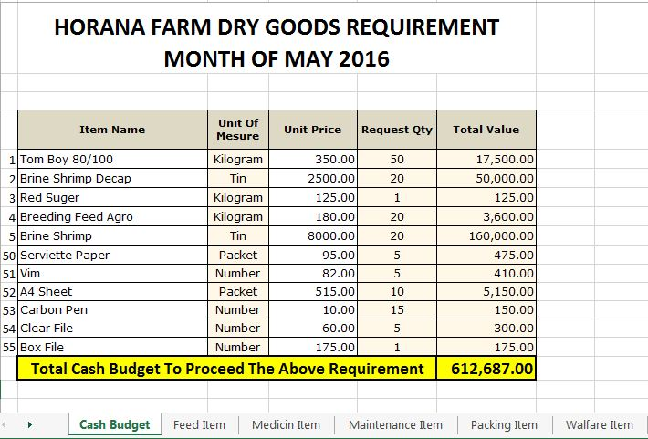

* Separate the procurements for cash and credit purchases. 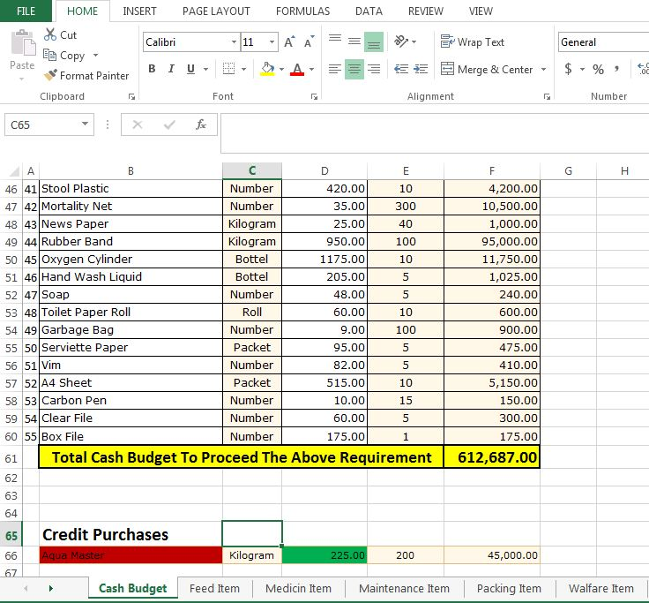
* Send cash budget via mail to supervisor / HOD for approvals.

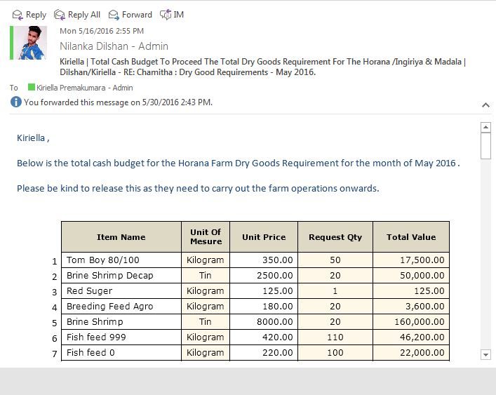

* Send credit purchases list for approvals.
* Send Purchase Order requests to supervisor/HOD.
* Obtain approvals for Purchases Orders from supervisor/HOD.