**Teknowledge Shared Services (PVT) LTD.**

**OPR for Coordinate with Accounts Dept. , Coordinate with farms for specific requirements, specifications of products, payments, deliveries, new or changed requirements, etc.**

|  |  |
| --- | --- |
| **SUBJECT** | OPR for Coordinate with Accounts Dept. , Coordinate with farms for specific requirements, specifications of products, payments, deliveries, new or changed requirements, etc. |
| **DEPARTMENT** | Admin Operation |
| **RECORDER (Name Designation)** | Dishan Malaweera / Admin Operation |
| **APPROVED BY (Name Designation)** |  |
| **CREATED DATE** | 06/03/2016 |
| **NO. OF PAGES INCLUDING THIS PAGE** |  |

. 1. Introduction

After receiving the budget approvals from finance manager to release the cash funds coordinate with relevant personnel to collect funds for relevant procurements.

Coordinate for suppliers’ outstanding payments / due payments.

Coordinate with farms for any specific requirements request for the month or project. Farm may need some items relevant to specific requirement or project during or besides the monthly requirement.

Need to check and visit the right supplier for the right requirement/item. After checking the samples need to purchase and deliver to the Horana Farm.

If there any deliveries directly to Horana Farm coordinate with them to collect the delivery.

2. Contents

* Coordinate with accounts dept.
* Coordinate with farms for specific requirements, specifications of products, payments and deliveries , new or changed requirements

3. Process

* Check any approvals received for requested budget for farm requirements.

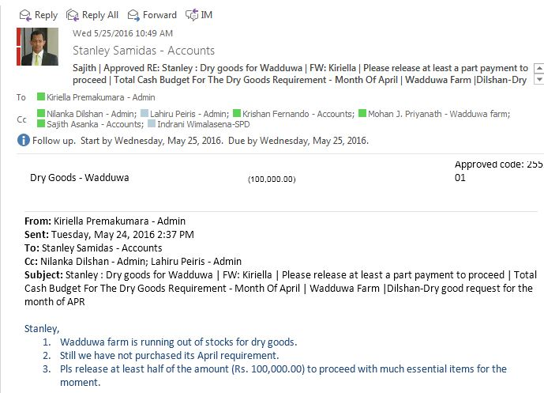

* Check for every farm requirement budget approvals received by finance manager.
* Check for any urgent payment made by accounts dep. for relevant requirements.
* Check for any due payments for the credit suppliers.
* Obtain approvals for due payments from accounts to proceed the orders ASAP.
* Obtain cash funds for relevant requirements.
* Coordinate with accounts for direct deposits to be done by accounts in favor of farm bank accounts to carry out the relevant purchases or other requested work by farms.
* Coordinate for any other supplier related matters.(SVAT credit vouchers/Invoices /Due Payments)
* Check any special requirements requested by Horana/Wadduwa & Maldives
* Check any specifications of products to be done for the requested items.
* Check for the right quality by checking the samples of the requested item.
* Check for any new requirement with specifications require for requirements/projects.
* Coordinate with farm staff for get any clarifications/details to get right specification/quality.
* Coordinate with farms to make arrangements to collect the deliveries arrange by head office directly to farms for placed orders on the relevant week or month.
* Coordinate with farms for any payments to be receive for any requested requirement/projects to be carry out by them.

Facilitate the farm operation by arranging dry good deliveries / weekly requirements for the regular shipments / fish productivity operations & other farm related operations

* Check any approvals received for requested budget for farm requirements.
* Check for every farm requirement budget approvals received by finance manager.
* Check for any urgent payment made by accounts dep. for relevant requirements.
* Check for any due payments for the credit suppliers.
* Obtain approvals for due payments from accounts to proceed the orders ASAP.
* Obtain cash funds for relevant requirements.
* Coordinate with accounts for direct deposits to be done by accounts in favor of farm bank accounts to carry out the relevant purchases or other requested work by farms.
* Coordinate for any other supplier related matters.(SVAT credit vouchers/Invoices /Due Payments)
* Check any special requirements requested by Horana/Wadduwa & Maldives
* Check any specifications of products to be done for the requested items.
* Check for the right quality by checking the samples of the requested item.
* Check for any new requirement with specifications require for requirements/projects.
* Coordinate with farm staff for get any clarifications/details to get right specification/quality.
* Coordinate with farms to make arrangements to collect the deliveries arrange by head office directly to farms for placed orders on the relevant week or month.
* Coordinate with farms for any payments to be receive for any requested requirement/projects to be carry out by them.
* Facilitate the farm operation by arranging dry good deliveries / weekly requirements for the regular shipments / fish productivity operations & other farm related operations