**TEKNOWLEDGE SHARED SERVICES-SRI LANKA**

**OPR TFI UK Production Planning**

|  |  |
| --- | --- |
| SUBJECT | TFI UK Production Planning |
| DEPARTMENT | PRODUCTION PLANNING |
| RECORDER | BUDDIKA MADURANGANA |
| APPROVED BY |  |
| CREATED DATE | 02/16/2016 |
| LAST UPDATED |  |
| PATH ON NETWORK FOLDER |  |
| NO. OF PAGES INCLUDING THIS PAGE | 4 |

1. **PO receiving**

We are getting POs from [localintranet@petsathome.com](mailto:localintranet@petsathome.com) to PAHPO group. In PAHPO group, Ian Y, Ian F, Lisa, Prodmgt, Labrmgt, Purodha, Andrea are included

PO comes as individual CSV file to PAHPO email group as below,

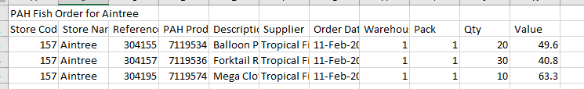

All POs to be recorded in a excel file for planning purpose.

1. **PO cycle**

Currently we are shipping POs on Tuesday, Wednesday and Thursday only. By Thursday we can receive all POs for Tuesday and Wednesday deliveries. Thursday delivery POs will be received on Friday.

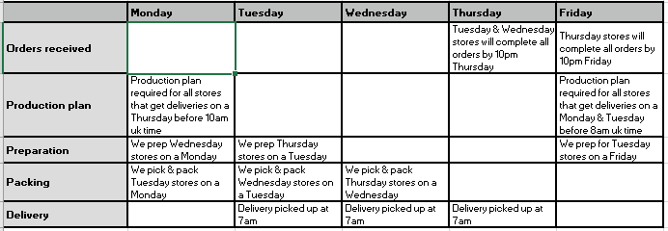

1. **PO delivery plan**

Po delivery plan as below for the trial period.

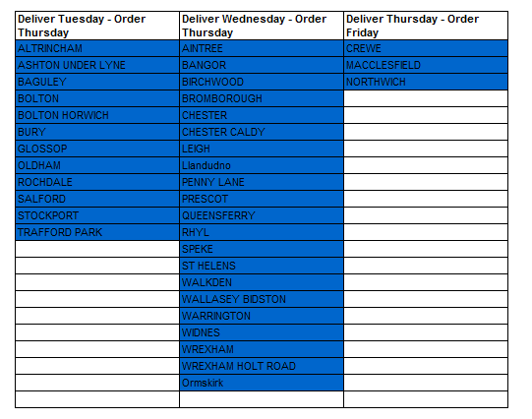

1. **Production Plan**

For the Tuesday and Wednesday deliveris, we need to provide the production plan on Friday before 1.00 PM SL time.

It must consist, packer report, bagger report and labor allocation.

Packer report, 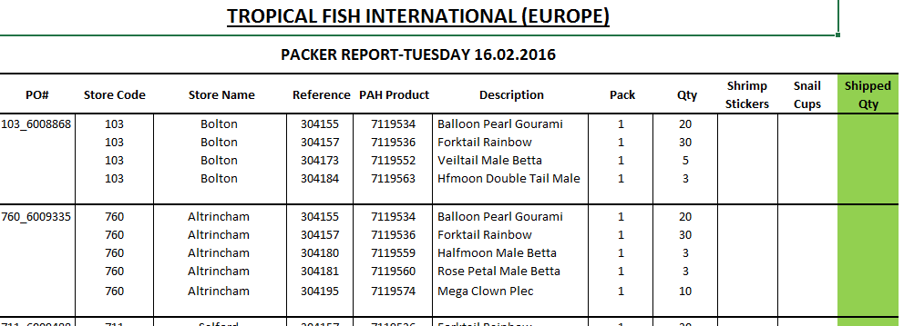

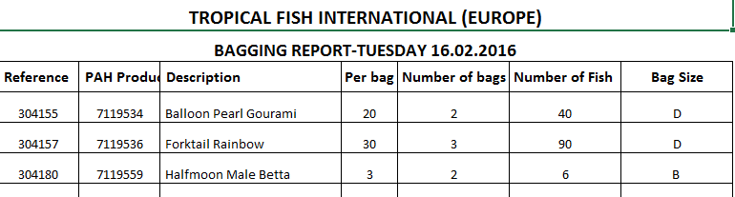

**CUC and Bagging details**,

|  |  |  |
| --- | --- | --- |
| **Species** | **TFI Code** | **animals per pot** |
| Assassin Snail Squad | 141-241213 | 3 |
| Zebra Snail Squad | 141-24588 | 3 |
| Red Spotted snail Squad | 141-24543 | 3 |
| Red Lip Snail Squad | 141-24578 | 3 |
| Spiral Horn Snail Squad | 141-246681 | 3 |
| Yellow Rabbit Snail Duo | 141-24818 | 2 |
| Long Nose Snail Duo | 141-24638 | 2 |
| Amano Shrimp Squad | 145-141485 | 3 |
| Cherry shrimp Squad | 147-90177 | 6 |
| Nano shrimp Squad | 147-1411025 | 6 |
|  |  |  |
| All bettas = bag size B |  |  |
| All CUC = Bag size A |  |  |
| ALL packs of multiple fish bag size D | |  |

Daily production plan to be sent to,

Ian Forster

Copy to

Ian Young, Lisa, Customer service, IT admin

Once the production plan completed, Label printing plan to be submitted to IT for bagging and packing label printing.

1. **Delivery notes**

Once the PO received by the relevant store, delivery note will be issued. It will be received to PAHdel email group as csv file.

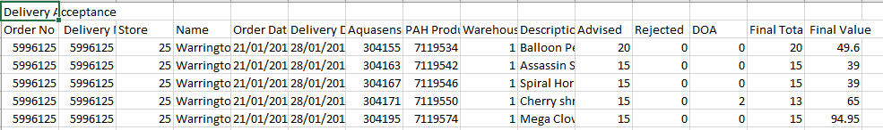

All the delivery notes to be recorded and need to follow up with the Customer service for any non-received delivery note.

Note:

Production planning is currently done manually as mentioned above and it will be done on PETSys once it ready.