**TEKNOWLEDGE SHARED SERVICES-SRI LANKA**

**OPR: Inventory Tracking (Fresh Water Item) - 193**

|  |  |
| --- | --- |
| SUBJECT | INVENTORY TRACKING (FRESH WATER ITEM) – 193 |
| DEPARTMENT | PRODUCTION PLANNING |
| RECORDER | Sivantha Sameera |
| APPROVED BY |  |
| CREATED DATE | 06.16.2016 |
| LAST UPDATED |  |
| PATH ON NETWORK FOLDER |  |
| NO. OF PAGES INCLUDING THIS PAGE | 3 |

**Objective**

Provide the accurate inventory details for production planning.

**Inventory Tracker Format**

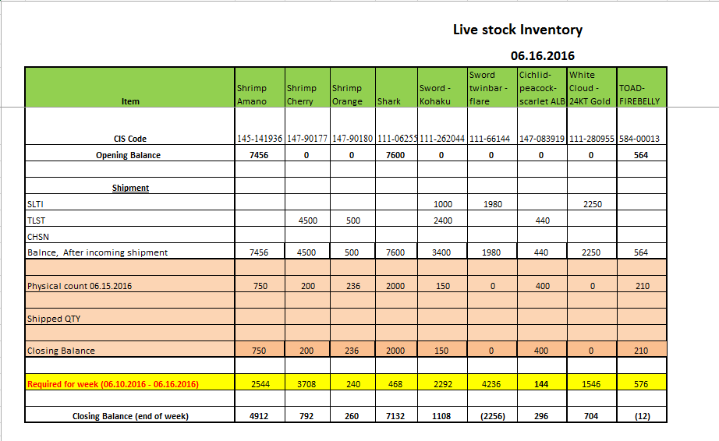

**Open Balance**

Every Wednesday after the production USWH send the Physical count. Opening balance can be taken that physical count.

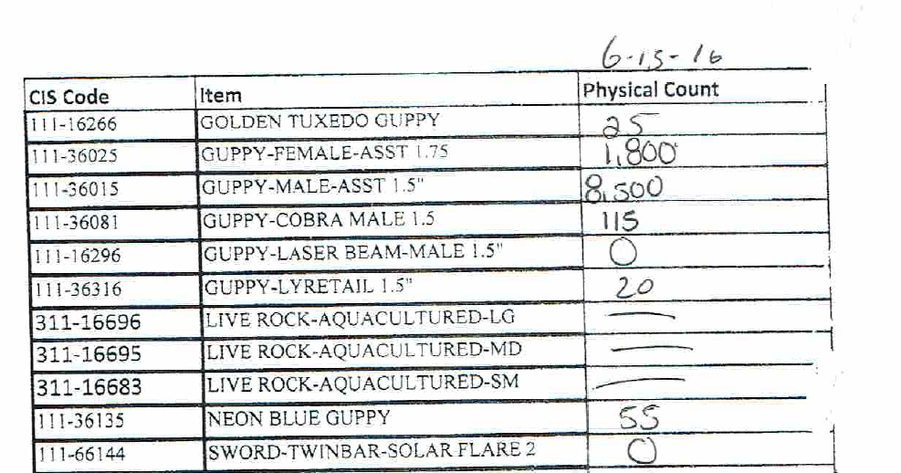

**Shipment**

Check the shipment planner and get the shipment invoice and track the shipped Quantities.

(SLTI, TISL, CHSN). Usually SLTI shipment Reach the USWH at Wednesday and TISL shipment reach the USWH at Sunday.

**Tracking the Daily shipment Quantities**

Once EOD completed, get the Shipped quantity report for ETF and track the shipped QTY.

Path – EDI Details – Shipped Quantity report

Link - http://www.cisintl.com/ShippedQtyRepo rtNew.aspx

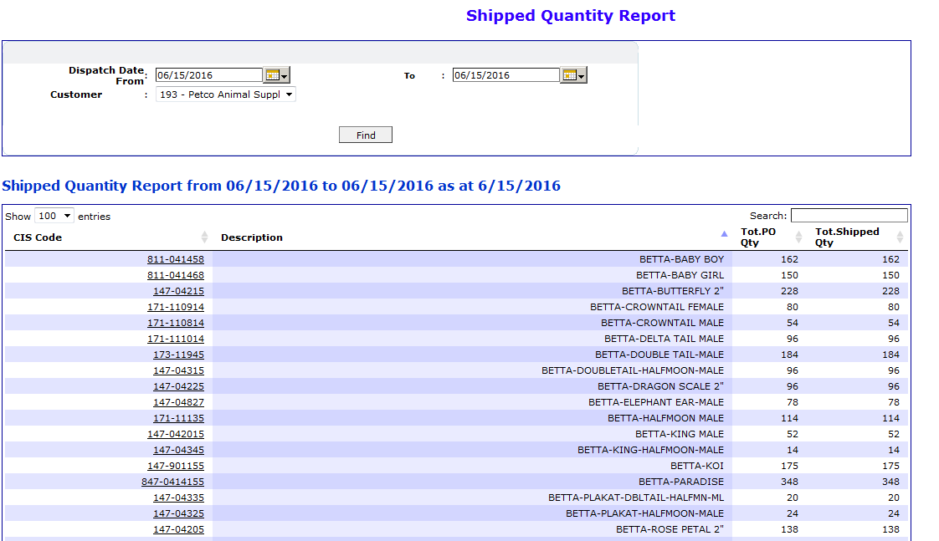

**Tracking Weekly Item requerd Quantity**

Every Sunday All the POs uplod the ETF for the coming week. Once upload the POs, PO Summary report with QTY can be taken and track the requard Item quantities for the coming week.

Path – EDI Details – PO Summery report With QTY

Link - <http://www.cisintl.com/OrdersWorkSheetQTY.aspx>

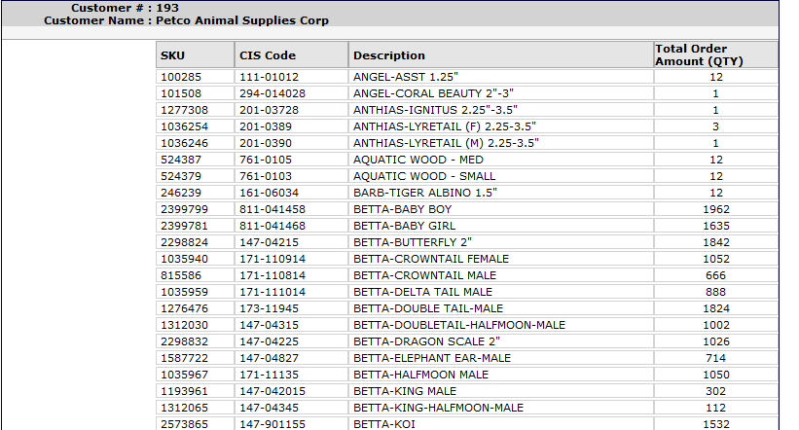Date rang – Current week Sunday to last week Sunday.