**TEKNOWLEDGE SHARED SERVICES-SRI LANKA**

**OPR FOR PRODUCTION PLANNING**

|  |  |
| --- | --- |
| SUBJECT | OPR FOR PRODUCTION PLANNING |
| DEPARTMENT | PRODUCTION PLANNING |
| RECORDER | BUDDIKA MADURANGANA |
| APPROVED BY |  |
| CREATED DATE | 12/04/2015 |
| LAST UPDATED | 03/04/2016 |
| PATH ON NETWORK FOLDER |  |
| NO. OF PAGES INCLUDING THIS PAGE | 7 |

# Objectives

1. To ship every single fish so we have a 100% Fill rate with the customer. The fill rate report will be evaluated by the customer every 15 days. Customer’s expected Fill rate is 95%.

Production plan to be prepared to achieve above target utilizing the available resources.

# PRODUCTION GUIDELINES

##### IDENTIFYING FISH SCHEDULED FOR SHIPPING

1. Check to see what fish are being shipped out next week and any promotions. Base on the last six-week shipping, coming week projection to be prepared & projected production tracker to be updated. The tracker must be prepared on Thursday for coming week and weekly plan to be finalize at the weekly meeting based on this document.
2. Go through the following 3 documents on the ETF website and the network.
   * Promo Calendar – ETF website
   * Shipment Planner – ETF website
   * Stock on hand – ETF website (If the item is not available in stock and if it is not included in the order worksheet being completed and the fish is not coming in, then the item should not be planned into production)
3. Add any back orders from the previous week. All back orders from the previous week needs to be prioritized for shipping on Monday.
4. Go through the ETF stock on hand to ensure the stock.

**PRODUCTION PLANNING PROCESS**

**1. ASSIGN STATIONS ON ETF**

Based on the projected Tracker, number of packers and bagger will be finalized and need to assign Station in ETF. This has to be done on every Sunday before starting the production plan.

Path <http://www.cisintl.com/ProductionMatrix/StationManagement.aspx>

Production Planning Admin-Station assignment

1. Select the station name
2. Select employee name
3. Select supervisor
4. Select Start and End time
5. Select day
6. Save

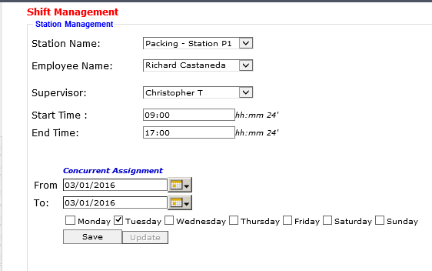

**2. ASSIGN MPOS TO ETF**

New MPOs for the production week to be assigned to ETF on Sunday morning.

1. Date Range: previous Sunday to this Sunday
2. Get the PO list
3. Select All
4. Go to Manual update panel
5. Update

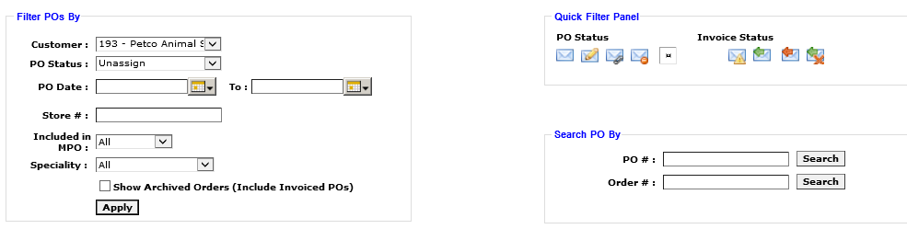

# GROUP POs

POs of the same store to be grouped to minimize the shipping cost. Following criteria to be followed.

1. POs can be grouped only if they are for same store.
2. Maximum 4 POs can be grouped at a time.
3. Wood/Rock /Plant POs to be excluded from the grouping.
4. Promotional POs are not group with regular POs. if there any requirement to do so, need to get Matts approval.
5. Betta less than six POs must to be grouped with other POs since these POs cannot be shipped alone.

**How to group**

Production Planning Admin - Purchase Order Grouping

Link: <http://www.cisintl.com/pogrouping.aspx>

Steps

1. Provide the date range
2. Customer: 193-Petco Animal Supplies
3. Find PO
4. Tick the POs which needed to be groped. (tick all option is available and un-tick if any PO that not to be grouped)
5. Group PO

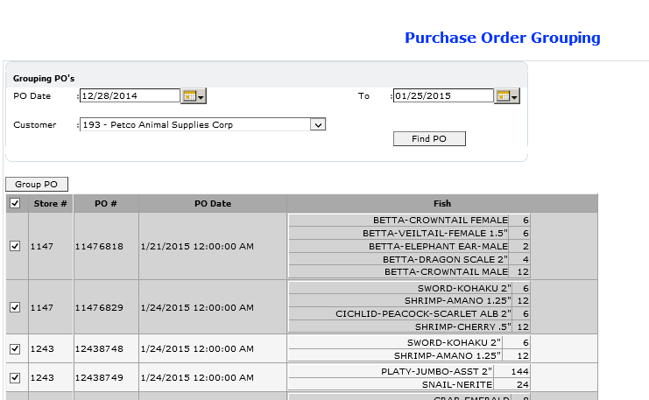

# ASSIGNING PO’S FOR PACKER THRU ETF

1. Login to ETF & go to **Production Planning Admin ->** Production Planning New
2. Put the date range “Sunday to MPO end date”
3. **Select Customer ID :** Customer for whose Orders Planning is being done: Eg. #193, #651, etc.
4. Click on “ **View Ungroup Combination”** to view the ungroup combinations Click on “ **View Group Combination”** to view the Group combinations
5. Then PO will be listed down in Ungroup & Group sections.
6. Put the relevant date for production date.

|  |  |
| --- | --- |
|  |  |

1. Select the station as for the relevant packer

|  |  |  |  |
| --- | --- | --- | --- |
| **Planned On** | |  |  | | --- | --- | |  | [...](http://www.cisintl.com/ProductionMatrix/ProductionPlan.aspx) | |
| **Station** |  |

1. Do a bulk upload . Selection of Packers for specific Qty of PO’s or Combinations or Groups is to be based STRICTLY ON THE INFO FILLED IN ON THE PRODUCTION GUIDELINE spreadsheet.
2. Click on the check box in from of the combination and press “SHOW PO’s IN THE COMBINATION” The count of the Pos will indicates on the available box enter the number of Pos you need to assigned for the packer and click assigned

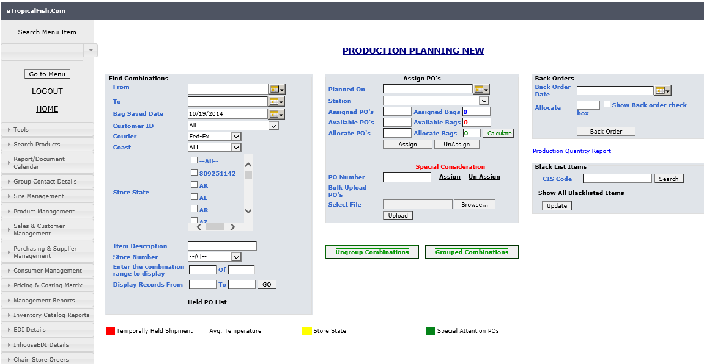

**SPECIAL ATTENTION POS & BACK ORDER ASSIGNMENT**

**These special attention POs and Back orders to be prioritize in daily production.**

* As per the customer requirement, some Stores/States to be planned on particular production date.
* Example: Store#596 to be planned on Monday.
* Special attention POs must be assigned in separate breakdown.
* Back orders to be prioritized on Monday and instruction to be given/highlighted to ware house to ship all on Monday to avoid cancellation.

**HIGHLIGHT THE BACK ORDERS IN PACKER BREAK DOWN.**

Need to assign all the back orders to a single packer and need to highlight back orders as below.

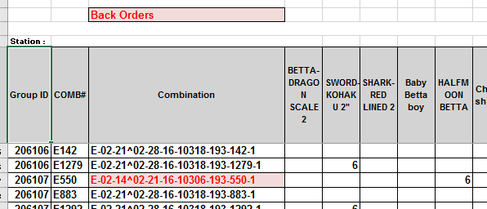

**SAVE BAGS**

Bags to be saved for the each packer which assigned for the production.

* Fish Breakdown and Bagger assignment – View Fish breakdown details.
* Provide the date, Production Station and Customer is 193.
* Load Calculated Value should be selected to view the system assigned bag values. Need to check EOQs and Save#bags.

<http://www.cisintl.com/ProductionMatrix/FishBreakDownReport.aspx>

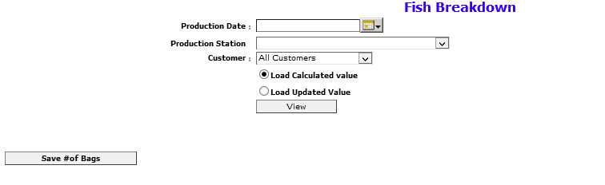

# BAGGER ASSIGNMENT

After the bag saving, need to assign bags to the bagger. This will allow baggers to print the labels for bags.

* Fish Breakdown and Bagger assignment – Bagger Assignment.
* Provide date, Customer#193 & View.
* Select the bagger name which you need to assign & tick the fish types which needed to be assigned for the selected bagger.
* Add
* Assign Bags.

<http://www.cisintl.com/ProductionMatrix/baggerAssignment.aspx>

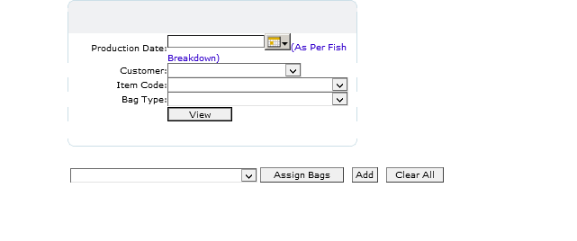

# HOW TO GET PACKER REPORT THRU ETF

1. The go to “Packer breakdown “under “production planning Admin”
2. Put the production date.
3. Select the relevant station.
4. Courier UPS
5. If the POs are assigned as grouped, then need to click on the “Show grouped breakdown”
6. It the POs are assigned as ungrouped, then click on ““Show ungrouped breakdown”.

<http://www.cisintl.com/ProductionMatrix/packerbreakDown_Nw.aspx>

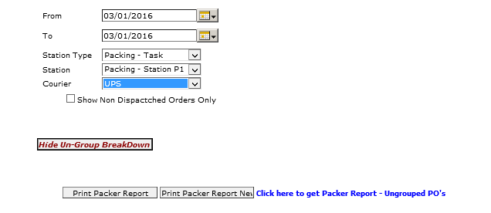

Note: After completion of fish breakdown, need to inform IT admin to check the packing assignment

|  |  |  |  |
| --- | --- | --- | --- |
| **Petco** |  |  |  |
| **Packing station** | **Packer Name** | **No Of Un Grp po's** | **No of Grp Po's** |
| **P1** | **Reserve** | 4 |  |
| **P2** | **Richard** | 115 | 12 |
| **P3** | **Anthony** | 31 | 44 |
| **P4** | **Fabiola** |  | 143 |
|  |  |  |  |
|  |  | 150 | 199 |

**BREAKING DOWN DAILY PRODUCTION – Items to be prioritized**: - Refer to Standard Production Planning guideline document.

* Sunday Production: Betta POs, Wood/Rock to be planned
* Monday production: Back orders, Special Attention and Regular POs.
* Tuesday production: Any Back orders, Special Attention and Regular POs.
* Wednesday production: HI/AK/PR, Special Attention and Regular POs.
* Thursday production: Special Attention and remaining Regular POs.

Note: Proper communication is required to maintain with WHMgt and need to accommodate their requirement.