**CIS INTERNATIONAL HOLDINGS CORP**

**OPR FOR GRAND OPENINGS**

|  |  |
| --- | --- |
| **SUBJECT** | **GRAND OPENING PO’S** |
| **DEPARTMENT** | **COUSTOMER SERVICE** |
| **RECORDER (Name & Designation)** | **VIKUM MARASINGHE (CSE)** |
| **APPROVEDBY (Name & Designation)** | **PURODHA PERERA (HOD CS)** |
| **CREATED DATE** | **06/20/16** |
| **LAST UPDATED (MM/DD/YY)** | **06/20/16** |
| **PATH ON NETWORK FOLDER** | **N/A** |
| **NO. OF PAGES INCLUDING THIS PAGE** | **2** |

***Grand Opening PO’s***

*These are important orders that needs to be prioritize and packed under special attention and shipped out on time to be delivered on a specific date.*

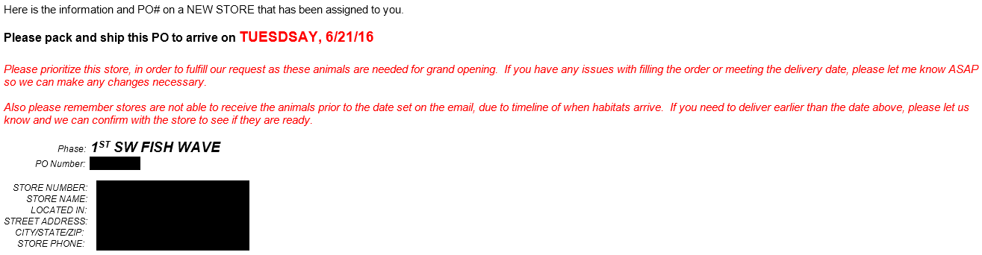

*These Orders mostly for a new store and can be for a special event (1st, 2nd, 3rd Fish Waves)*

* First update the weekly Customer Service Tracker with the information on the grand opening store and update the Grand opening tracker.
* Log into the ETF website, on the menu bar on the left hand side, look up the PO # under “PO Summary Totals Report” under EDI Details and check the items on the shipment and determine how long will the shipment will be on transit and plan the shipment for the date it’s been expected.
* E-mail a summary of the Grand Opening Orders to the Production Department and the Warehouse Management for production of the following day.
* Double check completion of all emergency orders with the warehouse at 2:00PM to ensure they are packed and ready for dispatching. If not make a second follow up at 3:00PM to ensure the orders are packed for shipping.
* Special Orders MUST be packed BEFORE noon by the Packer allocated for the Special Attn. order.
* Customer Service needs to be able to verify on the System, that the Orders have been packed and shipped and will escalate any issues to Andy (Warehouse & Admin manager) immediately, if the above Process is NOT adhered to.