**CIS INTERNATIONAL HOLDINGS CORP**

**OPR FOR PO CANCELATION**

|  |  |
| --- | --- |
| **SUBJECT** | **PO CANCELATION** |
| **DEPARTMENT** | **COUSTOMER SERVICE** |
| **RECORDER (Name & Designation)** | **VIKUM MARASINGHE (CSE)** |
| **APPROVEDBY (Name & Designation)** | **PURODHA PERERA (HOD CS)** |
| **CREATED DATE** | **06/20/16** |
| **LAST UPDATED (MM/DD/YY)** | **06/21/16** |
| **PATH ON NETWORK FOLDER** | **N/A** |
| **NO. OF PAGES INCLUDING THIS PAGE** | **2** |

***PO Cancelation***

When received a cancelation request from Petco, Refer the below screenshot.

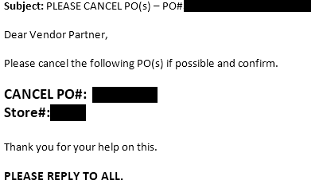

When received a cancelation request from Petco,

* Log into the ETF website and look up the PO # under “PO Summary Totals Report” on EDI Details and check the PO and its line items/ Status very carefully.
* If the PO is already shipped, needs to provide the PO Status to the client stating the PO cannot be canceled as the PO has been already shipped out.
* If the PO status is “Open”, Go to the Change PO Status menu and suspend the PO.

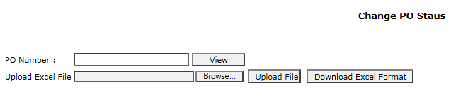

* Once canceled the SID will be 12.
* Double check the PO Status from “PO Summary Totals Report” and confirm to the client that the PO has been canceled.