**Tropical Fish Intl Ltd**

**OPR FOR LOGISTIC SHIPMENT CHECK LIST**

|  |  |
| --- | --- |
| **SUBJECT** | **Coordinating with Sales & Marketing, Order Entry and Farms for getting shipment plans** |
| **DEPARTMENT** | **Logistic Colombo** |
| **RECORDER (Name & Designation)** | **Ranjith Seevaratnam, Priyadhasha, Udaya Perera** |
| **APPROVEDBY (Name & Designation)** | **Udaya Perera** |
| **CREATED DATE** | **10\03\2016** |
| **LAST UPDATED** |  |
| **PATH ON NETWORK FOLDER** | **Z:\Gen Log\OPR** |
| **NO. OF PAGES INCLUDING THIS PAGE** | **1** |

**Coordinating with marketing and Farms for getting shipment plans**

Make sure relevant approvals are in order to proceed the Shipment (Sales, Marketing, Order Entry & Farm)

**Sales and Marketing,**

Obtain following documents/ Details as per below format from Manager- Marketing

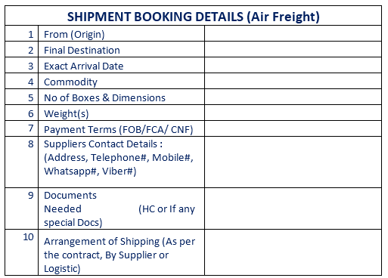

**Order Entry**

Re confirm the quantities and shipment dates according to the above format by email or following Shipment planner.

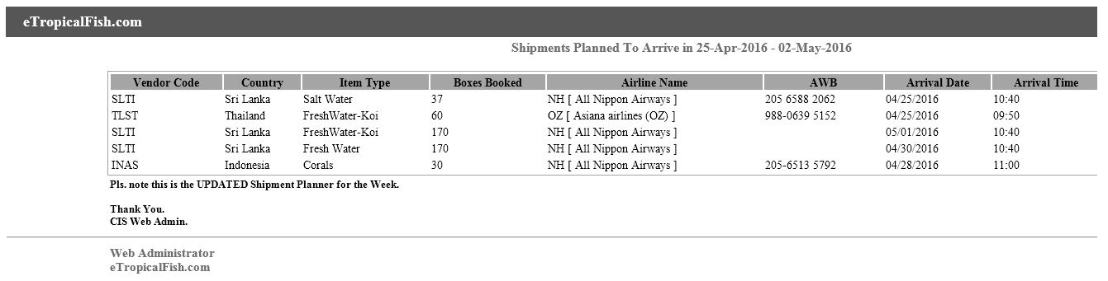

**Farms**

1. Contact Farm Operation Manager and ensure the delivery, hand over time, etc.. of cargo.
2. Contact Data Entry Executive
3. Invoice and Packing List for Preparation of Exports CUSDEC
4. Final Invoice and Packing List for customs and BOI verification at Air cargo village at Katunayake

Copy of CUSDEC

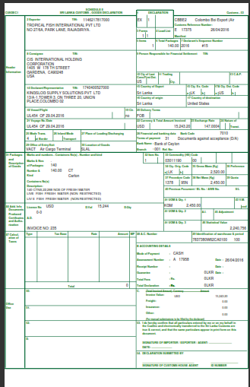

Copy of Invoice (For Entry Passing)

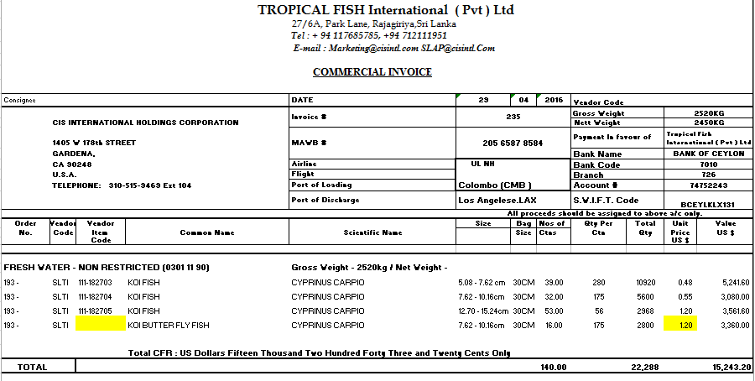

Packing List / Invoice (Final)

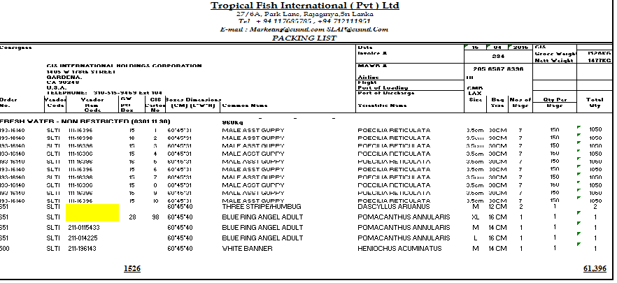

Final Commercial Invoice to be attached with final packing list (Shown above) for customs/ BOI verification at air cargo village at Katunayake.

Coordinate with Forwarder and consignee through email regarding correspondent. Please note that forwarder and consignee depend on the category of freight.