**OPR for Check Emails and & send F/U mails**

1. Follow-ups and Monitoring pending reports starting from with the system mail received from the ETF as follow,

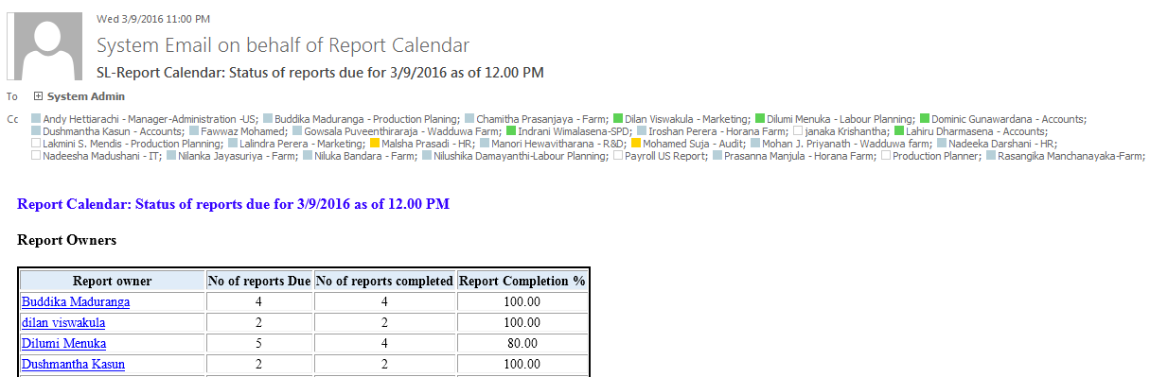

1. And it also gives the details of the reports which are complete as follows,

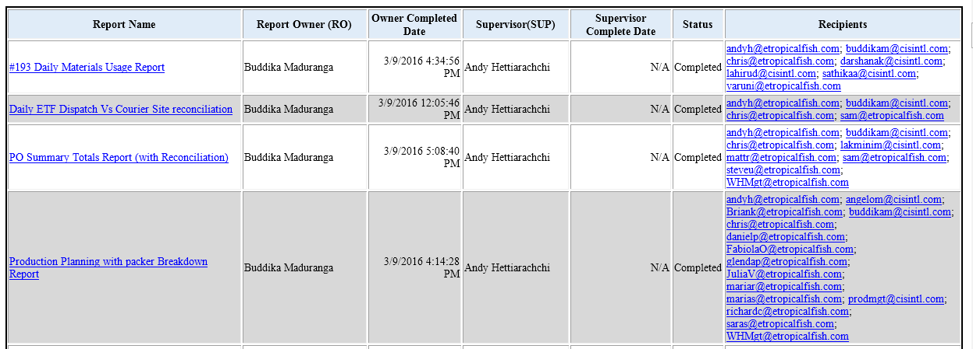

Also you will see the pending reports as well

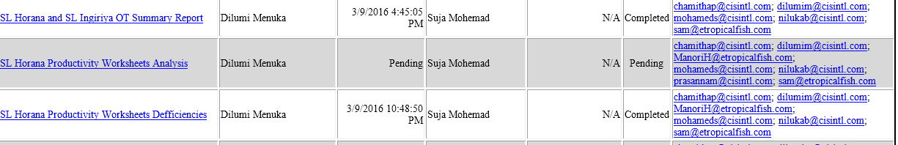

According to the pending reports need to send pending notice to the report owner to confirm the delay.

1. Sending F/U mails for pending reports.

Forward the mail received from ETF system alert and write to the report owner mentioning about his pending reports that to know whether the employee need more time to do the report or need any changes or the report is no longer.

Get the pending report details -

Use pending mail format which has written for a standard and copy mail body and also place the pending report details.

1. To Report owner and Cc to supervisor and department head/ HOD of system admin
2. Subject – Name (according to the company policy) | F/U Regarding Incomplete Report due for Date (report date)
3. Name of the report owner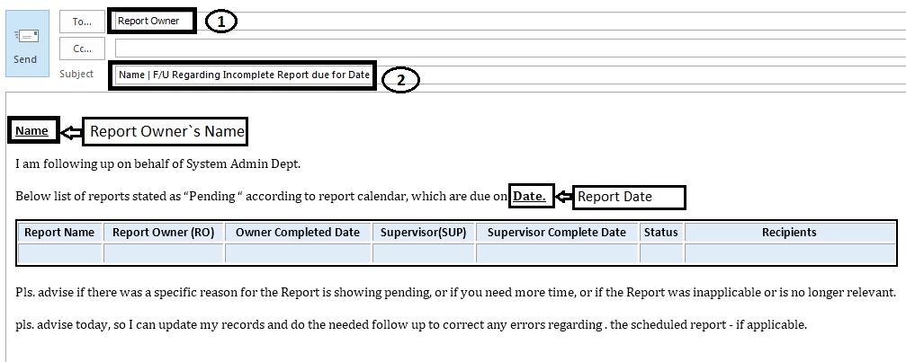
4. React according to the reply as system admin will do the report amendments and if there is any other issue will forward to the IT department.
5. Sending F/U mails for pending meetings. – Same as send mail regarding pending reports as follows,
6. To- meeting participant with the Cc to HOD of system admin
7. Subject – Meeting Participants Name (according to the company policy) | F/U Pending Meeting due for Date (meeting due date)
8. Meeting Participants Names

