**CIS INTERNATIONAL HOLDINGS CORP**

**OPR for Monitoring & reporting to IT Admin on all Petco.com inquiries for orders already been shipped out**

|  |  |
| --- | --- |
| **SUBJECT** | **Monitor & report to IT Admin on all Petco.com inquiries for orders already been shipped out** |
| **DEPARTMENT** | **Customer Service Department** |
| **RECORDER (Name & Designation)** | **Purodha Perera** |
| **APPROVEDBY (Name & Designation)** | **Purodha Perera** |
| **CREATED DATE** | **06/29/2016** |
| **LAST UPDATED** | **06/29/2016** |
| **PATH ON NETWORK FOLDER** | **N/A** |
| **NO. OF PAGES INCLUDING THIS PAGE** | **1** |

**Monitor & report to IT Admin on all Petco.com inquiries for orders already been shipped out**

1. 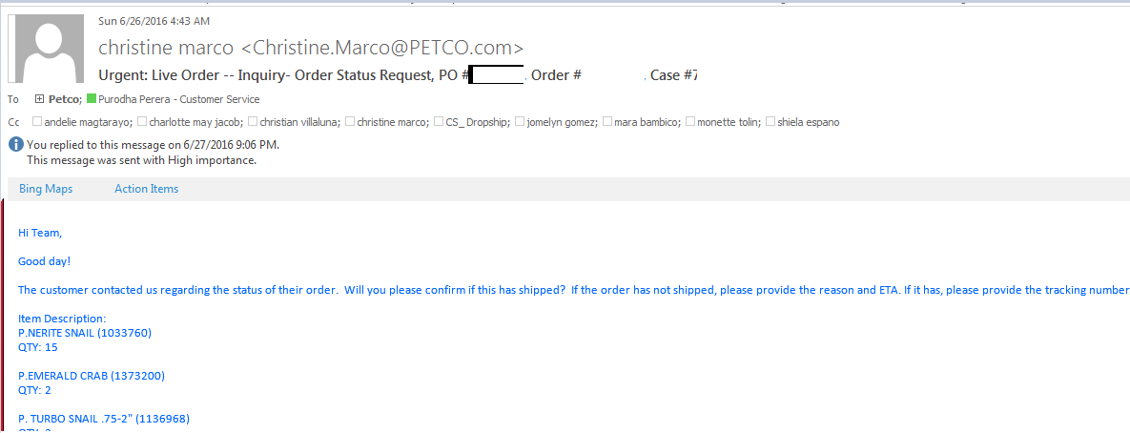E-mail inquiries received from Petco.com orders

1. PO should already be shipped out as per ETF
2. Respond to the customer with available information
3. Forward to Matt & IT Admin for further research since this could be due an EDI notification failure
4. Once IT Admin & Matt has a resolution, a complete response with clarity would be given to the customer with the action taken