**Tropical Fish Intl Ltd**

**OPR FOR LOGISTIC SHIPMENT CHECK LIST**

|  |  |
| --- | --- |
| **SUBJECT** | **Ensure export/ Import paperwork is in place before the collection takes place (Internal/External)** |
| **DEPARTMENT** | **Logistic Colombo** |
| **RECORDER (Name & Designation)** | **Ranjith Seevaratnam, Priyadhasha, Udaya Perera** |
| **APPROVEDBY (Name & Designation)** | **Udaya Perera** |
| **CREATED DATE** | **28/04/2016** |
| **LAST UPDATED** |  |
| **PATH ON NETWORK FOLDER** | **Z:\Gen Log\OPR** |
| **NO. OF PAGES INCLUDING THIS PAGE** | **7** |

**Ensure export/ Import paperwork is in place before the collection takes place (Internal/External)**

Ensure export/ Import paperwork is in place before the collection takes place

**Normal Fish Shipment**

Invoice

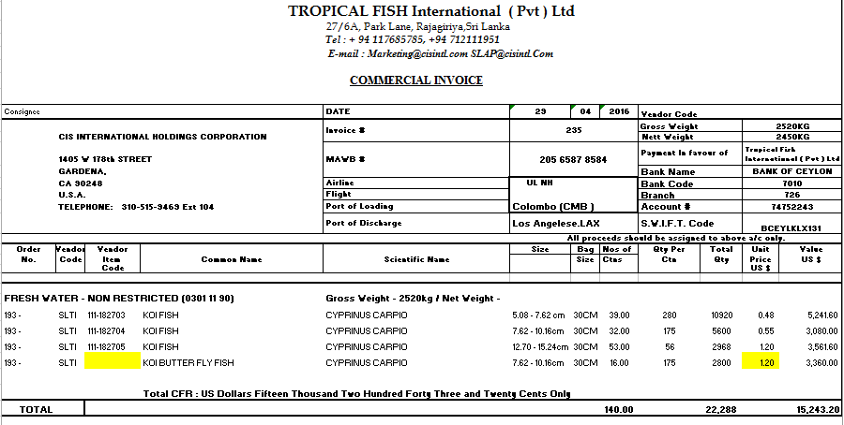

**Packing List**

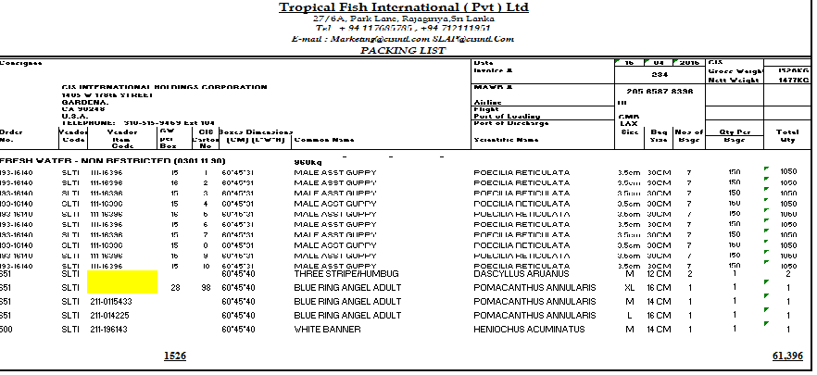

**Master Airway Bill**

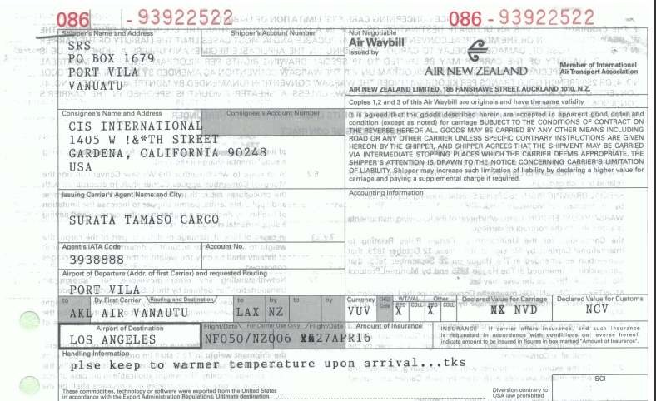

**KOI Fish shipment**

**Invoice**



**Packing List**



**Master Airway Bill**



**Health Certificate from DAPH**

